**Table of Contents**

Table of Contents

Introduction: Your Digital Business Journey

Chapter 1: Pre-Registration Essentials

1.1 Choosing the Right Business Structure

1.2 Name Availability: Securing Your Brand

1.3 Gathering Required Documents

1.4 Payment Preparation

Chapter 2: The Online Registration Process: A Detailed Walkthrough

2.1 Accessing the CAC Portal

2.2 Account Creation and Login

2.3 Name Reservation Procedure

2.4 Filling the Online Application Forms

2.5 Document Upload: Best Practices

2.6 Secure Online Payment

2.7 Application Submission and Confirmation

2.8 Downloading Your Certificate

Chapter 3: Post-Registration: Building Your Business Foundation

3.1 Obtaining Certified True Copies (CTCs)

3.2 Opening a Corporate Bank Account

3.3 Tax Identification Number (TIN) Registration

3.4 Understanding Post-Registration Obligations

Chapter 4: Troubleshooting and Common FAQs

4.1 Name Availability Issues and Alternatives

4.2 Document Upload Errors and Solutions

4.3 Payment Problems and Resolution

4.4 Application Rejection: Understanding and Rectifying

4.5 Frequently Asked Questions (FAQs)

Conclusion: Your Business, Digitally Empowered

**Introduction: Your Digital Business Journey**

Welcome to the streamlined world of online business registration in Nigeria. This eBook is your practical guide to navigating the Corporate Affairs Commission (CAC) portal, empowering you to launch your business efficiently. In today's digital landscape, online registration offers speed, convenience, and transparency, essential for modern entrepreneurs. We'll break down each step, ensuring you understand the process and avoid common pitfalls. Let's embark on your digital business journey!

**Chapter 1: Pre-Registration Essentials**



**1.1 Choosing the Right Business Structure:**

The first step is selecting the appropriate business structure. A **Business Name** is ideal for sole proprietorships or partnerships, offering a simpler registration process and lower costs. It's perfect for freelancers, small retail shops, or service providers. A **Limited Liability Company (Ltd)**, on the other hand, provides limited liability protection, separating your personal assets from business liabilities. This structure is suitable for businesses seeking investment, expansion, or a more formal corporate image. Consider your long-term business goals when

making this decision.

**1.2 Name Availability: Securing Your Brand:**

Your business name is your identity. Before proceeding, visit the CAC website (www.cac.gov.ng) and utilize the name search tool. Enter your desired name and check for availability. Similar names might be rejected. To avoid delays, brainstorm multiple name options and ensure they are unique and relevant to your business. Avoid using offensive or misleading names. Remember to also check for trademark availability separately.

**1.3 Gathering Required Documents:**

Preparation is key. For a **Business Name**, you'll need a scanned copy of a valid government-issued ID (National ID, Driver’s License, Passport) and a passport photograph. For an **Ltd**, prepare scanned copies of valid IDs and passport photographs for all directors and shareholders. You'll also need the proposed company address and the detailed information of each director/shareholder (names, addresses, occupations, email and phone number).

**1.4 Payment Preparation:**

Online registration requires online payment. Ensure you have a functional debit card or access to online banking. Verify that your card is enabled for online transactions and that you have sufficient funds. Also ensure that you have a stable internet connection during the payment process.

**Chapter 2: The Online Registration Process: A Detailed Walkthrough**

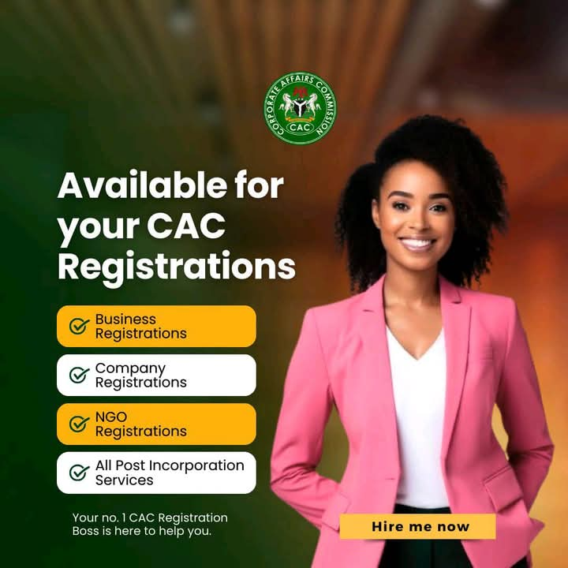

**2.1 Accessing the CAC Portal:**

Open your preferred web browser and type in www.cac.gov.ng. The CAC website is the official portal for all online business registrations.

**2.2 Account Creation and Login:**

If you're a new user, click on the 'Register' button and provide your email address and a secure password. Verify your email address through the link sent to your inbox. If you already have an account, click 'Login' and enter your credentials.

**2.3 Name Reservation Procedure:**

After logging in, navigate to the name reservation section. Enter your chosen business name and click 'Search.' If the name is available, reserve it by paying the reservation fee. This reserves the name for a specific period, giving you time to complete the registration.

**2.4 Filling the Online Application Forms:**

Proceed to the online application form. Fill in all the required fields accurately. Pay close attention to details, especially addresses and contact information. For an Ltd, you'll need to provide details of directors, shareholders, and share capital. Double-check all information before proceeding.

**2.5 Document Upload: Best Practices:**

Scan all documents in PDF or JPEG format. Ensure the scans are clear, legible, and within the specified file size limits. Upload each document to the corresponding section of the application form. Name your files descriptively (e.g., 'Director_ID.pdf').

**2.6 Secure Online Payment:**

Follow the prompts to make payment using your debit card or online banking. Ensure you have a stable internet connection. After successful payment, you'll receive a payment confirmation.

**2.7 Application Submission and Confirmation:**

Review all the information you've entered and the uploaded documents. Once you're satisfied, click 'Submit.' You'll receive an application confirmation with a reference number. Save this number for future reference.

**2.8 Downloading Your Certificate:**

After your application is approved, you'll receive an email notification. Log in to your CAC account dashboard and download your certificate of registration. Print and save a digital copy for your records.

**Chapter 3: Post-Registration: Building Your Business Foundation**

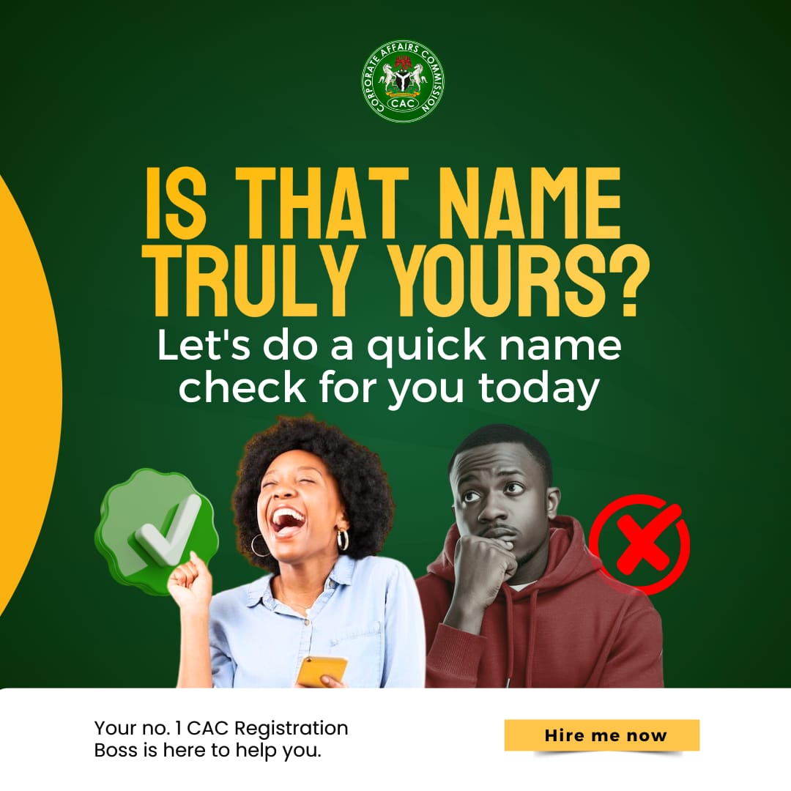

**3.1 Obtaining Certified True Copies (CTCs):**

For official purposes, you might need Certified True Copies (CTCs) of your registration documents. Apply for CTCs through the CAC portal and pay the required fee.

**3.2 Opening a Corporate Bank Account:**

With your registration certificate, visit a bank of your choice and open a corporate bank account. This separates your personal finances from your business finances.

**3.3 Tax Identification Number (TIN) Registration:**

Register for a Tax Identification Number (TIN) with the Federal Inland Revenue Service (FIRS). This is essential for tax compliance.

**3.4 Understanding Post-Registration Obligations:**

Familiarize yourself with CAC regulations, including annual returns filing, changes in company structure, and other compliance requirements. Staying compliant is crucial to avoid penalties.

**Chapter 4: Troubleshooting and Common FAQs**



**4.1 Name Availability Issues and Alternatives:**

If your chosen name is unavailable, try adding descriptive words or exploring similar names. Use the CAC name search tool to find alternative names.

**4.2 Document Upload Errors and Solutions:**

Ensure documents are properly scanned, clear, and within size limits. If you encounter errors, re-scan the documents and try again. Check your internet connection.

**4.3 Payment Problems and Resolution:**

Verify your payment details and internet connection. If issues persist, contact your bank or the CAC support team.

**4.4 Application Rejection: Understanding and Rectifying:**

Carefully review the reasons for rejection. Make the necessary corrections and re-submit your application.

**4.5 Frequently Asked Questions (FAQs):**

* How long does the online registration process take?

This varies depending on the specific registration and website, but generally ranges from a few minutes to an hour.

* What are the fees for online registration?

Fees vary widely depending on the type of registration. Check the specific website for current fee schedules.

* Can I make changes to my application after submission?

This depends on the system. Some allow changes before processing, while others do not. Check the site's instructions.

* What documents are required for annual returns?

Required documents vary by entity and jurisdiction. Common examples include financial statements, tax forms, and company records.

**Conclusion: Your Business, Digitally Empowered**

Congratulations! You've successfully navigated the online CAC registration process. This eBook has provided you with the necessary tools and knowledge to launch your business efficiently. Embrace the digital age and leverage your registered status for growth and success. Remember to stay compliant and continually build a strong foundation for your entrepreneurial journey.