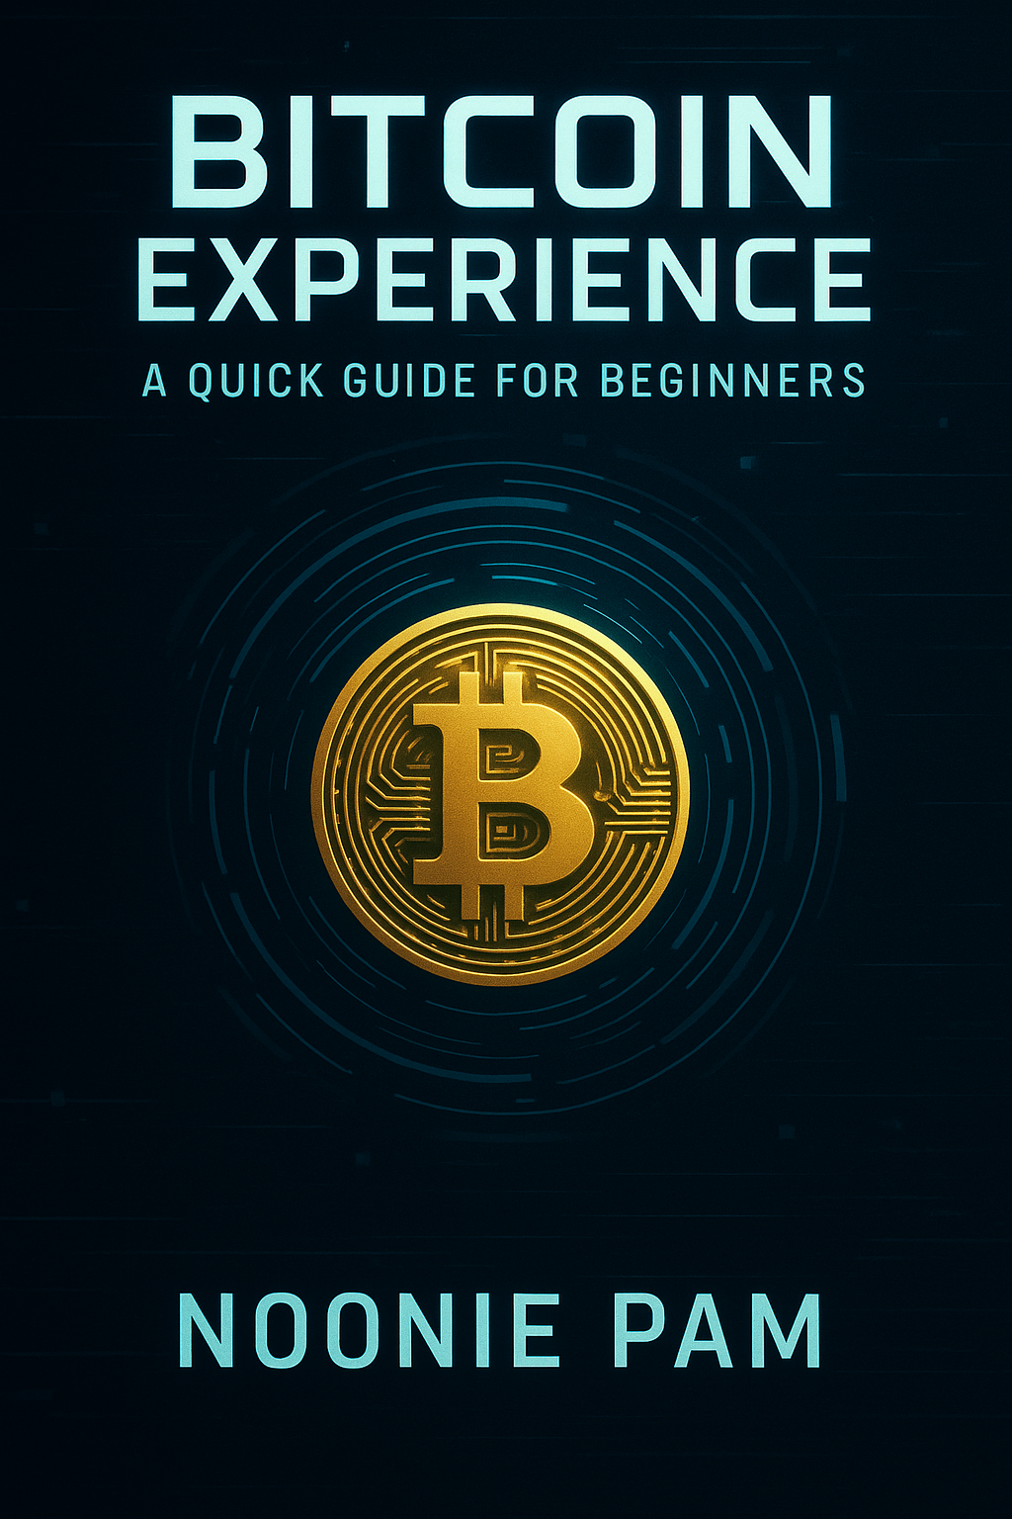

Bitcoin Experience: A Quick Guide for Beginners

By Noonie Pam

\*\*Preface\*\*  
  
In the past decade, Bitcoin has gone from being an obscure project on the internet to a powerful global financial network...  
  
\*\*Chapter 1: What Is Money?\*\*  
  
Let’s start with a simple question that most people never think to ask: What is money?...  
  
[...] (Additional chapters would continue)