Vedic Numerology

1. **What is Numerology :**

Numerology (known for the 20th century as Aritmancy) is a belief in the occult, divine or mystical relationship between the number and once or more by coincidence. It is also a study of numeric value through the alphanumeric system of letters in words and names. If numerology is applied to the person's name, it is a form of anomy. Is often associated with astrology and other weird art.

Numerology is the study of numbers and the strengths guide ruling class. It is established the plan that numbers have their own singular capacity and reverberation that can influence our lives.

**2. How does numerology work?**

Numerology is a belief system that assigns significance to numbers and their potential influence on various aspects of life, personality, and destiny. It operates on the premise that numbers have unique vibrations and properties that can provide insights into a person's characteristics and life path. Numerologists analyse birthdates, names, and other significant dates to derive numbers that are then interpreted to reveal personal qualities, potential career paths, and even future events.

How Numerology Works in Practice:

1. **1. Number Extraction:**

Numerologists extract numbers from a person's birthdate and name (and sometimes other significant dates).

1. **2. Calculation:**

These numbers are then reduced to single digits (or occasionally master numbers like 11, 22, or 33) through a process of addition.

1. **3. Interpretation:**

Each single digit number is assigned a specific meaning and vibration. For example, the number 1 is associated with leadership, while 6 is linked to responsibility.

1. **4. Profile Creation:**

By combining the numbers derived from the birthdate and name (and other dates), a numerological profile is created.

1. **5. Insights:**

This profile is then used to offer insights into a person's personality, strengths, weaknesses, career path, and potential life events.

1. **6. Applications:**

Numerology can be used for various purposes, including self-discovery, relationship compatibility, and career guidance.

* 1. **Some important numbers**
* Life path number

Derived from a person's birth date, this number is considered one of the most important in numerology.

* Soul number

Also known as the Soul Urge number, this number can suggest a person's purpose, values, and compatibility with others.

* Expression number

Also known as the Destiny number, this number represents a person's core identity.

* Karmic debt numbers

These numbers include 13, 14, 16, and 19. They indicate that a person has karmic debt to work through in this lifetime.

**4. The history of numerology**

Its spans thousands of years, with roots in many ancient civilizations Ancient origins.

* Babylon: Numbers were used to interpret cosmic influences on human affairs
* Egypt: Numbers were used in rituals, architecture, and the construction of pyramids
* China: Numbers were used to influence the harmony and balance of spaces
* Assyria: The king built a wall 16,283 cubits long to match the numerical value of his name

**5. Modern numerology**

* Numerology is accessible through online resources
* It has influenced popular culture
* It is used to understand the spiritual world and guide personal insights
  1. **How to calculate numbers:**

**Two important things to generate numbers:**

* 1. Date of Birth – (Ex – 01-11-2002)
  2. Name
* **Type of Numbers :**

1. **Basic Numbers ( Driver, Mulank, Rute Number, Personality ) :**

Basic Number means total of Date (From part of DOB). Its indicate personality, behaviour and self-assessment of a person. Its showing your personality, behaviour, cherecture, aura etc.

Example 1 : If Birth date is 01-11-2002

Then Basis number is 0+1=1

Example 2 : If Birth date is 15-11-2002

Then Basic Number is 1+5=6

1. **Destiny Number ( Conductor, Bhgyank, Queen Number) :**

Destiny Number is means total of full date of birth. It should be total up to reach on single digit. Its showing your life part like up and downs, Illness, profit and loss, marriage, challenges, career etc. It’s also calling life management number.

Example 1 : If Birth date is 01-11-2002

Then Destiny number is 0+1+1+1+2+0+0+2 = 7

Example 2 : If Birth date is 15-11-2002

Then Destiny Number is 1+5+1+1+2+0+0+2=12

1+2 = 3

Destiny Number is 3

1. **Supporting Number :**

Supporting Number means total of Date if date is coming in two digit for example- 11, 12,13,14,15 and up to 31st. If date is coming in single digit then no need to calculate supporting number differently.

Example 1 : If Birth date is 01-11-2002 then basic number is also a supporting number.

Example 2 : If Birth date is 15-11-2002

Then supporting number is 15

Note : 1. We can understand through a example of a Bus.

|  |  |
| --- | --- |
| Driver | conductor |

* If Basic number and Destiny numbers are enemy than your life number will support and it would be good.

**7.Vedic numerology Grid :**

In Numerology, a grid, often a 3x3 grid, is used to map out a person's life path, strengths, and weaknesses based on their birth date. It helps analyze the impact of individual numbers and their combinations on different aspects of life. Each number within the grid is believed to possess unique energy and influence, impacting areas like career, relationships, health, and spiritual growth.

* **Number Associations:**

Each number is associated with specific elements and life areas. For example, the number 1 might represent career and planning, while 5 could signify stability and balance.

* **Missing or Repeating Numbers:**

The presence or absence of certain numbers in the grid can indicate a person's strengths and areas where they may face challenges

**Grid at one glance**

* All numbers having fixed house for their place as per below chart:

|  |  |  |
| --- | --- | --- |
| 3 | 1 | 9 |
| 6 | 7 | 5 |
| 2 | 8 | 4 |

1. **How to affixed number in every box**
   1. Mention all number of Date
   2. Mention all number of Month
   3. Mention all number of year except centaury
   4. Mention Basic Number
   5. Mention Destiny Number
2. **Understand through examples :**

Example 1 :

|  |  |  |  |
| --- | --- | --- | --- |
| **Detail** |  | **Grid** |  |
|  |  |  |  |
| **DOB : 01-11-2002** |  |  |  |
|  |  | **111** |  |
| **1.      Mention all number of Date : 1** |  |  |  |
| **2.      Mention all number of Month- 1 1** |  |  |  |
| **3.      Mention all number of year except centaury- 2** |  |  |  |
| **4.      Mention Basic Number - 1** |  | **7** |  |
| **5.      Mention Destiny Number-7** |  |  |  |
|  |  |  |  |
|  | **2** |  |  |
|  |  |  |  |
|  |  |  |  |

|  |  |  |  |
| --- | --- | --- | --- |
| Example 2 |  |  |  |
|  |  |  |  |
| **Detail** |  | **Grid** |  |
|  |  |  |  |
| **DOB : 07-12-1990** |  |  |  |
|  |  | **1** | **9** |
| **1.      Mention all number of Date : 7** |  |  |  |
| **2.      Mention all number of Month- 1 2** |  |  |  |
| **3.      Mention all number of year except centaury- 9** |  |  |  |
| **4.      Mention Basic Number - 7** |  | **7** |  |
| **5.      Mention Destiny Number-2** |  |  |  |
|  |  |  |  |
|  | **2 2** |  |  |
|  |  |  |  |
|  |  |  |  |

|  |  |  |  |
| --- | --- | --- | --- |
| Example 3 |  |  |  |
|  |  |  |  |
| **Detail** |  | **Grid** |  |
|  |  |  |  |
| **DOB : 27-11-1985** |  |  |  |
|  |  | **1 1** | **9** |
| **1.      Mention all number of Date : 2 7** |  |  |  |
| **2.      Mention all number of Month- 1 1** |  |  |  |
| **3.      Mention all number of year except centaury- 8 5** |  |  |  |
| **4.      Mention Basic Number - 9** |  | **7 7** | **5** |
| **5.      Mention Destiny Number- 7** |  |  |  |
|  |  |  |  |
|  | **2** | **8** |  |
|  |  |  |  |
|  |  |  |  |

|  |  |  |  |
| --- | --- | --- | --- |
| Example 4 |  |  |  |
|  |  |  |  |
| **Detail** |  | **Grid** |  |
|  |  |  |  |
| **DOB : 12-01-1980** |  |  |  |
|  | **3** | **1 1** |  |
| **1.      Mention all number of Date : 1 2** |  |  |  |
| **2.      Mention all number of Month- 1** |  |  |  |
| **3.      Mention all number of year except centaury- 8** |  |  |  |
| **4.      Mention Basic Number - 3** |  |  |  |
| **5.      Mention Destiny Number- 4** |  |  |  |
|  |  |  |  |
|  | **2** | **8** | **4** |
|  |  |  |  |
|  |  |  |  |

|  |  |  |  |
| --- | --- | --- | --- |
| Example 5 |  |  |  |
|  |  |  |  |
| **Detail** |  | **Grid** |  |
|  |  |  |  |
| **DOB : 13-03-1980** |  |  |  |
|  | **3 3** | **1** |  |
| **1.      Mention all number of Date : 1 3** |  |  |  |
| **2.      Mention all number of Month- 3** |  |  |  |
| **3.      Mention all number of year except centaury- 8** |  |  |  |
| **4.      Mention Basic Number - 4** |  | **7** |  |
| **5.      Mention Destiny Number- 7** |  |  |  |
|  |  |  |  |
|  |  | **8** | **4** |
|  |  |  |  |
|  |  |  |  |

|  |  |  |  |
| --- | --- | --- | --- |
| Example 6 |  |  |  |
|  |  |  |  |
| **Detail** |  | **Grid** |  |
|  |  |  |  |
| **DOB : 03-11-2004** |  |  |  |
|  | **3 3** | **1 1** |  |
| **1.      Mention all number of Date : 3** |  |  |  |
| **2.      Mention all number of Month- 1 1** |  |  |  |
| **3.      Mention all number of year except centaury- 4** |  |  |  |
| **4.      Mention Basic Number - 3** |  |  |  |
| **5.      Mention Destiny Number- 2** |  |  |  |
|  |  |  |  |
|  | **2** |  | **4** |
|  |  |  |  |
|  |  |  |  |

1. **Number and Nature of Planets:**

In numerology, nine planets are associated with numbers from 1 to 9. Each planet has a specific number and associated nature, influencing various aspects of life. The nine planets are: Sun (1), Moon (2), Jupiter (3), Rahu (4), Mercury (5), Venus (6), Ketu (7), Saturn (8), and Mars (9). These planetary influences are believed to shape individual personalities and life events. These nine planets, known as Navagrahas, have a profound impact on human destinies, personalities, and life events.

Here's a more detailed breakdown:

* **Sun (Number 1):** Represents leadership, authority, and creativity.
* **Moon (Number 2):** Influences emotions, intuition, and nurturing.
* **Jupiter (Number 3):** Symbolizes wisdom, good fortune, and optimism.
* **Rahu (Number 4):** Associated with sudden gains, transformations, and challenging experiences.
* **Mercury (Number 5):** Represents communication, intellect, and adaptability.
* **Venus (Number 6):** Symbolizes love, beauty, and harmony.
* **Ketu (Number 7):** Linked to spiritual growth, intuition, and detachment from the material world.
* **Saturn (Number 8):** Represents discipline, responsibility, and hard work.
* **Mars (Number 9):** Characterized by energy, passion, and action.

|  |  |  |
| --- | --- | --- |
| No | Planet | Nature |
| 1 | Sun (Surya) | King, Father |
| 2 | Moon ( Chandrama) | Queen , Mother, Mind |
| 3 | Jupiter (Brahaspati, Guru) | Teacher , Guru |
| 4 | Rahu | Scoundrel (Badmash) |
| 5 | Mercury ( Budh) | Prince, Rajkumar, Friendly |
| 6 | Venus ( Shukra) | Teacher of Monster, demon (Rakshas), Also a Saatvik |
| 7 | Ketu | Winner , Detached ( Bematlabi) |
| 8 | Saturn ( Shani) | Judge |
| 9 | Mars ( Mangal) | Commander General ( Senapati, Yodha) |
|  |  |  |

1. Sun (Surya) :

* Nature : Represents King Status, Big Energy, Creator Mind, Experimental mind, Proud (Ghamandi), Aatma Significator (Aatma ka Karak), Leadership quality, Administration Quality, Authority Holder, Diplomatic, anger, listens to everyone and does whatever feel (Sunta sab ki karta man ki) Egoistic, Disciplined, Rules and regulation holder, Punctuality, Suitable for business and start-ups, Wish to respect, Decision making ability, Physically strong, Destroyed yourself but will not let loved once be harmed, Daring, Focused, Don’t mix quickly, Calculative, Matured seeing in little age.
* Related birth Dates in Numerology: 1, 10, 19, 28
* Body Part : Right Eye
* Illness : Heart , Brain, Leaver, Blood presser, weakness in bones, water fall in left eye.

Element: Fire

* Lucky Date : 1,10,19,28

Lucky Day : Sunday, Monday

* Lucky colour : Red, Yellow, Gold
* Gemstone : Ruby

Crystal : Citrine, Sunstone

* Profession and Job : Gold , Copper, Engineering, Astrology, Science related, Govt Job, Real state, Architect, Business management, Politics, Administration, Surgeon, Doctor, Electricity related work etc.
* Marriage: Good and right marriage. Chances for two marriage.
* Precautions (Upay) : Don’t show off, Don’t obstinate, Don’t egoistic, Don’t believe quickly on everyone before proper documentation, Don’t anger, Don’t lose respect ( Ijjat pe bat na aane de), Leave careless and Lazy (Aalash), Stop ordering, Don’t rush (Jaldbaji) to marriage.
* If energy multiply in numerology:
* 1, 1 = Emotion express good, Communication strength
* 1,1,1 = Esteem nature, Diplomacy zero
* 1,1,1,1 and more = Overflow of sun nature, Good fame, Cheating possibilities from others
* Important notes :
* Number 1 is also having quality of Number 9
* Master Date :

A. 19 = Sun + Mars

Good Date, by birth money, enjoyed in past life so struggle in this life so need to pay according to past life.

B. 28 = 10 = Moon + Saturn+ Sun

1. Moon ( Chandrama) :

* Nature : Represents Queen Status, Mother, Imagination strong, Intelligent, Good memory, mind change in speed, factor of mind (Man ka karak), remember past, mind (Man), Emotion feeling person, Good communication skill, not focused (Changing mind in 2-3 days), A pot without a bottom, Emotional, not stable, Traveller, less Decision making ability, Good connectivity, Good Intuition power, Physically weak, Soft spoken, Romantic, Loves nature, make friends quickly, lack of confidence, knowing everything but not working accordingly, good learning skill, moody nature, clean heart, not disclose income, Retail cash flow, good manners and etiquette.
* Related birth Dates in Numerology: 2,11,20,29
* Body Part : Left Eye
* Illness : Lungs, Kidney, water flow in eyes, cough-cold, overthinking, asthma, stomach, nervous system, Eyes, leaver and kidney related issue, depression
* Element: Water
* Lucky Date : 2,11,20,29
* Lucky Day : Sunday, Monday, Friday
* Lucky colour : Silver, white, light green
* Gemstone : Pearl

Crystal: Moon stone

* Profession and Job : Travelling, Counselling, Water related work, Fishes related work, Flow and circulated system related work, Mind related work, Sales and marketing is good, Art and theatre, Good work in under some one, Growth in water surrounded cities, chemistry, sociology, music, Tero reading, merchant navy, hospitality, dairy, Journalist etc.
* Marriage: Good partner, Argumenta married life, Emotional relation, friendly with opposite gender, possiable two marriage
* Precautions (Upay) : don’t say yes every time, don’t do multiple jobs, don’t leave work incomplete, become daring, focus on mental stability in place of emotion, build confidence, focus on physical hard work, Control nerves system, observe others first, avoid dark colour
* If energy multiply in numerology:
* 2,2 = Not good, attention requirement very much from others, not stable very much
* 2,2,2 and more = Oversensitive, proud, much emotional, depression, mental health issue, drunk, bed habits, much imagination
* Important notes :
* No 2 will be support to No 1
* People born in BRIGHT HALF (Shukl Paksh) having strong moon and people born in DARK HALF (Krishna Paksh) is having loose moon
* If MARSH is strong then MOON will not weak.
* MOOLANK 2 and MOOLANK 4 related people can be criminal
* MOON ruts your mind
* Master Date :

1. 11 = Intuition and inspiration, Knowledge of future, Spiritual ability, Deeply feeling, impressing power
2. 22 = Intuition and inspiration, Knowledge of future, Spiritual ability, Deeply feeling, impressing power
3. Jupiter (Brahaspati, Guru) :

* Nature : Represents Teacher, Guru, Parents, Knowledge, Wisdom, Dictatorship (Tanashahi Pravarti) Expansion ability, Kind maker, Over knowledge (Gyani Baba), Darkness under the lamp (Diya Tale andhera), Obesity factor (Motape ka karak), big thighs, willing to grow, Not focused on one place, Good starter but bed finisher, Not interested to work in Job and under presser, having both right way and wrong way to do something, state forward speaker, desire to improve, doing forceful orders, sound observation, clean heart, diplomatic talking ability, Manipulative talking ability, Much self-expression, focus on power and authority, ambitious, disciplined, Influencing ability, warried about future, Earn money but cannot secure earned money, Spending money on luxury, Social, Getting cheat, Good motivational speaker, don’t like family relationship, sound memory, good human being, Logical and practical, Keep secrete of internal marital.
* Related birth Dates in Numerology: 3,12,21,30
* Body Part : liver, pancreas, and fat
* Illness: Brain, Diabetes, Joint pain in legs, mussels cram, Kidney, jaundice.
* Element: Air
* Lucky Date : 3,12,21,30
* Lucky Day : Tuesday , Friday and Saturday
* Lucky colour : Yellow
* Gemstone : Yellow sapphire
* Crystal : Amethyst
* Profession and Job: Education, Ayurveda, Astrology, Business management, Banking, Counselling.
* Marriage: Jupiter's benevolent energy infuses marriages with an experience of expansiveness & optimism. Couples with harmonious Jupiter affects regularly enjoy a love that transcends barriers, bearing in mind non-public increase & mutual know-how.
* Precautions (Upay) : don’t hands shake, not use alcohol and nonwage, don’t eat too much, don’t sleep too much, don’t have much self-expectation.
* If energy multiply in numerology:
* A. 3 = Best
* B. 3,3 and more = Bed , Good starter but bed finisher
* Important notes :
* A. Obesity factor (Motape ka karak) destroys MARS.
* B. Major growth to be in 21st to 24th year of age
* Master Date : Nil

1. Rahu :

* Nature : Represents Scoundrel ( Badmash), shadow planet, taking moons shadow, thinks suddenly happening, selfish, don’t carring peoples, society and relation only thinking that own work should not effect, Much friends, night life good, getting cheats due to nature, mind running through every corner, telling fake things (Hawa Hawai Bate karna), having only head(Sar) so using only head to earn money, don’t want to do physical work, Bed past life so struggle in starting face, Sudden success and then carefree (Befikra) so falling from the Top, getting surprises, not supporting from father, greedy (Lalachi), misunderstand other people, don’t know limitation, doing more show off, more anger, short tempered, not stable, social working thought, unexpected loss and gains, secrete mind, effected married life, financial issue in old age, not benefit from parental property, also knowing as DRAGON head, Logical and having good research, cannot execute in right way, Love affair before marriage, much arguments, married life struggle, trouble in sleeping and a part of brains keep going, not doing discriminate.
* Related birth Dates in Numerology: 4,13,22,31
* Body Part : Head
* Illness Anxiety (Dar, Bhay), Illness due to drunk (Nasha), disease in intoxication (nase) of the body, stomach and gas issue, Ulcer, skin issue.
* Element: Air
* Lucky Date : 4,22,31,3,12,21,30
* Lucky Day : Monday, Wednesday, Friday
* Lucky colour : Green, Brown, Light blue
* Gemstone : Gomed
* Crystal : Amethyst
* Profession and Job : Research, Accounts, Builder, Science, Transport, sales and marketing, Politics, Journalist , commission based work
* Marriage: Potentially causing delays, obstacles, unconventional relationships, or even marital discord
* Precautions (Upay) : Strong to Jupiter, Rahu Mantra, worship to lord shiva, stop expenditure and make saving, blood presser control,
* If energy multiply in numerology:
* A. 4 = Not good in chart
* B. 4,4 = Good, Obstinate (Jiddi), Disciplined, want to do work by self
* C. 4,4,4 and more = Bed, stress, sudden loss, Need support and counselling, knowing everything but not doing accordingly
* Important notes :
* A. Growth period from age 28th
* B. Having only Head so working only mind
* Master date :

1. 22= Moon + Moon, Direct light from moon, Confidence, leadership quality, struggle due to sudden event
2. 13 = Sun +Jupiter + Rahu = Hard work, disciplined, daring, standing against any situation, late success, misused of power in past life and far away from responsibility in past life so struggle in this life, number of death, breaking old and creating new path, creativity and leadership quality, extra efforts and achievement possible.
3. Mercury (Budh) :

* Nature : Represents Prince, Rajkumar, speech, Voice, sisters, little children, Intelligence, calculative, Logical thinking, brilliant mind, business mind, Fit with every number, Determined, related to mind, manipulative, smart worker, self-expectation with hard work, communication skill good, run on self-way, Long vision, rich, farness from parents, having quality but tolerates emotions (Emotions ko bardast karte hai), creative mind set, much arguments, active and positive personality, good mental ability ( can judge people), completing work in less time, desire to earn money in short time, Risk taking ability good, good research and discovery, flexible nature, not having much emotion, talkative, diplomatic, fun loving, like to run right way, romantic, strong will power, Good reputation.
* Related birth Dates in Numerology: 5,14,23
* Body Part : Nervous system, brain, skin, nose, and hands
* Illness : Tongue related, Skin, weak immunity, cough-cold, nervous system issue, depression ,
* Element: Earth
* Lucky Date : 2,23,3,12,26,8,30
* Lucky Day : Thursday, Wednesday, Monday
* Lucky colour : Green, White ( Avoid black and dark)
* Gemstone : Green emerald
* Crystal : Green aventurine
* Profession and Job : Stock market expert, mass communication, maths, business, advertising, money related work, banking and finance, astrologer, CA, low, journalism, teaching, sales and marketing
* Marriage: Effective communication is the cornerstone of any relationship, and Mercury plays a vital role in this aspect. A strong Mercury in your birth chart can facilitate clear and open communication with your partner, which is crucial for a love marriage to thrive
* Precautions (Upay) : Required positive envirment, need to make flexible energy otherwise vision would effect, need to keep alive desire, morning walk, keep balanced diet.
* If energy multiply in numerology:
* A. 5 = Best
* B. 5,5 = Self responsible, determind, will power strong, increase focus, romantic, could not force to native,
* C. 5,5,5 and more = Proudly, arguments and anger, fall into trap of ons own making, lost giver nature, communication bed
* Important notes :
* It’s a good number
* Father of mercury is Moon and mother of mercury is 2nd wife of Jupiter (Tara) so this is an illegitimate child
* One part of child hood happen lonely ( Far from parents)
* Growth from age of 23rd to 32
* Master DOB : 14
* SUN + RAHU+ Mercury
* Freedom, Disciplined, Responsible, misuse freedom in past life, charming nature and unpredictable, need to avoid short cut and embassies nature, need to far from addiction for everything

1. **Venus :**

* Nature : Teacher of evils, Luxurious, wife, beauty, handsome and love, benefice planet, sexual satisfaction, sexual organs, beauty and smartness, can be activate after marriage, Romantic, don’t like PUJA-PATH, Friend circle minimum, shield (Dhal) for nearest people, Sukracharya is having SANJEEVNI VIDHYA, selfish and practical, caring for assets, hobbyist for beautiful places, Like travelling, unstable nature, like to look attracting, having money but can’t assume, smiling face, not appreciating anyone early, sacrificing for lovers, not anger early, having addiction (Satvik addiction), Obstinate, Not listening point of view of opposition, Introword, Health issue, Lazy, Brand lover, attract from attractive people, food lover and cook, good voice, expenditure on himself, doing show off, artistic nature, not matching opinion with father, get family support, Responsible.
* Related birth Dates in Numerology: 06,15,24
* Body Part : Sexual part and reproductive system
* Illness : anxiety , Kidney, stone in kidney, face issue, eyes, sexual organ related issue, face related issue, sexual issue
* Element: Fire
* Lucky Date : 06,15,09,18,27,24,31,4
* Lucky Day : Thursday, Tuesday, Friday and Saturday
* Lucky colour : Light blue, light pink, white
* Gemstone : Diamond
* Crystal : Rose quartz
* Profession and Job : Cooking, body building, singer, fashion, healer, modelling, perfume, cosmetic, writer, beauty related jobs
* Marriage: Venus is often referred to as the planet of love and romance. A strong Venus in your birth chart can indicate a propensity for love marriage. It signifies attraction, sensuality, and a deep connection with one’s partner.
* Precautions (Upay) : Focus on creativity, relationship issue if placed with Jupiter, Keep fit your physical body, don’t trust on everyone, respect to women, don’t importance everyone beyond.
* If energy multiply in numerology:
* A. 6 = Good, Luxury, wealth and money, good looking
* B. 6,6 = Good with Family love, insecurity, negative thoughts, motivation required, romantic, relationship issue
* C. 6,6,6 and more = Over, overthinking, overprotective for family, fighting with opposite gender, issue in fertility.
* Important notes : Venus is associated with marriage and romantic relationships, representing love, beauty, and harmony
* Master DOB : 15
* SUN + Venus+ Mercury

1. Ketu

* Nature : Servant of Saturn, peaceful planet, spiritual, occult, astrology, research, not having head so heart is effective, make connection heart to heart, spiritual mind in age of 40-45, captured desire for long time, giver planet and providing something to others, good writer and book reader, independent nature, thinking process different from others, unstable nature, like travelling, intuition and imagination power good, exploring nature, can be make YOGI, Money can be used for social work, caring of future, stable married life, good businessman, positive for others but negative for himself, balancing planet, kind full nature, realisation in whole life, mature in little age, God believer, like self-work, work slowly, good hair growth, involve in occult in last age, growth after 28 years of age, one affair before marriage, Jupiter is balancing to Ketu, self-made people, emotional people, disclosing after deal close,
* Related birth Dates in Numerology: 7, 16, 25
* Body Part : Right ear, hair, and growth
* Illness : skin issue, anxiety, stomach,
* Element: Fire
* Lucky Date : 7,25,3,12,21,30
* Lucky Day : Thursday, Friday, Saturday
* Lucky colour : Black, grey, brown, Blue
* Gemstone : Cats eyes (Lahsuniya)
* Crystal : Tiger Eye
* Profession and Job : Import-export, detective, astrology, occult, religious, driving, travelling, editing, theatre, private sector
* Marriage: Individuals with this placement may marry later in life or find stability in relationships only after experiencing challenges in their early years. Saturn's presence emphasizes the importance of commitment, responsibility, and long-term goals in partnerships.
* Precautions (Upay) : Keep peace in heart, don’t be over emotional, think about self-profit and loss, keep stable in decision, physical workout, don’t depend on other for own success and growth, don’t underestimate himself, don’t underestimate to wife, far from smoking, do meditation,
* If energy multiply in numerology:
* A. 7 = Good
* B. 7,7 = overthinking, unique thinking, early maturity,
* C. 7,7,7 and more = Over, overthinking, live in own world, carefree from world, bad relationship, early disconnect from people, detachment, good knowledge, not satisfied from a part of life
* Important notes : Its indicates discipline, responsibility, and a strong work ethic and delay
* Master DOB : 16

SUN+VENUS+KETU

Power number, over realising, was opposite from GOD and universe in past life so realising in this life.

1. **Saturn**

* Nature : Represents Servants, Ground staff, security guard, day to day work, delay in work, Son of Sun, Not a desired child of Sun, Childhood of Saturn was without father, Poison in eyes, Poison in all drashti- 3,7,10 , Bad effective eyes, planet for justice, Give result of KARMA, Old planet, handicapped planet (Devi ke garbh pe lat mari thi), slow nature, don’t like bad things, struggling married life, don’t cheat with others, malefic planet, adjective (Napunsak) planet, helpful nature, don’t believe early, overthinking and slow decision, not much religious, strict teacher, struggle in life, Mind and experience good, double hard work, up and downs in life, having good friends, Bad enemy if getting cheats (Really doing bad after cheating), loneliness, don’t believe in show off and be simple, early provoke (Bharkna), always complete own work, don’t care others, don’t do publish own work and planning, get appreciation, either big successful or a big frailer, good patience, lazy, only wine drinker in addiction, slowly success according to hard work, starting life is JOB, Money minded people and caring of future, sensible, disciplined, deep thinking, hungry to work and do work under presser, soft from inside but hard from outside, Egoistic, don’t take help from others, more systematic, old thinking and don’t like privacy disturbance, Don’t get money back from others.
* Related birth Dates in Numerology: 08, 17, 26
* Body Part : head, face, muscular system, external sex organs, blood vessels, kidneys, prostate gland, groins, rectum, colon, and testicles
* Illness : Burns related, hair growth, stomach related, infection in blood and urine, pain in joints
* Element: Air and Earth
* Lucky Date : 3,12,21,05,23,26,17
* Lucky Day : Tuesday, Thursday, Friday, Sunday
* Lucky colour : Brown, Black, Blue ( Avoid light colour)
* Gemstone : Blue sapphire
* Crystal : Black tourmaline
* Profession and Job : Technical field, civil engineering, occult science, agriculture, police, politician, jailer, coal, sports, contract basis work, advocate, Judge
* Marriage:. Often signifies delayed or mature partnerships. Individuals with this placement may marry later in life or can face challenges in early stage and stability can take Place after very hard work.
* Precautions (Upay) : Don’t see in eyes in Shani temple, take hands behind at the time of PARIKRAM, Do charity, keep engaged in anything, listen advise of others, don’t give more importance to money, don’t go illegal field, avoid addiction, avoid extra marital affairs, always work under guidance.
* If energy multiply in numerology:
* A. 8 = Not Good, loneliness
* B. 8,8 = Good , Good wealth, success with delay, keeps money at much places, argumenta
* C. 8,8,8 and more = Over, overthinking, early detachment, unsuccessful
* Important notes : its significance revolves around hard work, discipline, and the pursuit of long-term goals
* Master DOB : 17

Sun+Ketu+Saurn = Good fame in research field

1. **Mars**

* Nature : Represents Brother, land and property, strength, adventure, competitive mind, immunity system, sexual power, helpful nature, mussels repress, commanders, God of War, taking energy from SUN, Compatibility from SUN, Army leader, Diplomacy, Can dominate on SUN in diplomacy, friend of SUN, Energetic, sharp mind, positive result, brave, Blood flow good, merits of all planets, extraordinary number, Sun and mars are supporting each other, powerful, short tempered, always ready to fight, Impulsive, quick division, quick action, don’t like dependency, stand out from the crowd, accident possible in life, argument in married life, criminal record, soft with women’s, doing show off, talking about self-achievements, providing security to under workers, don’t like interference, big risk taker, securing of family, confidence, leadership quality, aggression, boldness, intelligent, desire to improve, money minded, behave like feeling, good body, fast learner, quickly depressing, romantic and emotional.
* Related birth Dates in Numerology: 09,18,27
* Body Part : Muscular system, external sex organs, blood vessels, kidneys
* Illness : Mental health week, stomach issue, BP ect.
* Element: Earth
* Lucky Date : 6, 15, 24, 5, 14, 23, 9 ,27
* Lucky Day : Monday, Thursday, Friday
* Lucky colour : Red, Orange
* Gemstone : Red Coral
* Crystal : Red carnelian
* Profession and Job : Surgeon, Doctor, civil services, police, army, detective, fire related work, solder , thief, Robber, scientist, wrong work
* Marriage: Mars, the fiery planet, adds a passionate dimension to love and marriage. While a well-placed Mars can bring excitement and intensity to a relationship, an afflicted Mars may lead to conflicts. It’s essential to find a balance between the fiery energy of Mars and the gentle nature of Venus for a successful love marriage.
* Precautions (Upay) : donet blood, don’t argument in marriage life, don’t be fool by opposite gender, don’t show off, control on angriness, don’t let people take advantage, don’t drive fast, keep far from win and nonwage, lesion from others
* If energy multiply in numerology:
* 9 – Best
* 9,9 – Its right up to a point, critical to understand, giver nature, diplomatic, very energetic, more over confidence, over caring nature
* 9,9,9 – very bed, over thinking, always irritated, week mind
* Important notes : It is considered a powerful, courageous, and lucky number, often linked to ambition, determination, and energy
* Master DOB : Nil

1. **Mahadasha , Antardasha, Per day and Month Number**
   * 1. **Mahadasha**

Mahadasha refers to a major planetary period that influences a person's life for several years. It is a period governed by one of the nine planets, believed to significantly impact various aspects of a person's life, including their experiences, events, and overall destiny.

Process to calculate Mahadasha

* Take basic number from date of Birth
* Add basic number in year of Birth
* Find your Mahadasha finishing year
* Period between your birth and Mahadasha finishing year would be your Mahadasha of a particular planet for a particular period
* Add next number of your basic number and find next mahadasha
* Learn through two examples :

Example 1 :

|  |  |  |  |  |  |
| --- | --- | --- | --- | --- | --- |
| **Date of Birth** | **Year of Birth** | **Add Basic Number** | **Mahadash Finishing year** | **Mahadasha** | **Peried** |
| **01-11-2002** | 2002 | 1 | 2003 | Sun | 2002-2003 |
|  | 2003 | 2 | 2005 | Moon | 2003-2005 |
|  | 2005 | 3 | 2008 | Jupiter | 2005-2008 |
| **Basic Number is : 1** | 2008 | 4 | 2012 | Rahu | 2008-2012 |
|  | 2012 | 5 | 2017 | Murcary | 2012-2017 |
|  | 2017 | 6 | 2023 | Venus | 2017-2023 |
|  | 2023 | 7 | 2030 | Ketu | 2023-2030 |
|  | 2030 | 8 | 2038 | Seturn | 2030-2038 |
|  | 2038 | 9 | 2047 | Mars | 2038-2047 |
|  | 2047 | 1 | 2048 | Sun | 2047-2048 |
|  | 2048 | 2 | 2050 | Moon | 2048-2050 |
|  | 2050 | 3 | 2053 | Jupiter | 2050-2053 |
|  |  |  |  |  |  |
| Example 2 : |  |  |  |  |  |
|  |  |  |  |  |  |
| **Date of Birth** | **Year of Birth** | **Add Basic Number** | **Mahadash Finishing year** | **Mahadasha** | **Peried** |
| **12-01-980** | 1980 | 3 | 1983 | Jupiter | 1980-1983 |
|  | 1983 | 4 | 1987 | Rahu | 1983-1987 |
|  | 1987 | 5 | 1992 | Mercury | 1987-1992 |
| **Basic Number is : 3** | 1992 | 6 | 1998 | Venus | 1992-1998 |
|  | 1998 | 7 | 2005 | Ketu | 1998-2005 |
|  | 2005 | 8 | 2013 | Saturn | 2005-2013 |
|  | 2013 | 9 | 2022 | Mars | 2013-2022 |
|  | 2022 | 1 | 2023 | Sun | 2022-2023 |
|  | 2023 | 2 | 2025 | Moon | 2023-2025 |
|  | 2025 | 3 | 2028 | Jupiter | 2025-2028 |
|  | 2028 | 4 | 2032 | Rahu | 2028-2032 |
|  | 2032 | 5 | 2037 | Mercury | 2032-2037 |

* + 1. **Antardasha**

Antardasha, meaning "inner period" or "sub-period", refers to the smaller, more detailed time periods within a larger Mahadasha, or "major period". Antardashas allow for a more precise analysis of events and their timing, adding nuances to the broader influence of the Mahadasha. Each Antardasha is ruled by a different planet, creating a dynamic interplay of energies.

Process to calculate Antardasha

* Find basic number from your DOB
* Find Full Month number from your DOB
* Find Year of Birth from your DOB
* Find your Birth day – i.e. Sunday, Monday, Tuesday ect.
* Find Number of Your birth day –

|  |  |
| --- | --- |
| Day | Numbers |
| Sunday | 1 |
| Monday | 2 |
| Tuesday | 9 |
| Wednesday | 5 |
| Thursday | 3 |
| Friday | 6 |
| Saturday | 8 |

* Add your Basic number, Full Month and day number in particular year and find a year.
* Add last two digit of calculated year
* Learn through an example :

|  |  |  |  |  |  |  |  |
| --- | --- | --- | --- | --- | --- | --- | --- |
| **Date of Birth** | **Year of Birth** | **Basic Number** | **Full Month** | **Birth day Number** | **Total** | **Antardasha** | **Planet** |
| **12-01-1980** | 80 | 3 | 1 | 6 | 90 | 9 | Marsh |
|  | 81 | 3 | 1 | 6 | 91 | 1 | Sun |
|  | 82 | 3 | 1 | 6 | 92 | 2 | Moon |
| **Basic Number is : 3** | 83 | 3 | 1 | 6 | 93 | 3 | Jupiter |
| **Month - 01** | 84 | 3 | 1 | 6 | 94 | 4 | Rahu |
| **Last two digit of Year -80** | 85 | 3 | 1 | 6 | 95 | 5 | Mercury |
| **Birth day - Friday** | 86 | 3 | 1 | 6 | 96 | 6 | Venus |
| **Birth day No-6** | 87 | 3 | 1 | 6 | 97 | 7 | Ketu |
|  | 88 | 3 | 1 | 6 | 98 | 8 | Seturn |
|  | 89 | 3 | 1 | 6 | 99 | 9 | Marsh |
|  | 90 | 3 | 1 | 6 | 100 | 0 | Null |
|  | 91 | 3 | 1 | 6 | 101 | 1 | Sun |
|  |  |  |  |  |  |  |  |
| * **Calculation Method** |  |  |  |  |  |  |  |
|  |  |  |  |  |  |  |  |
| Year | 1980 | 1981 | 1991 | 1988 | 2024 |  |  |
| Basic | 3 | 3 | 3 | 3 | 3 |  |  |
| Month | 1 | 1 | 1 | 1 | 1 |  |  |
| Day Number | 6 | 6 | 6 | 6 | 6 |  |  |
| Total | 1990 | 1991 | 2001 | 1998 | 2034 |  |  |
| Last two digit | 90 | 91 | 1 | 98 | 34 |  |  |
| Total of Last two digit | 9 | 10 | 1 | 8 | 7 |  |  |

* + 1. **Per Day / Personal Day number**

The Personal Day number provides insights into the daily energy and influences on a person's life. It offers a more detailed understanding of daily events and their potential impact of days ruling planet.

Process to calculate Per Day / Personal Day number

For Example if DOB is 01-11-2002 and Todays date is 10-04-2025 than how we calculate personal day number:

* 1. Destiny number – 7
  2. Current Month -4
  3. Total of Todays Date and Month – 1+4=5
  4. Personal Day Number is – 7+4+5 = 7
     1. **Monthly Number / Dasha**

The monthly number refers to the numerical representation of a specific month. This Personal Month number helps provide insight into the energy and influences of that particular month in your life By the particular planet.

For Example if DOB is 01-11-2002 and Todays date is 10-04-2025 than how we calculate Monthly number as

1. First we calculate Antar Dasha (If Antar Dasha is 6)
2. Current Month No – 4
3. Then monthly no is 6+4= 10 = 1
4. Monthly Dasha is 1 (Sun)
5. **Impact of Missing Numbers**

Missing numbers in a chart or grid signify a lack of certain qualities or traits associated with that number, potentially indicating areas for personal growth and development. These gaps highlight the need to consciously cultivate those missing energies to achieve a more balanced life. Missing numbers can affect various aspects of life, including relationships, career, and personal growth.

|  |  |
| --- | --- |
| **No** | **Effects** |
| 1 | Weak communication, Fear of chat, can’t take stand for themselves, like partnership, low confidence, indecisive, low will power in young age |
| 2 | Lack of sensitivity, not friendly, Argumentative. Impatient. They are not punct1.Jal. don't take intuition, unable to make emotional connection quickly |
| 3 | Don't think much about future, Disturbed education, Obstacles In study, Retreats in difficult situation, Underestimate their potential, low confidence |
| 4 | Lack of discipline, not good organizer, can' I follow **a** routine every day, can't work hard with body |
| 5 | Lack of balance in life, Regular ups and downs In life, Difficult to achieve goal, Lack of emotional stability, don't drive well, need motivation |
| 6 | No family support. Irresponsible, don't share good bond with father/family, Issue in child birth |
| 7 | A feeling of Others aside, Disorganized, not religious/spiritual, less Interested In world affairs |
| 8 | Can't handle money, Careless, their trust builds quickly, don't complete given work, People fool them |
| 9 | Not very sharp minded, Emotional, less courageous, Low confidence, Think much about other's feeling |

1. **Friendship and compatibility Chart of Planets**

In numerology, friendship and compatibility are explored through analysing planetary influences and life path numbers. Planets are associated with different life path numbers and zodiac signs, and understanding their relationships can reveal insights into potential compatibility, particularly in friendships and romantic relationships. Compatible numbers are the numbers that you use to see your cometabolite with someone like marriage or while doing business with someone else. Understanding number compatibility can offer insights into relationships and life paths.

In summary, analysing planetary influences and life path numbers in numerology can offer insights into potential friendship and relationship compatibility, helping individuals understand and navigate their social connections more effectively.

In numerology, compatible numbers are the numbers that you use to see your cometabolite with someone like marriage or while doing business with someone else. Understanding number compatibility can offer insights into relationships and life paths. Generally, numbers 1, 5, and 7 are considered compatible with each other, while 2, 4, and 6 can present challenges, although some connections can still be strong.

Here's a breakdown of numbers friendship, Neutrality, enemies and compatibility

**Friendship and compatibility chart**

|  |  |  |  |  |
| --- | --- | --- | --- | --- |
| No. | Friend | Neutral | Enemy | Compatible |
| 1 | 9,2,5,6,3,1 | 4,7 | 8 | 1,2,3,5,9 |
| 2 | 1,5,3,2 | 6,7 | 8,4,9 | 1.2,4,7 |
| 3 | 1,5,3,2,7 | 4,6,8,9,7 | 6 | 1,3,5,9 |
| 4 | 7,1,5,6,4,8 | 3 | 4,8,2,9 | 1,2,4,5,6 |
| 5 | 1,2,3,5,6 | 7,8,9,4 | NIL | 1,3,5,6,8 |
| 6 | 1,5,6,7 | 8,9,2,4 | 3 | 4,5,6,9 |
| 7 | 1,3,4,5,6 | 8,2,9,7 | NIL | 2,7,9 |
| 8 | 3,5,4,6,7,9 | 9 | 1,2,8,4 | 5,3,6,8 |
| 9 | 1,5,3 | 6,7,8,9 | 4,2 | 1,3,6,5,9 |

Marriage or Partnership Compatibility Process

* First, look at their basic and destiny numbers of both and see are they compatible with each other or not??
* Then analyse the basic chart of both of them to see how many friendly and anti-numbers they both have.
* If anti-numbers are high then compatibility will be less.it is important to have friendly numbers to have good compatibility.
* And then, give your suggestion after analyse of the chart.

Divorce chances

There should be divorce chances is below observations found in the chart:

* 1. If there is Mars number (9) in the chart with multiple time than the said person will be very aggressive, angriness and devilish
  2. If there is more non compatible planets
  3. If there is multiple energies of SUN

1. **Lucky Number**

Other than enemy and natural numbers of your basic number and destiny numbers are your lucky number. In other words friend’s number and compatible numbers of your basic and destiny number are your lucky number.

How we can decide which you’re lucky numbers are?

For example: Your basic no is 3 and your destiny number is 7 than your lucky numbers are 1, 5, 3

Other step by step method to calculate your lucky number:

* 1. Write down all numbers from 1 to 9
  2. Remove enemy and natural number of your basic number and destiny number
  3. Remaining numbers would be your Lucky numbers

1. **Favourable dates for any events**

Favourable dates refers to an auspicious time or moment considered favourable for commencing important activities or events. It's a specific period determined by Numerological calculations.

Favourable date’s selection aims to identify the most favourable time to start or complete a task, ensuring positive outcomes. Many important events, such as weddings, business ventures, and housewarming ceremonies, are traditionally scheduled to coincide with a Muhurat (Favourable Time and Date).

Step by step process to calculate favourable date for any event

* 1. Calculate your Name Number
  2. Write down your basic number
  3. Write down total of date of event
  4. Make total of your name number, basic number and event total
  5. Determine that result would be favourable for you or not by referring your basic and destiny number or name number
  6. For example ;

IF Name number is – 40= 4

Basic no – 8

Date of Event number is 16-03-2011 = 14 = 5

Than total of Name number, Basic Number and Date of Event no is 17 = 8

Than analyst that the same number is favourable or not

1. **Prashan Grid or Horary Grid**

A Prashna grid (also known as a horary grid) is a specific type of numerology chart used for answering specific questions about a particular situation or event. It's like a "question-and-answer" numerology system, offering insights into a specific query based on the time and date of the question. It is most important when a person don’t knowing his/her Date of Birth.

Here's a more detailed explanation:

* **Purpose:**

Prashna grids are used to gain insights into a specific situation or event that is pressing or unclear.

* **Method:**

The chart is created based on the time and date of the question being asked, not the individual's birthdate.

* **Interpretation:**

The numbers in the grid, along with their placement and relationships, are interpreted to provide guidance and answers to the query.

* **Key Difference:**

Unlike birth date charts, which focus on an individual's life path and overall personality, Prashna charts are focused on a particular question or event.

* **Applications:**

Prashna numerology can be used to explore various areas, such as career, relationships, finances, and health.

Process to apply Prashan Grid

* A person can ask only one question a day.
* First, calculate the name number of the native.
* Write down the time in 24 hrs format, when the person asked the question.
* For Example: Name number is 1. Time in 24 hrs format is 18:46 PM.
* Now, make the grid and put these number in it.

|  |  |  |
| --- | --- | --- |
|  |  |  |
|  | 11 |  |
|  |  |  |
| 6 |  |  |
|  |  |  |
|  | 8 | 4 |

1. **Success Number**

Every single number is lucky and can be successful. However, certain numbers are generally associated with qualities and characteristics that can be considered beneficial for achieving success.

To calculate your success number, take your date of birth, then take your month number and at last add both the numbers.

Then, calculate single digit which will be your success number.

For EX-1-11-2002=7 [here 1 is date of birth and 11 is your month number].

Success number will be [1+11 =12=3].

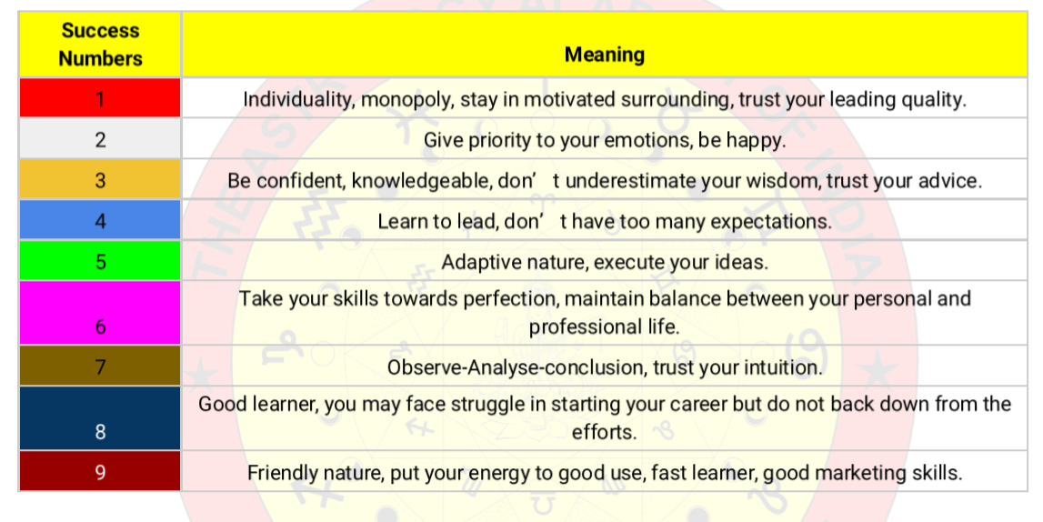

1. **Name Number**

In Vedic numerology, name numbers are derived by assigning numerical values to each letter in a name and then reducing the sum to a single digit (1-9). This process reveals insights into an individual's personality, potential, and life path.

Elaboration:

* **Assigning Values:**

Each letter in the alphabet is assigned a corresponding numerical value.

* **Calculating the Name Number:**

You sum up the numerical values of all the letters in a person's name.

* **Reduction to a Single Digit:**

If the sum is a two-digit number (like 18), you add the digits together (1+8 = 9). This reduces the number to a single-digit number (9 in this case).

* **Interpreting the Name Number:**

Each number from 1 to 9 is associated with specific traits, strengths, weaknesses, and life paths, providing a deeper understanding of an individual's character and destiny.

Alphabet to Number Chart

|  |  |  |  |  |  |  |  |
| --- | --- | --- | --- | --- | --- | --- | --- |
| **1** | **2** | **3** | **4** | **5** | **6** | **7** | **8** |
| A | B | C | D | E | U | O | F |
| I | K | G | M | H | V | Z | P |
| J | R | L | T | N | W |  |  |
| Q |  | S |  | X |  |  |  |

Here's a step-by-step guide:

1. **Assign numerical values:** Each letter is assigned a number corresponding to its position in the alphabet.
2. **Sum the values:** Add up the numerical values of all the letters in your name which would be compound number of Name.
3. **Reduce to a single digit:** If the sum is a two-digit number or higher, continue adding the digits together until you reach a single-digit number (1-9).

Example:

Let's calculate the name number for the name "RAHUL”

1. **Assign numerical values**

R=2, A=1, H=5, U=6, L=3.

1. **Sum the values**

2 + 1 + 5 + 6 + 3 = 17.

1. **Reduce to a single digit**

1 + 7 = 8.

Therefore, the name number for "RAHUL" is =8 And Compound number of RAHUL is 17

We can also check below things by this method

* + Mobile No
  + House No
  + Vehicle No
  + Locker No
  + Business Name
  + Compare with other person name number

Name Checking and Changing

Name number checking" refers to analysing the numerical value of a person's name (often their full birth name) to understand its potential influence on their life path, personality, and career. "Changing" a name in this context means altering the spelling or letters of a name to adjust its numerical value and, consequently, its perceived energies and potential outcomes.

Changing a Name in Numerology:

* **Alignment with Destiny:**

Numerologists may suggest changing a name to align it with a person's birth date or other numerological calculations, such as the life path number, to enhance specific aspects of their life.

* **Balancing Energies:**

Name changes can be used to address imbalances in a person's energies, such as a mismatch between their life path and expression number.

* **Attracting Desired Outcomes:**

By adjusting the name's numerical value, numerologists believe they can help a person attract more positive or specific outcomes in their life

In the name checking, name should be compatible and favourable as per below analysis.

Process of Name checking and changing

* + Result in the compound number chart would be in favour
  + Name number should be Favourable in Friendship Chart
  + Name number should be Favourable in Compatible chart
  + Name number to basic number should be favourable
  + Name number and destiny number should be favourable
  + Check Energy of every number in the name number which would also favourable for us.
  + If the name number and its compound number is not favourable for us than we should change the same.
  + After changing the name, it should be right 108 times per day for at least 40 days to get best result.

1. **House Number**

A house number refers to the house number (Like A505) of a dwelling, and it's believed to have a vibrational energy that can influence the home's atmosphere and the experiences of its residents. By reducing the house number to a single digit, you can gain insights into the potential energies and themes associated with that home.

Total of your house number would be your house number. We should also include any alphabet in the house number.

For example:

If your house no is A 515

Than your house number would be 1+5+1+5 = 12 = 3

1. **Number Combinations in Grid**

In numerology, number combinations refer to the interplay and significance of two or more numbers within a numerological chart, often revealing deeper insights about a person's personality, potential, and life path. By analysing how numbers combine and influence each other, numerologists can gain a more comprehensive understanding of a person's overall energy and life story.

Why Study Number Combinations?

* **Comprehensive Understanding:**

Analysing individual numbers is a starting point, but understanding their interplay provides a more complete picture.

* **Unveiling Hidden Strengths and Weaknesses:**

Combinations can reveal hidden talents, areas where a person excels, and potential challenges they may face.

* **Predicting Life Paths:**

Certain combinations can indicate a person's likely career path, relationships, and life goals.

* **Understanding Life Events:**

Number combinations can also offer insights into significant events and turning points in a person's life.

Important Considerations

* **Individual Interpretations:**

While general meanings exist for number combinations, the specific interpretation will vary depending on the individual and the context of the numerological chart.

* **Balance and Harmony:**

Numerology emphasizes the importance of balance and harmony in a person's life, and number combinations can help identify areas where balance may need to be achieved.

* **Self-Discovery:**

Ultimately, understanding number combinations is a journey of self-discovery, and it can provide valuable insights into one's strengths, weaknesses, and potential.

Various Combinations:

* 1. Growth combination :

|  |  |  |
| --- | --- | --- |
|  |  |  |
| 3 | 1 | 9 |
|  |  |  |
|  |  |  |
|  |  |  |
|  |  |  |

* Carrier Graf boost Fast, Creativity, Knowledge, dare, leadership, coverage, Hon’ble Career
  1. Parasmani Raj Yog:

|  |  |  |
| --- | --- | --- |
|  |  |  |
|  |  |  |
|  |  |  |
| 6 | 7 | 5 |
|  |  |  |
|  |  |  |

* Good Business and positive aura, Good speaker, Artist number, No financial issue, Good living slandered, Less education
  1. Struggle combination :

|  |  |  |
| --- | --- | --- |
|  |  |  |
|  |  |  |
|  |  |  |
|  |  |  |
|  |  |  |
| 2 | 8 | 4 |

* Struggle Combination, Get promotion and self-growth after lot of experience, Accident chances
  1. Education and Love combination

|  |  |  |
| --- | --- | --- |
|  |  |  |
| 3 |  |  |
|  |  |  |
| 6 |  |  |
|  |  |  |
| 2 |  |  |

* Good education, Earning through education and business, Growth after marriage, Love marriage, This combination will do marriage , Creative personality ,Success become far from house
  1. Renunciation (Sanyas) Combination

|  |  |  |
| --- | --- | --- |
|  |  |  |
|  | 1 |  |
|  |  |  |
|  | 7 |  |
|  |  |  |
|  | 8 |  |

* Renunciation chances, Political career chances, Narendra Modi chart, not attach early, Money, Good combination, Foreign travelling
  1. Family property disturbing combination

|  |  |  |
| --- | --- | --- |
|  |  |  |
|  |  | 9 |
|  |  |  |
|  |  | 5 |
|  |  |  |
|  |  | 4 |

* Issue in family land and property, Get own work by hook by cook, Technical opportunities, Talkative
  1. Powerful authority combinations

|  |  |  |
| --- | --- | --- |
|  |  |  |
|  | 1 | 9 |
|  |  |  |
|  |  | 5 |
|  |  |  |
|  |  |  |

* Good business Mind, Powerful authority, Govt Support, Achievement, Success, political, ups and downs in starting face, good for share market, money, not suitable to break commitment
  1. Luxury combination

|  |  |  |
| --- | --- | --- |
|  |  |  |
|  |  |  |
|  |  |  |
| 6 |  | 5 |
|  |  |  |
|  |  | 4 |

* Money, Power, Property, luxury, short cut money from share market and gambling, black money
  1. Silver combination

|  |  |  |
| --- | --- | --- |
|  |  |  |
|  |  |  |
|  |  |  |
|  |  | 5 |
|  |  |  |
| 2 | 8 |  |

* Good property, success after struggle, if Saturn double than good result in property
  1. Materialistic combination

|  |  |  |
| --- | --- | --- |
|  |  |  |
|  | 1 |  |
|  |  |  |
| 6 |  |  |
|  |  |  |
|  | 8 |  |

* Done as talk, experienced, king status, fame, like expensive items, if Saturn double that get good profit and achievement
  1. Pitra dosha struggle combination

|  |  |  |
| --- | --- | --- |
|  |  |  |
|  |  | 9 |
|  |  |  |
|  | 7 |  |
|  |  |  |
| 2 |  |  |

* Career challenges, education disturb, financial life disturb, family issue, child birth issue
  1. Kal-Sharp Dosha Combination

|  |  |  |
| --- | --- | --- |
|  |  |  |
| 3 |  |  |
|  |  |  |
|  | 7 |  |
|  |  |  |
|  |  | 4 |

* Expression issue, whole evil, communication skill and work issue, expend and success, growth issue, Rahu and Ketu effects badly on Jupiter

Note: If both of the last two combination made in the chart than both of last two combination has been cancelled

* 1. Aggressive Business mind combinations

|  |  |  |
| --- | --- | --- |
|  |  |  |
|  |  | 9 |
|  |  |  |
|  |  | 5 |
|  |  |  |
|  |  |  |

* Sharp Mind, good marketing skills, anything can talk even if it is suitable or not, fraud can happen with these people.
  1. Lack of appreciation combination

|  |  |  |
| --- | --- | --- |
|  |  |  |
|  | 1 |  |
|  |  |  |
|  |  |  |
|  |  |  |
|  | 8 |  |

* Lack of respect, not appreciation at work place as well as home
  1. Higher Study Combinations

|  |  |  |
| --- | --- | --- |
|  |  |  |
|  | 1 | 9 |
|  |  |  |
|  |  |  |
|  |  |  |
|  |  |  |

* Good study, dearness, master level person, IPS, IS or higher authority level, Bad angriness
  1. Attractive Combinations

|  |  |  |
| --- | --- | --- |
|  |  |  |
|  | 1 |  |
|  |  |  |
|  | 7 |  |
|  |  |  |
|  |  |  |

* Lucky, attractive, at least one affair
  1. Struggle and unlucky combination

|  |  |  |
| --- | --- | --- |
|  |  |  |
|  |  |  |
|  |  |  |
|  | 7 |  |
|  |  |  |
|  | 8 |  |

* Struggle in life due to Ketu and Saturn, difficulties, luck is not in favour, intuition power good
  1. Unstable Emotion combination

|  |  |  |
| --- | --- | --- |
|  |  |  |
|  |  |  |
|  |  |  |
|  | 77 | 5 |
|  |  |  |
|  |  |  |

* Attractive person but unstable emotion by nature
  1. Good behaviour Combination

|  |  |  |
| --- | --- | --- |
|  |  |  |
|  |  |  |
|  |  |  |
| 6 | 7 |  |
|  |  |  |
|  |  |  |

* Open minded, good behaviour people, cool, multiple affairs
  1. Poison combination

|  |  |  |
| --- | --- | --- |
|  |  |  |
|  |  |  |
|  |  |  |
|  |  |  |
|  |  |  |
| 2 | 8 |  |

* Poison combination, struggle and complicity, accident chances
  1. Cursed connection combination

|  |  |  |
| --- | --- | --- |
|  |  |  |
|  |  |  |
|  |  |  |
|  |  |  |
|  |  |  |
|  | 8 | 4 |

* Cursed connection (Shrapit Yog), different thinking, accident chances, relationship issue, loss happening, do strong to Rahu and puja of Mahadev
  1. Higher level education combination

|  |  |  |
| --- | --- | --- |
|  |  |  |
| 3 | 1 |  |
|  |  |  |
|  |  |  |
|  |  |  |
|  |  |  |

* Smart in study, higher level education, ambitious
  1. Materialistic, Wealth and networking combination

|  |  |  |
| --- | --- | --- |
|  |  |  |
|  | 1 |  |
|  |  |  |
|  |  | 5 |
|  |  |  |
|  | 8 |  |

* Materialistic combination, money, power, good networking skill
  1. High Materialistic combination

|  |  |  |
| --- | --- | --- |
|  |  |  |
|  |  | 9 |
|  |  |  |
|  |  |  |
|  |  |  |
|  |  | 4 |

* Having energy of Mars and Rahu, very much angriness, short tempered, not listening from any one, don’t control on talk, there is chances to get obligations
  1. Authority holder combination

|  |  |  |
| --- | --- | --- |
|  |  |  |
|  | 11 |  |
|  |  |  |
|  |  |  |
|  |  |  |
|  |  |  |

Good energetic, authority holder, leadership quality, chances to get fraud, should listen from others, should not purchases property on your own name.

* 1. Esteem energy and Spiritual combination

|  |  |  |
| --- | --- | --- |
|  |  |  |
|  | 1 | 9 |
|  |  |  |
|  | 7 |  |
|  |  |  |
|  |  |  |

Esteem energy, intelligence, fast and quick decisions, spiritual also, higher education, IPS, IS and higher authority holder. If 5 is also come in the chart then it would be more good and best combination

* 1. Smartness and Marketing combination

|  |  |  |
| --- | --- | --- |
|  |  |  |
|  |  | 9 |
|  |  |  |
|  |  | 55 |
|  |  |  |
|  |  |  |

Very smart and sharp, very talkative nature, good marketing skill, power and money, intelligence

* 1. Black Magic effect combination

|  |  |  |
| --- | --- | --- |
|  |  |  |
|  |  |  |
|  |  |  |
|  |  |  |
|  |  |  |
| 2 |  | 4 |

Fast effect of black magic

* 1. Own efforts and success combination

|  |  |  |
| --- | --- | --- |
|  |  |  |
| Blank | 1 |  |
|  |  |  |
| Blank |  |  |
|  |  |  |
| 2 |  |  |

These people make money by own efforts, some unstable nature

* 1. Emotionally unstable combination

|  |  |  |
| --- | --- | --- |
|  |  |  |
|  |  | Blank |
|  |  |  |
|  |  | 5 |
|  |  |  |
| 2 |  |  |

These people are emotionally unstable. Will give remedy of 9 number

* 1. Married life disturb combination

|  |  |  |
| --- | --- | --- |
|  |  |  |
|  | 1 | Blank |
|  |  |  |
|  |  | Blank |
|  |  |  |
|  |  | 4 |

Married life disturb, fighting with each other’s, egoistic nature, up and downs in life, quick decisions, will give remedy of 9 or 5

* 1. Bad Life combination

|  |  |  |
| --- | --- | --- |
|  |  |  |
|  |  |  |
|  |  |  |
|  |  |  |
|  |  |  |
|  | 888 | 4 |

Very bad chart, downfall due to own decisions, will face challenges in life, chronic decease, need to mahamratyunjay jap, suicide chances

* 1. Lack of money and over emotion combination

|  |  |  |
| --- | --- | --- |
|  |  |  |
|  |  |  |
|  |  |  |
|  | 77 | 55 |
|  |  |  |
|  |  |  |

* Lack of money, sleep disturb, over emotions, anxiety, will give remedy of 6,7 or 3

Brief detail in excel chart about various combinations:

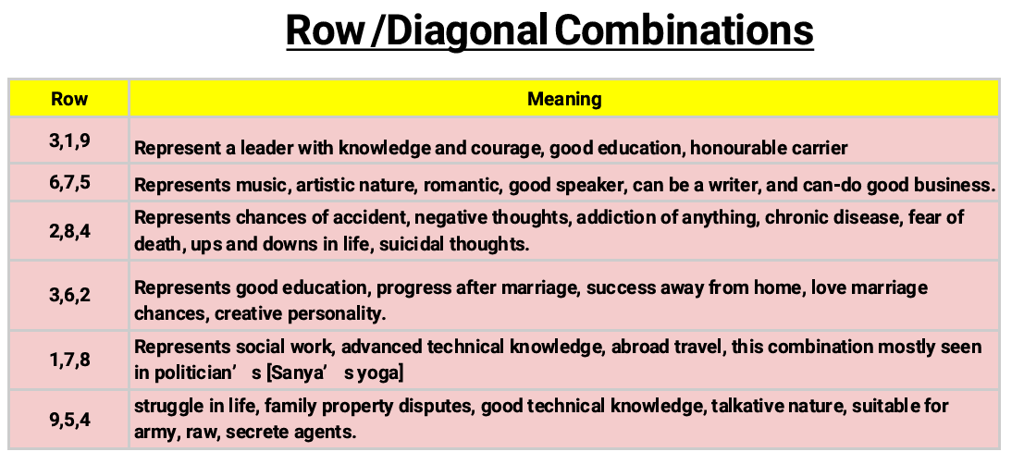

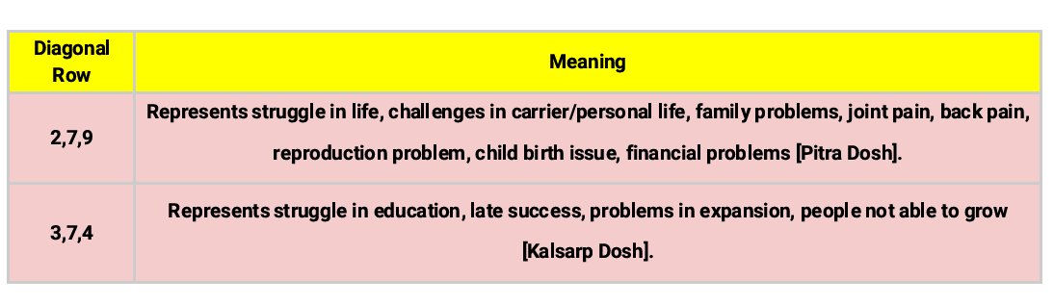

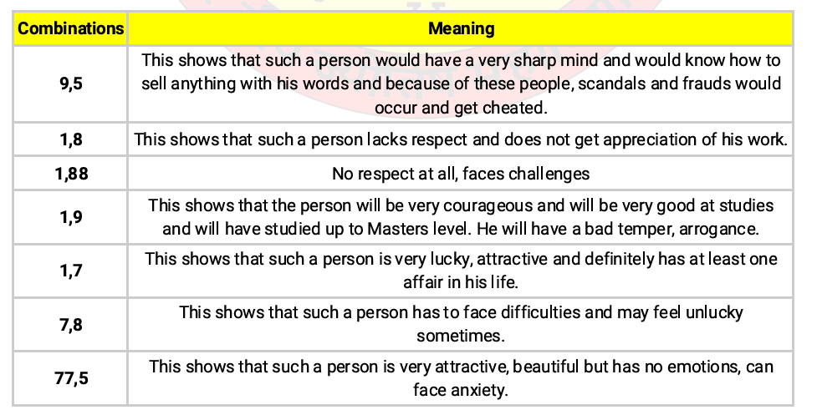

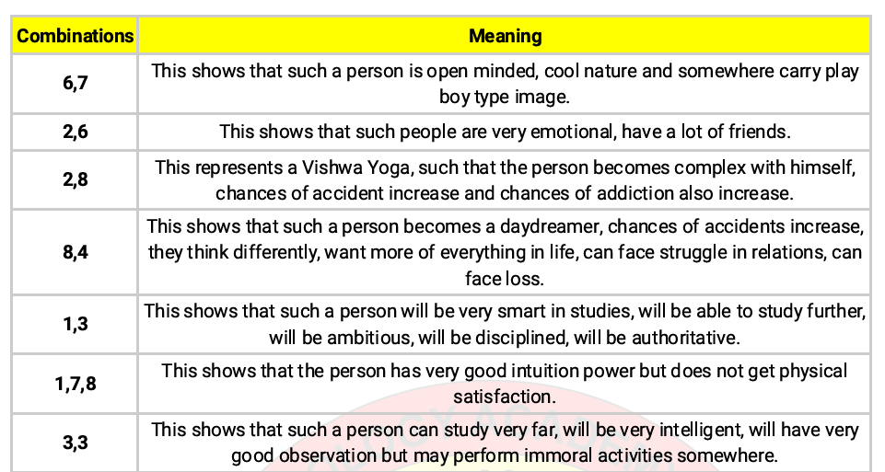

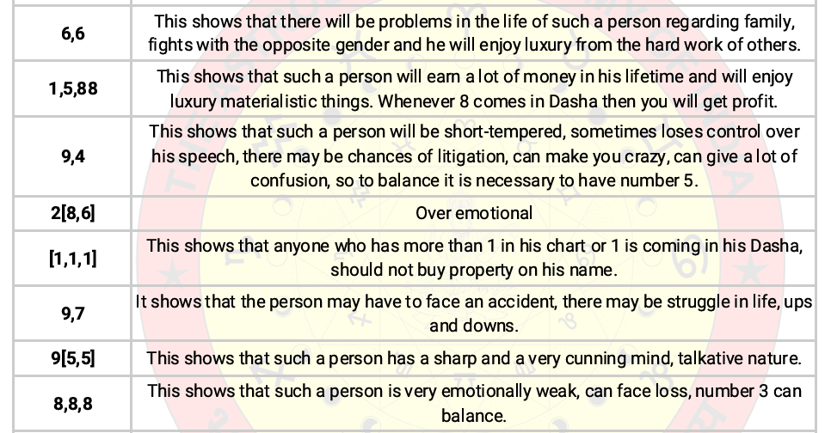

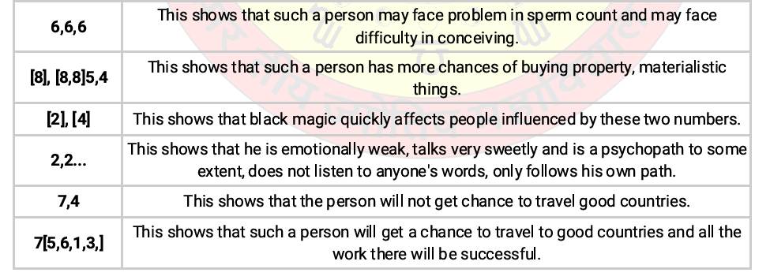

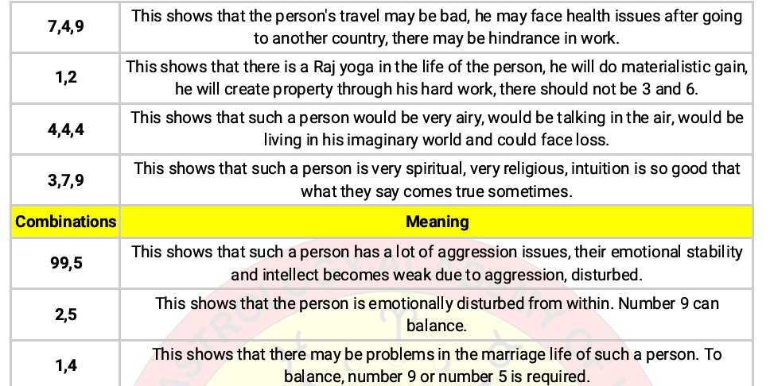

1. **Mobile Numerology**

Mobile Numerology is an evolving practice that transforms a mobile Number into a luck accelerator by leveraging core principles of numerology

In this modern age, no one can envision their lives without their mobile phones. However, what if a person bought the latest smartphone but the mobile number is unfavourable? Have people ever stopped to think about the immense impact their mobile numbers might have on crucial aspects of their lives? These days, many people have started using numerology to pick their mobile numbers so that they are closer to individual vibrations. A particular mobile number that is harmoniously aligned with one’s number can usher good luck and fortune in his/her life.

Benefits of a lucky mobile number

Enhanced luck: A lucky mobile number can attract positive energy and opportunities and enhance one’s overall luck in various aspects of life, be it love/marital life, career, education and money.

Improved communication: It can lead to better communication, ensuring that important calls and messages are received and answered promptly.

Reduced stress: A harmonious mobile number can reduce stress and promote a sense of calmness when using one’s phone.

Boosted confidence: One’s mobile number resonates with him/her and can boost their confidence, leading to more success.

The significance of a mobile number’s single-digit total

Number 1: It’s a strong number that speaks about power, authority and command. There are a number of successes and fames.

Number 2: This is a perfect number for people who love art and music and are romantic. It depicts emotion, care and a fluctuating mind.

Number 3: It’s a number of expansions, ambition and management. It’s good for people who are writers, teachers, advisors and spiritual leaders.

Number 4: This number belongs to a smart but restless and unstable mind. People who are scientists and politicians associated with the media can use this number.

Number 5: This number represents change and a busy life. Generally, it’s good for businessmen and people who like adventures.

Number 6: This is the best number for homemakers - people who are family-oriented or interested in music, art and acting. If one is in love or wants love, try this number.

Number 7: This is the strongest mystical number. It’s perfect for research-oriented people and thinkers. One may have to work hard to achieve goals.

Number 8: This number is good for people who work for the masses. It may attract wealth if one works hard. It’s suitable for people who are in business, education and law.

Number 9: It can be a fortunate number. People with health issues shouldn’t keep this number. This can be good for people who are associated with healing and healthcare jobs, publishing and printing. It’s also beneficial for leaders.

People must avoid too much repetition of any single digit in their mobile numbers. For example, there shouldn’t be more than two zeros in a sequence or any digit repeating in a sequence. Also, one must avoid his/her bad or unlucky numbers. The above method can be used to pick landline numbers for homes or offices too. To unlock the full potential of one’s mobile numerology, consider getting a personalised numerology consultation for expert guidance.

Here's a step-by-step process of Mobile Number checking and changing:

1. **Calculate your Mobile Number Vibration:**
   * Take your mobile number.
   * Add all the digits together (including the country code if applicable if your profile is international).
   * If the result is a two-digit number, add the digits again until you get a single-digit number.
2. **Compare and analysis the Numbers:**
   * Compare with your Basic Number: It should be friendly and compatible.
   * Compare with your Destiny Number: It should be friendly and compatible.
   * Check compound of Mobile number total: It should be favourable according to compound chart.
   * Compare compound number with your basic and destiny number. It should be friendly and compatible.

Numerology believes that numbers resonate with each other, and certain numbers are considered lucky or unlucky based on their vibrations.

Example:

Let's say you were born on the 24th of a month (birth number: 2 + 4 = 6) and your mobile number is 9876543210.

1. **Basic Number:** 6
2. **Mobile Number:** 9 + 8 + 7 + 6 + 5 + 4 + 3 + 2 + 1 + 0 = 45. 4 + 5 = 9
3. **Comparison** for example:

Your birth number (6) and your mobile number (9) are different. In numerology, this might mean the mobile number doesn't perfectly resonate with your life path.

Some other points to know

* 1. More zero in the mobile numbers are not good as it can block your energy flow.
  2. End digit should be good as it is more showing in every time.
  3. Good numbers according to profile.
  4. Normally Avoid struggling numbers – 2,4,8,7
  5. Normally good numbers are – 1,3,5,6
  6. Outgoing would affect more than incoming, If anyone cannot change mobile number due to any reason than he should get another number for outgoing for better result.

Good mobile numbers for various profiles

|  |  |
| --- | --- |
| **Business** | **1,3,5,6** |
| **Politics** | **1,2,9** |
| **Art** | **3,6,9** |
| **Spiritual** | **2,7,9,3** |
| **IT Sector** | **5,6,8,4,7** |
|  |  |

**Good mobile Numbers according to driver**

|  |  |
| --- | --- |
| **Driver** | **Numbers** |
| **1** | **1,3,5,6** |
| **2** | **2,7,6** |
| **3** | **3,9** |
| **4** | **1,5,6 but avoid 8** |
| **5** | **1,5,6,9** |
| **6** | **6,9** |
| **7** | **2,7,5** |
| **8** | **5,6,3 but avoid 4** |
| **9** | **3,6,9 avoid 1** |

**Some mobile number combinations and their effects**

|  |  |
| --- | --- |
| Combination | Effects |
| 4,8 / 8,4 | Unlucky, Loss, Dream world life, loan and debt |
| 8,2 / 2,8 | Unlucky, Depression, Tension, Overthinking |
| 1,5 / 5,1 | Lucky Number, good for business and marketing, Money, Leadership quality |
| 6,8 / 8,6 | Financial growth, Long term financial stability |
| 3,9 / 9,3 | Imbalance of charm, complete recognition, Successful in creative field |
| 7,2 / 2,7 | Intelligent, good for spiritual purpose |
| 2,6 / 6,2 | Good for romance and sexual relationship, good if you want to add anyone in your life |
| 5,7 / 7,5 | Intelligent, sharp mind, good wisdom, deep thinking |
| Two times 1 | Lucky, good, name, fame, leadership, authority, |
| More than two times 1 | Some bad effects, name and fame with egoistic, |
| Two times 2 and more | Problem started if two times, stress, overthinking, piece end, lose confidence |
| Three times 3 | Knowledge, Not balanced, want to improve but can’t be, don’t accepting anything, not accepting own mistakes, wisdom is very necessary |
| Three times 4 | Disorganised, should not more in overall number, big risk taker, confusion, sudden ups and downs |
| Three times 5 | Like travelling, disturbing behaviour with opposite sex people, good network and marketing |
| Three times 6 | Materialistic, issue in gains, more responsibility |
| Two times 7 & More | Overthinking, detachment from social and materialistic, trust issue, |
| Two times 8 | Delay in work, growth disturbed, Job preferring, good for legal matters |
| Two times 9 & More | Very good energy, Aggression, power, hardworking, emotional and physical energy |

1. **Compound Numbers**

In numerology, compound numbers (2-digit numbers from 10 to 99) are derived from single-digit numbers and are used to provide a more nuanced understanding of the base number's characteristics. They amplify or diminish certain aspects of the base number, offering additional insight into its potential and how it manifests in a person's life. For example, the compound number 10 (1+0) emphasizes the leadership qualities associated with the number 1.

Here's a breakdown of how compound numbers work:

* **Base Number:**

The single-digit number obtained by reducing a compound number (e.g., 10 reduces to 1, 11 to 2, 12 to 3, etc.).

* **Compound Number:**

Two-digit numbers (10-99) that, when reduced to a single digit, represent the same base number.

* **Emphasis and Diminishment:**

Compound numbers either strengthen or weaken certain traits associated with the base number.

* **Additional Insight:**

They can be used to delve deeper into a number's meaning, especially when the initial single-digit interpretation is insufficient.

For example:

* The compound number 11 (1+1=2) can reveal more about the potential for intuition and insight associated with the number 2.
* The compound number 25 (2+5=7) might highlight the spiritual nature and analytical abilities linked to the number 7

Various compound numbers and their effects

|  |  |  |
| --- | --- | --- |
| No | Symbol | Effects |
| 10 | Wheel of Fortune | This is powerful number. People with no. 10 can earn good name and fame. But the result deeply depends on their efforts. This no. Represents fame, self-confidence, belief, success. These people have the potential to change their destiny. |
| 11 | A hungry lion with hands and legs tied | This is an unlucky number which denotes some problem in the future. It also represents betrayal. People affected by this number face a lot of difficulties in life. |
| 12 | self-sacrifice | This number denotes tension, self-sacrifice and problems because of others. These people suffer in life because of the deeds of people around them. This is considered to be unlucky. |
| 13 | Extremity | This number's result is extreme success or extreme failure. People need to judge whether this number favours them or works against them. Because of the extremities people choose to stay away from it |
| 14 | Storm, fire and flood | People affected by this number would suffer because of others. |
| 15 | Magic and occult mysteries | These people are self-centred. Such people are inquisitive about themselves and are impulsive. This number is very lucky if doesn't comprise of 4 and 8. Otherwise these people can use negative means to achieve what they want. |
| 16 | A king falling of a tower because lightening | Unlucky number. This numbers indicates problems in the future. Whams the person for the coming accidents and misfortunes. It denotes a failure because of destiny. |
| 17 | An eight-edged twinkling stars of Venus | Lucky number. It denotes the end of all problems and difficulties and it takes a person to good heights. It gives you name and fame. But if this number is composed of4 and 8 it Is considered to be very unlucky. |
| 18 | Blood drops falling from a shining moon and a dog & wolf living them. A crab is approaching | Family problems. These people suffer because of their enemies. Such people earn money by being religiously corrupt. They benefit from social problems and revolts. You should not choose this number for any auspicious work |
| 19 | Sun(The prince of heaven) | A very lucky number. People get happiness, success, fame. Their plans are fulfilled and they achieve their goals |
| 20 | An angel blowing a trumpet below it there is a woman and a man& child coming out of a coffin and praying | Lucky number. It denotes justice and new opportunities. it says that though problems would be faced in the path but ultimately with the help of the nature success would be achieved. |
| 21 | The world | This number represents success and fame. Such people would reach the peak of their career and shine different from the crowd. These people would have to struggle a bit for their success. A very lucky in itself |
| 22 | A person turns blind because of others errors. An angry lions approaching to attack him | This is an unlucky number. It denotes failures and. problems because of others. Such people dream of things that-can never be achieved. They fail to protect themselves from the problems raised because of others. They often take wrong decisions in others influence. Such people should be very careful in taking decisions. |
| 23 | The royal star of lion | A very lucky number It gives success and it denotes help from other powerful people |
| 24 | Success in love | This number denotes success because of love. Such people rise in life with the help of opposite sex. This is a lucky number. |
| 25 | Strength gained through experienced and benefits through observation | This number represents success with one’s own experience and struggle. A person may have to face difficulties in ‘he start sofa venture but would surely achieve success in the coming future. This is considered to be a_ lucky number. People working under them also benefit from their experience. |
| 26 | Warnings of the future | This number represents serious problems in the future. These people will have to face defame and failures because of association with other people. They face major failures in betting and gambling. Unlucky number, warns you to be careful in the future. |
| 27 | The sceptre | This number gives you power and leadership qualities. If such people work with their own minds they can achieve success for sure. Lucky number. |
| 28 | Opposite and defame | This number represents opposition from others. Such people are often over confident about their work but if they are not careful) about their work, it can lead them to defamation and failures. These people should not trust others too much as they are prone to betrayal. They should not oppose anyone without a reason. They can face court cases in their business They may have to suffer a lot because of a small mistake. Unlucky number. |
| 29 | Uncertainly and betrayal | This number represents betrayal, problems, tension from friends and opposite sex. These people should be very careful in whatever they do. Unlucky number |
| 30 | Depends upon the will and desire of the person | Such people are very intelligent. They prefer knowledge to money. This also denotes learning lessons, from past events. This is a neutral number. Success or failure depends on a person’s thinking. |
| 31 | Solitude | Such people do not save much money. They Jove to be in solitude. They stay away from friends and family. They do not have much aims in life. From a family point of view this is not a lucky number. |
| 32 | Unity and fame | This number is very lucky. Denotes fame, success and self-confidence. You should trust your instincts and be determined on your decisions. If you listen to others advice much you would face problems in your life. |
| 33 |  | This number denotes success because of love. Such people rise in life with the help of opposite sex. This is a lucky number. |
| 34 |  | This number represents success with one’s own experience and struggle. A person may have to face difficulties in ‘he start sofa venture but would surely achieve success in the coming future. This is considered to be a_ lucky number. People working under them also benefit from their experience. |
| 35 |  | This number represents serious problems in the future. These people will have to face defame and failures because of association with other people. They face major failures in betting and gambling. Unlucky number, warns you to be careful in the future. |
| 36 |  | This number gives you power and leadership qualities. If such people work with their own minds they can achieve success for sure. Lucky number. |
| 37 | Rising fortune | People get success in. love and friendship both. They benefit in a partnership. Such people rise with the help of opposite sex. |
| 38 |  | This number represents betrayal, problems, tension from friends and opposite sex. These people should be very careful in whatever they do. Unlucky number |
| 39 |  | Such people are very intelligent. They prefer knowledge to money. This also denotes learning lessons, from past events. This is a neutral number. Success or failure depends on a person’s thinking. |
| 40 |  | Such people do not save much money. They Jove to be in solitude. They stay away from friends and family. They do not have much aims in life. From a family point of view this is not a lucky number. |
| 41 |  | This number is very lucky. Denotes fame, success and self-confidence. You should trust your instincts and be determined on your decisions. If you listen to others advice much you would face problems in your life. |
| 42 |  | This number denotes success because of love. Such people rise in life with the help of opposite sex. This is a lucky number. |
| 43 | Struggle | This number depicts struggle, problems, tensions, rivalries, defame, obstacles. This is an unlucky number |
| 44 |  | This number represents serious problems in the future. These people will have to face defame and failures because of association with other people. They face major failures in betting and gambling. Unlucky number, warns you to be careful in the future. |
| 45 |  | This number gives you power and leadership qualities. If such people work with their own minds they can achieve success for sure. Lucky number. |
| 46 |  | People get success in. love and friendship both. They benefit in a partnership. Such people rise with the help of opposite sex. |
| 47 |  | This number represents betrayal, problems, tension from friends and opposite sex. These people should be very careful in whatever they do. Unlucky number |
| 48 |  | Such people are very intelligent. They prefer knowledge to money. This also denotes learning lessons, from past events. This is a neutral number. Success or failure depends on a person’s thinking. |
| 49 |  | Such people do not save much money. They Jove to be in solitude. They stay away from friends and family. They do not have much aims in life. From a family point of view this is not a lucky number. |
| 50 |  | This number is very lucky. Denotes fame, success and self-confidence. You should trust your instincts and be determined on your decisions. If you listen to others advice much you would face problems in your life. |
| 51 | Warrior and victory | This is a unique and powerful number which signifies strength and victor-Such people get unexpected opportunities to rise in life. These people get success wherever they work but they also have a lot of enemies. They are suspected to be harmed or murdered by friends. |
| 52 |  | This number depicts struggle, problems, tensions, rivalries, defame, obstacles. this is an unlucky number |
| 53 | Success and intelligence | This number is lucky for politician, detectives and military personnel. These people have the will to struggle. If you are satisfied with your name you need not change it. If you want financial rise then change your name. |
| 54 |  | Success, prosperity, intelligent, lucky. To avoid accidents read Hanuman Chalisa. You need not change your name. |
| 55 |  | Such people are hasty indecisions and then regret their decisions. You should change your business. |
| 56 |  | These people get success but after a lot of efforts. They are spendthrifts. You should change your name so that you may get success a little early. |
| 56 |  | Lucky, good businessman, jolly natured. Should not change their name. |
| 57 |  | Lucky, good businessman, jolly natured. Should not change their name. |
| 58 |  | Emotional, Kind hearted. Can plan very well but fail to take care of the budget. Should not change their name. |
| 59 |  | You will have to face a lot of problems. You will benefit from travel. You will have enough money for your needs. |
| 60 |  | Lucky number. You should not change your name. Change your attitude a bit. |
| 61 |  | You will have a lot of difficulties in initial life but will have success in later age. If your age is less than 40 you may change your name. Your luck will shine with travel. |
| 62 |  | Hardworking, dedicated people. You will have sudden rise in your life. You should change your business instead of name |
| 63 |  | Name is lucky. Helping in nature. Such people are spendthrifts. Should save money |
| 64 |  | Family problems, problems with colleagues. Should change your name for positivity. In financial regards name is lucky. Such people are always stuck with problems. |
| 65 |  | Successful life, content and reaches the top level. They get all the materialistic things in life. Prone to accidents. Should read Hanuman Chalisa and Suraksha Kawatch |
| 66 |  | Lucky number. Such people-are jolly In nature, good in business and soft spoken. They get Success in different spheres of life: They reach success with help of their contacts. Name has magnetic powers by which they are able to defeat their enemies easily. |
| 67 |  | Lucky number. Such people are alert, fearless, beautiful, healthy and awakened. They get success but a little later than expected. If they plan and work they would definitely reach inner goal. They should be practical in their approach. |
| 68 |  | Should change their name immediately. These people are always depressed and unsuccessful in life. Neither do they have the ability to do something big on their own nor do they get anyone's support. They face obstacles in whatever they do. |
| 69 |  | Lucky number. Financially. Sound, prosperous, Happy, optimist and successful. Married life blessed. They benefit in partnership. They should take advantage of their political connections for financial growth. |
| 70 |  | Lucky number. End result is positive. Have good qualities. Gets success in Whatever they do. They live a luxurious life. They face little financial problems in the beginning of any work but in short time they get success. |
| 71 |  | Lucky number should not change their name. Emotional, kind hearted, hard working. They do not worry about results. Work very hard. They can plan very well for future and thus get success. They excellent writing and as advisors. |
| 72 |  | People who are affected-by this number struggle a lot _.in_ their childhood. They have to face a lot of hardships before they get success. They help others a lot but fail to gain others support. They should change their name to avoid so many struggles in life. |
| 73 |  | These people have the ability to work. They are religious and soft spoken They are financially strong and live a prosperous life. They have a high self-esteem and do not take favours from others. They are content with what they have. |
| 74 |  | People with this number are patient, understanding and alert They may have to face problems because of their success and property. They may have to face opposition from family members. If you stay on their words they will get success. They should not take responsibility for others finances. Should change their name. |
| 75 |  | Unlucky number. These people always suffer because of others. Health problems, betrayal from friends |
| 76 |  | Lucky number. People get success in all spheres of life. Married life is blessed. They, are benefited from partnership. They should take advantage from their friend and other contacts. |
| 77 |  | Unlucky. They have to struggle a lot in life. They are eager to save money. They benefit from travel in business. They face obstacles in executing their plans. |
| 78 |  | Should change their name. They have to face a lot of obstacles and problems. In spite of a lot of hard work they fail to get success. They are always tensed. |
| 79 |  | Lucky number. They have success and prosperity in life. They benefit from people in the social. They are prone to accidents. They should read hanuman chalisa to avoid the same |
| 80 |  | Lucky number. Religious, emotional and keeps sympathy with others. People whom they help and support get more success as compared to them. If people want success in business and money then change your name else it is fine. |

1. **Remedies of every planets co- relate with astrology system**

Remedies are practices used to enhance or balance the influence of specific numbers on an individual's life. These remedies, often involving crystals, colours, days, and specific actions, are designed to align an individual with cosmic forces and improve their luck, harmony, and overall well-being. Remedies are associated to remove bad impact of every grid and improve prosperity in life.

Here's a more detailed look at numerology remedies:

1. Understanding the Significance of Numbers:

* Each number from 1 to 9 holds unique characteristics and vibrations, influenced by celestial bodies like the Sun, Moon, and planets.
* Missing numbers in a numerological chart or Lo Shu Grid can create imbalances or challenges in an individual's life.
* Repeated numbers can also have a strong impact, potentially amplifying certain qualities or energies.

2.

Common Numerology Remedies:

* **Crystals and gems:**

Specific crystals and gems are recommended for each number, believed to enhance their positive attributes and mitigate negative aspects. For example, Citrine is associated with the number 1 and can boost confidence and self-expression.

* **Colours:**

Certain colours are linked to specific numbers and are often incorporated into clothing, decor, or meditation to balance energies.

* **Days:**

Certain days of the week are associated with particular planetary influences and can be used to focus on specific aspects of life.

* **Actions:**

Engaging in specific activities like wearing specific clothing, donating to charity, worship to god, chanting mantras, wear or performing certain rituals can also be used as remedies.

* **Rudraksha:**

Wearing or worshipping Rudrakshas (sacred beads) can be particularly helpful for addressing imbalances related to specific numbers

Remedies of specific planets

* 1. Sun

The Sun represents father, soul, power, fire, bones, eyes east direction, copper metal, govt. jobs, High positions, and designation. Some Remedies for Sun are:

1.  Do not consume salt on Sunday.

2. Worship the Lord Vishnu, respect the father, a father-like person, and touch the feet of elders.

3. Drink water in a silver glass.

4. Offer red flowers to Lord Ganesha on eleven or twenty-one Sundays.

5. Offer water to the Sun every morning in a copper vase with rice, red flowers, and vermilion.

6. Chant "Om grihini suryaya namah" mantra 108, 51 and 21 times every morning and evening.

7.  Worship Bhairo baba on Sundays.

8. Donate self-weight = Wheat grain in the temple on Sundays.

9. Aditya Hraday Strot Path

10. Crystal suggested – Citrin and Sunstone

11. Gemstone suggested – Ruby

* 1. Moon

The Moon represents the mother, mind, child, water, lungs, mental health, etc. Some Remedies for Moon are:

1.  Respect your Mother and motherly and old ladies, take blessings of mother every day, and never hurt your mother.

2. Wear a Silver bangle, pearl string, or Chandrakant mani around the neck.

3. Donate water, salt, milk, white sugar and medicine, but if the moon is placed in the 6th, 8th and 12th house then don't donate these things.

4. If the moon is a week in the chart then that person shouldn't consume milk or curd at night.

5. Worship Lord Shiva , chant "Om Namah Shivaye" and offer white Sugar or Mishri with water flow

6. Give milk-made sweets, milk, and sweet cooked rice to a girl below 10 years.

7.  Worship clockwise conch every day.

8. Three white flowers on every Monday and a full Moon immerse in the flowing river.

9. Every Monday afternoon eats curd and rice only.

10. Mantras Suggested – “Om em kleem somay namah” “Om shreem Shreem Chandamase Namah”

11. Gemstone suggested – Pearl

12. Crystel suggested – Moon Stone, Clear quartz

13. Shiv Chalisa Path

* 1. Jupiter :

Jupiter Represents Knowledge, intelligence, education, religious activities, devotion, ancient literature, wealth, respect, elders, elder brother, trees with fruits, fat in the body, diabetes, ears, banks, income tax, treasurer, temple, religious institutions, legal matters, justice department, the court of law, written exams, editor, principal, teacher, share market, minister, tourist, municipal corporation, astrologer, Vedas, shastras,  son, judge, liver, asthma, northeast direction. Some remedies of Jupiter are:

1.  Donate lentil gram tied in yellow cloth in the temple.

2. Apply turmeric/saffron tilak on the forehead.

3. Wear gold around the neck and keep your nose clean.

4. Do regular cleaning of the place of worship.

5. Worship to Lord Vishnu or Lord Krishna

6. Chant Jupiter's mantra every day- “Om brahm Brahaspatye Namah” “Om gram greem grom sh guruve namah”

7. Donate things related to Jupiter.

8. Water the Peepal tree regularly.

9. Vishnu Shahastra Name Path

10. Worship and Puja of banana tri

11. Wear yellow cloths and bath by Haldi mixed water

12. Keep keshar chandan Tilak on Head

13. Gemstone suggested – Yellow sapphire

14. Crystal suggested – Citrin (Sunhala), 7 Chakra and Amethyst

1. Rahu :

Rahu Represents foreign travel, society, skin diseases, itching, poison, chronic diseases, widow, fear, pilgrimage, rude behaviour, foreign settlement, extramarital affair, arguments, pain, swelling, etc., cunningness, gambling, cleverness, backstabber, addiction, stones in the kidney, self-respect, enemies, explorer, illegal activities, export, detective. Some remedies of Rahu are:

1. Donate reddish, tea packets, Chandan ka itra, electronics, and blue coloured things.

2. Visit Dargah and offer green chadar.

3. Feed 4kg reddish to the elephant.

4. Recite Sarswati and Bhairov Chalisa

5. Apply saffron tilak on the forehead and Sit on the floor in the kitchen and eat food.

6. Visit the Shiva temple every day and offer Aegle marmelos to Lord Shiva.

7. Feed grains to the birds every morning and start the work from Wednesday.

8. Shiv Rudraksh Path

9. Shiv chanting and meditation

10. Avoid smoking

11. Don’t wear blue coloured cloths

12. Crystel suggested- Amethyst

13. Mantra – “OM Ram Rahve Namah”

1. Mercury :

Mercury Represents Speech, arts, intelligence, friends, metal gold, business, memory, stone, skin and brain problems, education Intelligence, cleverness, voice, happiness, education, maths, writing, arguments, astrology, dance, drama, family, business, negotiator, maternal uncle, friends, relatives, throat, nose, ears, lungs. Some remedies of Mercury are:

1.  Do Durga Saptshati yourself or get it done and Recite Sankat Nashaan Ganapati Stotra daily.

2. Eat green cardamom and basil every Wednesday.

3. Feed the cow green fodder every Wednesday.

4. Flow green cardamom into the water every Wednesday.

5. Flow Jiggery into the water.

6. Chant Mercury mantra every day

7. Don't eat saboot moong.

8. Wear a gold/ silver chain or a copper coin.

9. Worship to Lord Ganpati with offering Durva on every Wednesday

10. Offer Green Gram to Lord shiva and Nandi Ji

11. Offer green grass to Cow on regular basis

12. Gemstone suggested – Emerald

13. Crystal Suggested – Green aventurine

14. Mantra – “ Om bram breem brom sh Budhay Namah”

1. Venus :

Venus represents Vehicles, luxury, prosperity, love, marriage, Child birth-related problems, sexual organ disease, wife, lust, youth, happiness and prosperity, ornaments, beauty, fragrance, flowers, creativity, designer objects, white-coloured objects, beautiful body, big eyes, curly hair, poetry, music, black hair, desire, alcohol, drugs, short height, sexual diseases, eyes, intestines, appendix, diabetes. Some remedies of Venus are:

1.  Wear silver jewellery and white cloths

2. Donate white silky cloths, cotton, and curd and other white things like Milk, Sugar, rice etc.

3. Serve mother and cow every Friday.

4. Put a white rose in a river or well on Friday.

5. Donation things related to Venus, and distribute sweets to little girls.

6. Chant the Venus mantra every day and keep your character clean.

7. Donate things related to Jupiter.

8. Worship every day goddess Laxmi or maa Durga.

9. Apply perfume to body and cloths. Also bath by perfume mixed water

10. Feed ghee and white sugar mixed bread

11. Gemstone Suggested – Opel

12. Crystal suggested – Rose Quartz

13. Mantra – “ Om Sum Sukray Namah” Om Dram Dreem Drom sh Shukray Namah”

1. Ketu :

It is considered Moksha Karaka, dogs, roosters, animals with horns, stammering, intestines, imprisonment, piece of land in foreign, slavery,  religion, astrology, medicines, detachment, writing, monetary gains, winning over enemies, transfer, drugs, occult, urine, prostate, blockages, piles. Some remedies of Ketu are :

1. Donate bananas, Aamchhor, kacchi imli, achaar, double or multicolour wire, rope, Double shaded blanket, and donate lead if Ketu in 1st and 7th house.

2.  Do Ketu mantra every day- “ Om stram Streem Strom sh ketve namah”

3. Black/white sesame seeds shed into the water, l

4. Wear a gold ring on the left-hand thumb, Ketu Mani, or Lehsunia stone.

5. Offer Durva and coconut to Lord Ganesha

6. Serve girls and never insult your wife and keep a good relationship with your mother.

7. Burn garlic clove and flush it.

8. Feed foods to Blank and white dog everyday

9. Worship to Sacred Fig Tree and offer green grass mixed water on every Saturday with Lamp of clarified butter

10. Gemstone and crystal suggested – Cat eyes

11. Worship to God Ganpati

1. Saturn :

Saturn represents life, age, death, sorrow, poverty, disrespect, flatterer, sickness, inappropriate behaviour, lowly works, natural disasters, old age, diseases, sin, secrecy, imprisonment, job, scientific laws, oil, labour, servant, agriculture, sacrifice, falling from a height, insult, draught, loan, hard work, black seeds of ration, wooden stick, poison, legs, ash, handicap, self-sacrifice, arms, robbery, wool, import, delay, service department, foreign language, pride, greed, theft, handicapped leg, feet, nerves in the feet, tantra, sadness, paralysis, tiredness. Some remedies of Saturn are:

1.  Do not lie, stay away from any kind of bad addiction, and don't cheat anyone.

2. Feed channa to monkeys.

3. Do a shadow donation by seeing your face in mustard oil.

4. Flow a Coconut or almonds into the water.

5. Flow mustard oil and kali urad daal together into the water.

6. Chant Saturn mantra every day – “ Om sham shanischaray Namah”, and recite Hanuman Chalisa, Bajrang Baan, and Sunder Kand every day.

7. Help blind people or feed food to 10 blind people and sweets must be included.

8. Feed stray dogs if the dog is black then it's good.  Feed dog food and a dog biscuit. Don't feed sweets because sweets are injurious to a dog's health.

9. Worship to Lord Hanuman and Lord Shiva

10. Donate and help to poor people

11. Feed animals, birds and fishes

12. Gemstone suggested – Blue sapphire

13. Crystal Suggested – Lapis Lazuli

1. Mars :

The Mars is considered a war commander and a cruel planet. It represents passion, energy, wars, separation, etc. Mars can give Manglik dosha in a Kundli/horoscope if it has high energy. Some remedies of Mars are:

1.  Light a ghee lamp under the Peepal tree when day and night are meeting.

2. Abstain from non-veg, drink, hair cutting, shaving, and nail cutting on Tuesdays.

3. On Tuesday, go to Hanuman Ji's temple and light a jasmine oil lamp and add two cloves. Keep the lamp in front of Hanuman ji and read hanuman chalisa.

4. Offer Chola to Hanumanji on Tuesday. 11, 21, and 108 Tuesdays to get blessings.

5. Reciting Hanuman Chalisa, Ram Charit Manas, Bajrang Baad, Sunderkand on Tuesdays cures Mars in the horoscope.

6. Donating red-colored items, all malka daal, copper, batase, rewadiya (Indian sweet), and blood, etc. remove Mars's adverse effect.

7.  Chanting the mantra "Om Bhom bhomaye Namah" removes the adverse effect of mars.

8. To remove the adverse effects of mars install mangal yantra in the house temple.

9. Feed gram flour and motichoor laddoos to the monkeys.

10. Offer boondi, motichoor, or besan ladoo to hanuman Ji on Tuesdays.

11. Keep a red coloured small cloth in your pocket everytime

12. Mantra – “ Om kram kreem krom sh bhomay namah”

13. Gemstone suggested- Red Coral

14. Crystal Suggested – Red carnelian