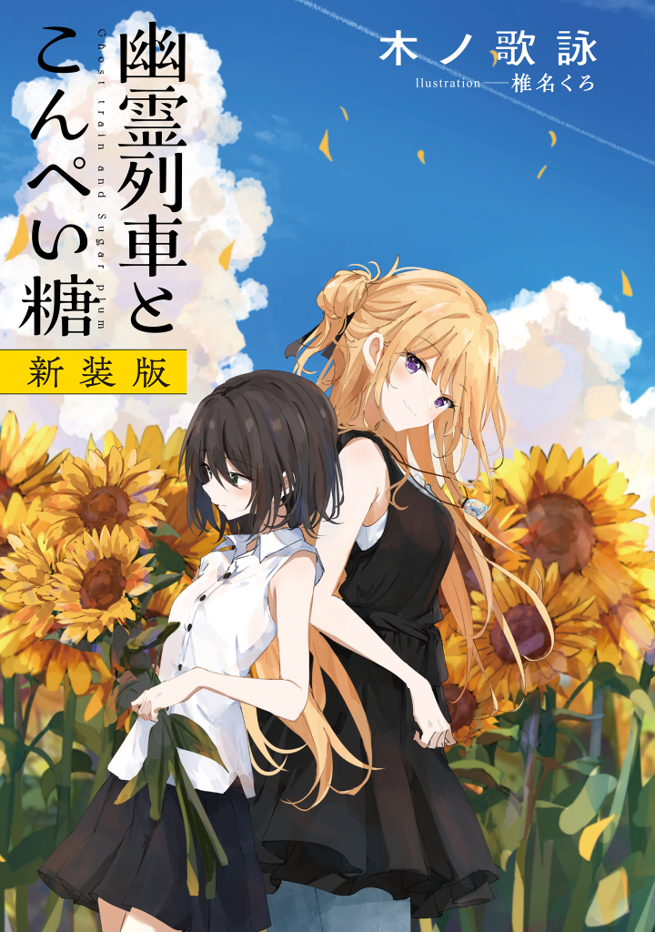

**Table of Contents**

Cover

Illustrations

Overture

# **Overture**

**1**

***It was the year 2007, on a certain day in July.***

I headed to the station with determination in my heart. It would have taken just 7 minutes on my bike, but I decided to go on foot anyway.

An impressive sight enveloped me—I was the only bipedal creature, no matter which way I looked—rice. Rice. And beyond that? That’s right. More rice fields.

As reflective of the current season, my field of view was veiled in a fresh coat of greenery.

—A picturesque scene of a boring countryside town. Cell phone signal was something you couldn’t even hope to get here or thereabout.

***The back of the girl walked unsteadily along the side of the rice fields. An onlooker might have thought she was sleepwalking.***

Outlanders might see the scene and be delighted by the sights… but for its residents? They’d probably be sick of it by now and wouldn’t even bat an eye, just as in my case.

Continuing with my walk, I pressed the play button on my iPod. A grand ensemble began to flow from my earphones.

It was the first track from the *Dancer in the Dark*movieOST*,*titled *Overture*. Just so you know, my iPod only contained the 7 songs from the full album.

By the time the fifth track, *In the Musicals,* ended, I had reached my destination—  
  
Maina Station. An unmanned timeworn terminal.

The surroundings of the station were as quiet as ever, not a living soul in sight.

“……?”