**Peak Performance Massage Therapy**

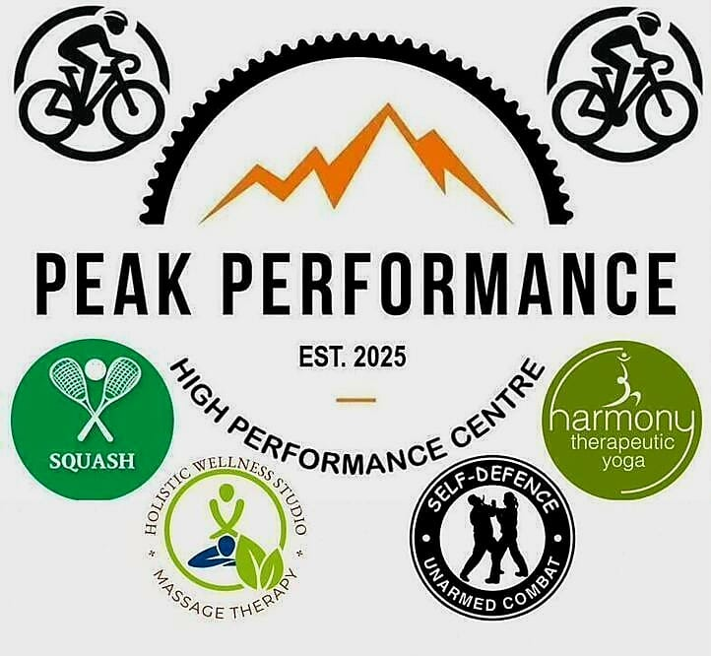

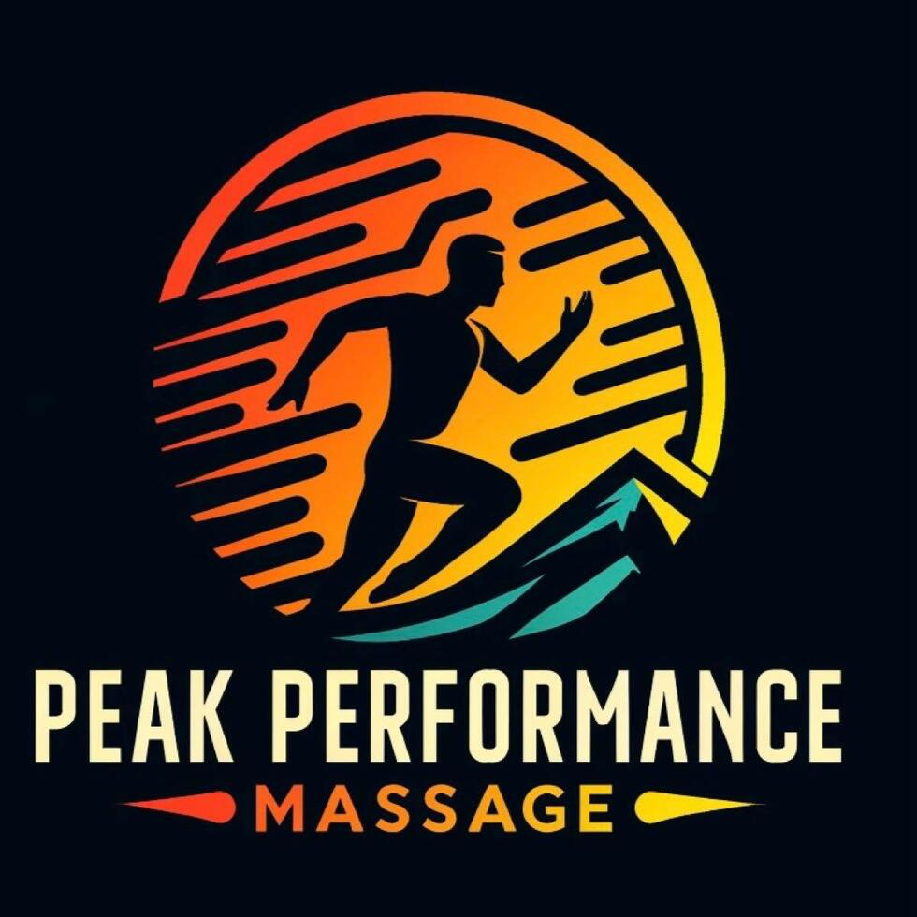

**Christo: WhatsApp – 084 565 3727**

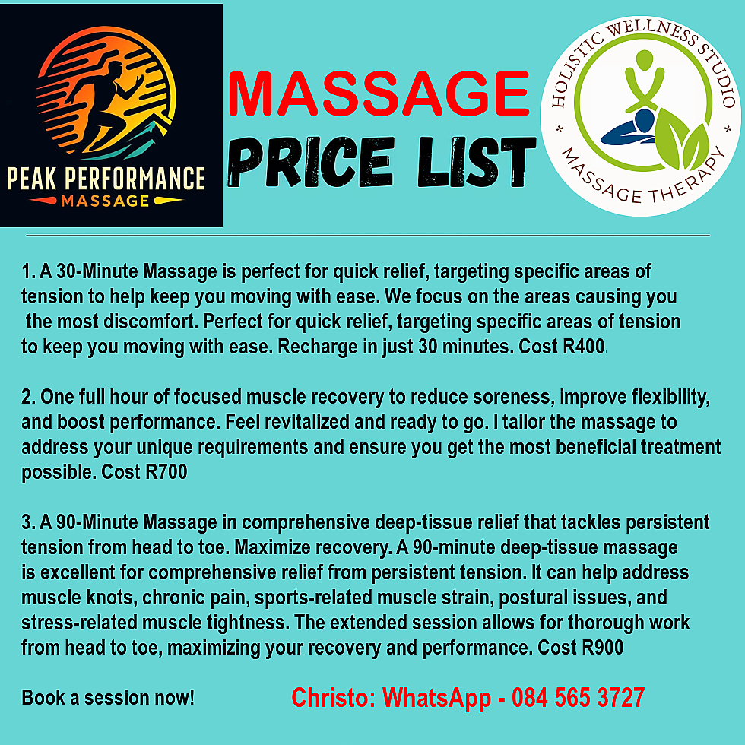

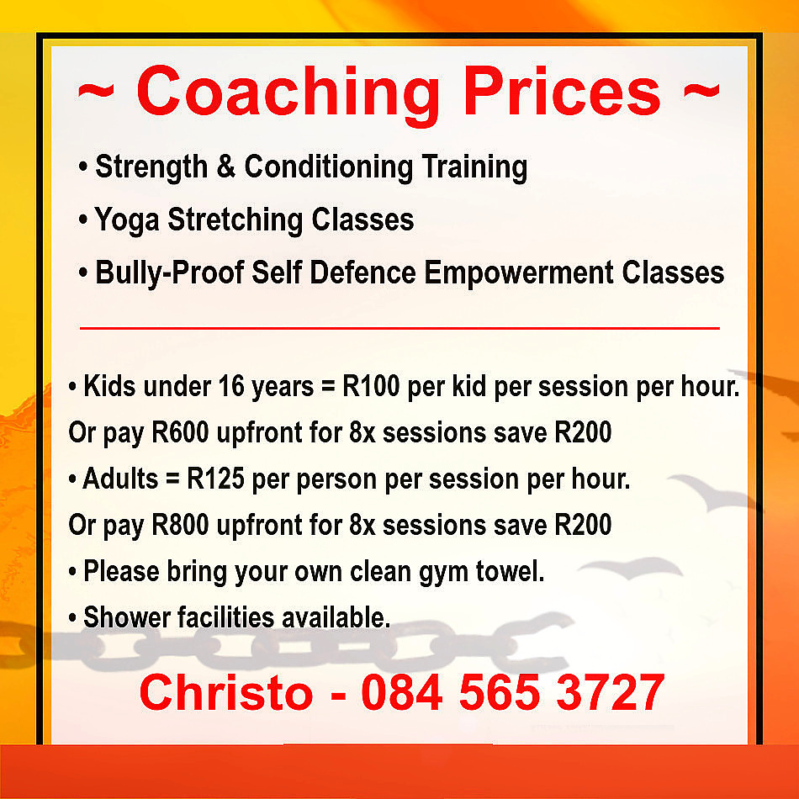

**Is Muscle Pain and Stiffness Hindering Your Athletic Performance?**

Athletes and active individuals often encounter challenges that impede their progress and enjoyment of physical activities. Common issues include:​

Ongoing discomfort that affects training consistency and performance.

Stiffness that restricts movement, making it difficult to perform optimally. ​

Conditions like strains and sprains resulting from repetitive stress on muscles and joints. ​

Prolonged muscle fatigue and soreness that delay return to training.

Book Your Session Now!

**Experience Relief and Enhanced Performance with Peak Performance Massage**

At Peak Performance Massage, we address the challenges athletes and active individuals face by:​

Our targeted techniques reduce muscle tension and discomfort, promoting relaxation and easing pain.​

Regular sessions enhance muscle elasticity, allowing for greater movement efficiency and reducing injury risk.​

By increasing blood flow and facilitating the removal of metabolic waste, our massages accelerate healing, enabling a quicker return to training.​

We address muscle imbalances and areas of tension, helping to prevent common injuries and maintain optimal physical condition.​

Our goal is to support your journey toward peak physical performance and well-being through personalized massage therapy.

Book Your Session Now!

**Unlock Your Full Potential**

Sports Massage for Faster Recovery and Better Performance

At Peak Performance Massage, we specialize in tailored sports massage therapies designed to meet the unique needs of athletes and active individuals. Our expert techniques aim to:

By improving flexibility and range of motion, our massages help you achieve optimal performance levels.​

Targeted massage techniques increase blood flow, facilitating the removal of toxins and reducing muscle soreness for quicker recovery.​

Regular sessions can identify and address muscle imbalances, reducing the risk of future injuries.​

Deep tissue manipulation relieves tightness, promoting relaxation and reducing discomfort.

Book Your Session Now!

**FAQ - Frequently Asked Questions**

1. What is sports massage, and how does it differ from regular massage?

Sports massage is specifically designed to support the needs of active individuals and athletes. It targets deeper muscle layers, focusing on preventing injuries, aiding recovery, and improving performance. While regular massage primarily promotes relaxation, sports massage incorporates techniques that address muscle tension, adhesions, and areas prone to overuse.

2. Who can benefit from a sports massage?

Anyone engaging in physical activity, from professional athletes to weekend warriors, can benefit from sports massage. It’s particularly effective for individuals involved in repetitive or high-intensity movements that can lead to muscle tension and stiffness.

3. What are the main benefits of sports massage?

Sports massage can help reduce muscle tension, improve flexibility, aid recovery from workouts or injuries, and enhance circulation. Regular sessions can support muscle health, decrease soreness, and even reduce the likelihood of future injuries.

4. Do I need to be an athlete to get a sports massage?

No, you don’t need to be an athlete to enjoy or benefit from a sports massage. Many clients choose sports massage to relieve chronic muscle pain, improve mobility, and address tightness from activities like sitting at a desk or driving.

5. How should I prepare for my sports massage session?

Arrive hydrated and avoid heavy meals before your session. Wear comfortable clothing and be prepared to communicate any areas of pain or tightness so your therapist can tailor the session to your needs.

6. What should I expect during a sports massage session?

Your therapist will work through specific areas of muscle tightness or discomfort, often using deeper pressure than a standard relaxation massage. They may use techniques like stretching, kneading, and trigger point release to help relieve tension.

7. Is sports massage painful?

Some areas may feel tender during the massage, especially if there is existing tension. However, the goal is to achieve relief, not to cause pain. Communicate with your therapist to adjust the pressure and make the experience as comfortable as possible.

8. How often should I get a sports massage?

The frequency depends on your activity level, goals, and any ongoing issues. Many people find benefits from bi-weekly or monthly sessions, while those training heavily may prefer weekly massages.

9. Can sports massage help with injury recovery?

Yes, sports massage can play a supportive role in injury recovery by promoting blood flow, reducing muscle tension, and helping with tissue healing. Consult with your therapist to determine the right approach if you have a specific injury.

10. What should I do after a sports massage?

After your session, stay hydrated, avoid intense activity for the next 24 hours, and stretch gently if advised by your therapist. This will help your muscles recover and fully benefit from the massage.

11. What areas of the body do you focus on in a sports massage?

The focus is typically on muscle groups that are most active or stressed in your sport or activity. Common areas include the back, legs, shoulders, and neck, but the massage can be customized to address your specific needs.

12. Do you offer other types of massage besides sports massage?

Yes, we offer a range of massage services, including relaxation, deep tissue, and rehabilitation-focused sessions. Just let us know your needs, and we’ll recommend the right type of massage for you.

13. What is your cancellation policy?

All sessions are non-refundable but can be rescheduled up to 2 hours prior to the session.

14. Are your therapists certified in sports massage?

Yes, our therapists are professionally trained and certified in sports massage techniques, ensuring you receive knowledgeable and skilled care.

15. Do you offer packages or membership options for regular sessions?

Yes, we offer discounted packages and memberships for clients who schedule regular sessions. Contact us for more details on pricing and options.

16. How long are your massage sessions?

Our sessions are typically available in 30, 60, and 90-minute duration. We can help you choose the length that best suits your needs and goals!

Book Your Session Now!

**How Sports Massage Can Improve Yoga Practice**

Yoga emphasizes flexibility, strength, and mindfulness. While yoga itself is therapeutic, combining it with sports massage can further enhance its benefits by improving muscle health, alignment, and overall well-being.

Benefits of Sports Massage for Yoga Practitioners

**1. Enhances Flexibility**

Loosens tight muscles to deepen poses and improve alignment.

Improves joint mobility for smoother transitions between asanas.

Supports the development of advanced poses by increasing range of motion.

**2. Promotes Relaxation**

Reduces stress and tension in the body, complementing yoga’s calming effects!

Enhances the mind-body connection allowing for a more meditative practice.

Relieves muscle fatigue, enabling longer and more focused sessions.

**3. Prevents Injuries**

Identifies and releases tight areas prone to strain, such as the hamstrings and lower back.

Supports proper alignment in challenging poses, reducing the risk of over-extension.

Helps address imbalances that could lead to chronic pain or discomfort.

**Evidence-Based Insights -**

Research in the International Journal of Yoga Therapy suggests that massage can enhance the physical and mental benefits of yoga by promoting relaxation and muscle balance. Combining these modalities creates a holistic approach to health and wellness.

**Practical Tips ~**

Schedule massages regularly to complement your overall health and wellness..

Focus on areas that feel tight or overworked during sessions.

Use self-care tools like yoga blocks and foam rollers to maintain flexibility between massages.

**Take the First Step**

Deepen your yoga practice with the support of sports massage. Book a session with Peak Performance Massage and experience the synergy of these two modalities.

**The Role of Massage in Weightlifting Recovery**

Weightlifting places significant stress on muscles, joints, and connective tissues. Recovery is essential for building strength and preventing injuries. Sports massage is a valuable tool for weightlifters to enhance recovery, improve performance, and maintain long-term muscle health.

**Benefits of Sports Massage for Weightlifters**

**1. Reduces Muscle Soreness**

* Alleviates DOMS after intense lifting sessions, allowing for quicker return to training.
* Enhances circulation to speed up recovery by delivering oxygen and nutrients to muscles.
* Helps flush out lactic acid and other metabolic byproducts.

**2. Improves Range of Motion**

* Releases tightness in key areas like shoulders, hips, and lower back.
* Supports proper lifting mechanics, reducing the risk of form-related injuries.
* Enhances joint mobility, which is critical for exercises like squats and deadlifts.

**3. Prevents Injuries**

* Addresses imbalances caused by repetitive movements, such as overdeveloped quads or tight pecs.
* Reduces tension in overworked areas, such as the traps and forearms.
* Helps identify potential issues before they escalate into serious injuries.

**Practical Tips for Weightlifters**

* Schedule massages during deload weeks to optimize recovery.
* Combine massage with stretching and mobility work to enhance flexibility.
* Use tools like massage guns and foam rollers for maintenance between sessions.

**Evidence-Based Insights**

Research in the *Journal of Strength and Conditioning Research* supports the use of sports massage to improve recovery and reduce the risk of injury in weightlifters. Regular sessions have been shown to enhance muscle repair and reduce inflammation.

**Take the First Step**

Achieve your weightlifting goals with the support of sports massage. Book your session with Peak Performance Massage today and take your strength training to the next level.

# Sports Massage for Cyclists: Key Benefits

cling is a demanding sport that requires strength, endurance, and flexibility. Long hours on the bike can lead to tight muscles, poor posture, and overuse injuries. Sports massage is an effective way for cyclists to stay in top form and recover efficiently.

**Key Benefits of Sports Massage for Cyclists**

**1. Relieves Muscle Tension**

* Targets tight areas like the quads, hamstrings, and calves, which bear the brunt of cycling.
* Reduces stiffness from prolonged riding positions, particularly in the lower back and neck.
* Helps alleviate tension in the glutes, a common area of strain for cyclists.

**2. Improves Flexibility**

* Loosens fascia and muscle tissue for better range of motion.
* Enhances pedalling efficiency and comfort, reducing the risk of repetitive strain injuries.
* Supports proper posture on the bike, minimizing discomfort during long rides.

**3. Prevents Overuse Injuries**

* Addresses repetitive strain issues in areas like the knees and hips.
* Promotes balanced muscle function, preventing compensatory patterns that can lead to injuries.
* Reduces the likelihood of conditions like iliotibial (IT) band syndrome.

**Evidence-Based Insights**

Studies in the *Journal of Sports Medicine* highlight the effectiveness of massage in reducing muscle fatigue and improving recovery in cyclists. Research also emphasizes its role in maintaining joint mobility and preventing chronic pain associated with cycling.

**Practical Tips for Cyclists**

* Schedule regular massages during training seasons to maintain muscle health.
* Combine massage with stretching and strength training for comprehensive care.
* Use self-massage tools like foam rollers to complement professional sessions.

**Take the First Step**

Whether you're a recreational rider or a competitive cyclist, sports massage can make a difference. Book your session today with Peak Performance Massage and ride stronger, longer, and pain-free.

# Why Runners Should Consider Sports Massage

Running is an excellent form of exercise that promotes cardiovascular health, builds endurance, and enhances mental well-being. However, the repetitive motion of running can lead to muscle imbalances, tightness, and even injuries. Sports massage is a powerful tool for runners to maintain peak performance and recover effectively.

**Benefits of Sports Massage for Runners**

**1. Improved Recovery**

* Reduces delayed onset muscle soreness (DOMS).
* Enhances circulation to remove metabolic waste and deliver nutrients to tired muscles.
* Supports faster healing of microtears caused by intense running sessions.

**2. Injury Prevention**

* Identifies and addresses muscle imbalances before they lead to injuries.
* Releases tight areas that could cause compensatory movement patterns.
* Helps maintain proper alignment and biomechanics during runs.

**3. Enhanced Performance**

* Increases flexibility and range of motion, allowing for a more efficient stride.
* Optimizes muscle function to reduce energy expenditure.
* Promotes mental relaxation, which can improve focus during training and races.

**When to Get a Sports Massage**

* **Before a Race**: Prepares muscles for peak performance by loosening tight areas and increasing circulation.
* **After a Run**: Aids in recovery by reducing muscle soreness and stiffness.
* **During Training**: Maintains muscle health and prevents issues from escalating into injuries.

**Evidence-Based Insights**

Research published in the *Journal of Sports Sciences* indicates that regular sports massage can significantly reduce muscle fatigue and enhance athletic performance. Studies also highlight its role in decreasing Cortisol levels, which supports overall recovery.

**Take the First Step**

Ready to elevate your running game? Book a sports massage session with Peak Performance Massage today and experience the benefits firsthand. Whether you're training for a marathon or enjoying casual jogs, we’re here to support your journey.

# Best Practices for Post-Workout Massage

Post-workout recovery is as important as the workout itself. A well-timed sports sage can enhance recovery, prevent soreness, and keep your muscles in peak condition. In this blog, we’ll cover why post-workout massage matters, best practices for optimizing recovery, and the techniques you can expect during a session.

**Why Post-Workout Massage Matters**

* **Flushes Out Toxins**: Improves lymphatic drainage to eliminate waste products. This helps reduce muscle fatigue and soreness.
* **Eases Soreness**: Reduces the intensity of DOMS. By addressing tight areas, massage can prevent prolonged discomfort.
* **Enhances Flexibility**: Restores mobility and prevents stiffness. This is especially important for maintaining proper form during future workouts.
* **Speeds Recovery**: Boosts circulation to deliver essential nutrients to muscles. Faster recovery means you can train more effectively.

**Best Practices for Post-Workout Massage**

1. **Timing**: Schedule your massage within 24-48 hours of your workout. This timing ensures you reap the benefits without interfering with your body’s natural recovery process.
2. **Hydration**: Drink plenty of water before and after to aid toxin removal. Staying hydrated supports circulation and muscle function.
3. **Communication**: Let your therapist know about any specific areas of discomfort. Tailoring the session to your needs enhances its effectiveness.
4. **Combine With Active Recovery**: Light activities like stretching or yoga complement the benefits of massage. Gentle movement helps reduce stiffness and promotes circulation.

**Additional Recovery Tips**

* Use foam rollers to supplement your massage. Foam rolling can help target specific tight areas and improve flexibility.
* Incorporate proper stretching routines into your post-workout plan. Stretching helps maintain range of motion and reduces stiffness.
* Follow a balanced diet rich in protein and carbohydrates to support muscle repair and energy replenishment.

**Take The First Step**

Massage therapy is an invaluable tool for athletes and fitness enthusiasts alike. Whether you’re preparing for a big event, recovering after a tough competition, or managing DOMS, the benefits are undeniable. At Peak Performance Massage, we’re here to help you achieve your goals and keep your body in top shape. Book your session today!

# How Sports Massage Helps Reduce DOMS (Delayed Onset Muscle Soreness)

# We’ve all felt it: the stiffness and soreness that kicks in a day or two after a tough workout. This is DOMS (Delayed Onset Muscle Soreness), and while it’s a sign of progress, it can be uncomfortable. Fortunately, sports massage offers an effective solution. In this blog, we’ll explore what causes DOMS, how massage can help, and practical tips for managing soreness.

**What Causes DOMS?**

DOMS occurs when tiny tears in muscle fibres from exercise lead to inflammation and discomfort. Common after high-intensity or unfamiliar activities, it’s your body’s way of adapting to new challenges. The soreness typically peaks 24-72 hours after exercise and can affect your performance if not managed properly.

**How Sports Massage Reduces DOMS**

* **Improves Blood Flow**: Speeds up the removal of waste products like lactic acid. Enhanced circulation also delivers oxygen and nutrients to support recovery.
* **Reduces Muscle Tension**: Relaxes tight areas, easing discomfort. Targeted techniques can address specific problem spots.
* **Promotes Healing**: Enhances nutrient delivery to repair muscle damage. This accelerates recovery and reduces downtime.
* **Boosts Flexibility**: Restores range of motion and reduces stiffness. Improved flexibility can also lower the risk of future injuries.

**Evidence-Based Benefits**

Studies show that massage therapy can significantly reduce DOMS and improve muscle function. Techniques like effleurage and petrissage are particularly effective. Additionally, massage has been shown to improve mood and reduce stress, further supporting recovery.

**Tips for Managing DOMS**

* Stay hydrated and eat a protein-rich diet. Proper nutrition supports muscle repair.
* Incorporate active recovery exercises. Light movement helps reduce stiffness and promotes circulation.
* Schedule a sports massage within 48 hours of your workout. This timing maximizes the benefits while minimizing discomfort.

**Additional Recovery Strategies**

* Foam rolling can complement massage therapy by targeting specific tight areas.
* Contrast showers or ice baths can help reduce inflammation.
* Stretching and yoga can improve flexibility and relieve tension.

**Take The First Step**

Don’t let DOMS slow you down. Book a sports massage with Peak Performance Massage and get back to doing what you love, pain-free!

# The Importance of Massage Before and After Competitions

# Whether you’re an elite athlete or a weekend warrior, massage therapy is a game-changer for performance and recovery. Incorporating massage before and after competitions can make a significant difference in how you perform and recover. This blog will delve into the science and benefits behind pre- and post-competition massages.

**Pre-Competition Massage: Setting the Stage**

* **Increases Circulation**: Warms up muscles for better performance. Enhanced blood flow ensures your muscles are oxygenated and ready to perform.
* **Reduces Tension**: Alleviates pre-event jitters and stiffness. A relaxed body is better equipped to handle the demands of competition.
* **Improves Flexibility**: Prepares your body for a full range of motion. This can be especially beneficial for sports requiring dynamic movements.

**Post-Competition Massage: Recovery and Rejuvenation**

* **Relieves Soreness**: Eases DOMS and muscle tightness. By addressing areas of tension, massage can significantly reduce post-competition discomfort.
* **Speeds Up Healing**: Enhances circulation to repair micro-tears in muscles. Faster recovery means you can return to training sooner.
* **Prevents Injuries**: Identifies and addresses potential problem areas early. Regular massage can help you stay ahead of potential issues.

**Why Timing Matters**

* **Pre-Event**: Schedule 24-48 hours before your competition for optimal results. This allows your body to absorb the benefits without feeling fatigued.
* **Post-Event**: Wait 24-72 hours after intense activity to maximize recovery. This timing ensures your body is ready to benefit fully from the massage.

**Integrating Massage into Your Routine**

Regular massage therapy can help you maintain peak performance year-round. Whether it’s part of your training plan or a recovery tool, consistency is key.

**Take The First Step**

Maximize your potential and recover smarter. Schedule your pre- and post-competition massages with Peak Performance Massage today!

# Post-Event Massage: Recovering After a Marathon

# Crossing the finish line of a marathon is a monumental achievement, but what comes next is equally important. A post-event sports massage is essential for recovery, helping to reduce soreness, speed up healing, and restore muscle health. In this blog, we’ll explore why post-event recovery matters, the benefits of massage, and how to optimize your post-marathon care.

**Why Post-Event Recovery Matters**

After intense physical exertion, your muscles are fatigued, inflamed, and often micro-damaged. Proper recovery helps:

* Minimize delayed onset muscle soreness (DOMS).
* Prevent long-term injuries.
* Restore optimal muscle function.

Marathon running places unique demands on the body. The repetitive impact on joints and muscles can lead to significant wear and tear. Without proper recovery, you risk prolonging soreness and increasing the likelihood of injury.

**Benefits of Post-Event Massage**

* **Reduces Inflammation**: Promotes lymphatic drainage to flush out toxins and reduce swelling. This is especially important for minimizing post-race discomfort.
* **Eases Muscle Soreness**: Relieves tension and promotes relaxation in overworked areas. A targeted massage can address specific hotspots like the calves or quads.
* **Accelerates Recovery**: Boosts circulation to deliver nutrients and oxygen for faster healing. Improved blood flow also helps repair micro-tears in muscle fibres.
* **Mental Relaxation**: Helps you decompress and reflect on your achievement. The mental benefits of massage can be just as valuable as the physical ones.

**What to Expect During the Session**

* **Timing**: Best scheduled 24-72 hours post-event to allow initial inflammation to subside. This timing ensures your body is ready to benefit from the massage.
* **Focus Areas**: Calves, hamstrings, quads, and any other muscles heavily used during the race. If you experienced any specific discomfort during the marathon, let your therapist know.

**Tips for Post-Marathon Recovery**

* Rest and hydrate adequately. Proper hydration supports the body’s natural recovery processes.
* Pair massage with light activities like walking or yoga. Gentle movement can help reduce stiffness.
* Follow a balanced diet to replenish energy stores. Include plenty of protein and carbohydrates to support muscle repair.

**Additional Recovery Tools**

* Foam rolling can complement your massage by targeting specific tight spots.
* Ice baths or contrast showers may help reduce inflammation.
* Compression garments can support circulation and reduce swelling.

**Take The First Step**

Celebrate your achievement and recover like a pro. Book your post-event sports massage with Peak Performance Massage now!

# What to Expect from a Pre-Event Sports Massage

Preparing for a big athletic event? Whether you’re gearing up for a marathon, a triathlon, or a local competition, a pre-event sports massage can play a crucial role in your performance. This type of massage therapy is designed to optimize muscle health, reduce the risk of injury, and help you feel your best on event day. In this blog, we’ll dive into the benefits, techniques, and best practices for a pre-event sports massage.

**What Is a Pre-Event Sports Massage?**

A pre-event sports massage is a specialized treatment tailored to prepare your body for the demands of physical activity. Unlike a deep tissue or relaxation massage, the focus here is on stimulating circulation, enhancing flexibility, and priming your muscles for peak performance. It’s not about relaxation but rather about activation—getting your body into the optimal state for competition.

**Benefits of Pre-Event Sports Massage**

* **Improved Circulation**: Boosts blood flow to muscles, ensuring they’re oxygenated and ready for action. Proper circulation helps reduce muscle fatigue and enhances endurance.
* **Enhanced Flexibility**: Loosens tight areas to improve your range of motion. This can be especially beneficial for activities requiring agility and precision.
* **Reduced Tension**: Relieves pre-competition stress and muscle stiffness. A relaxed body often translates to a relaxed and focused mind.
* **Injury Prevention**: Identifies and addresses potential problem areas before they become issues. By addressing minor tightness or imbalances, you can reduce the risk of strains and pulls.

**What to Expect During the Session**

* **Duration**: Typically lasts 20-30 minutes, focusing on the muscles you’ll use most during your event. For example, runners may focus on their legs, while swimmers might prioritize their shoulders and arms.
* **Timing**: Ideally scheduled 24-48 hours before your event. This timing ensures your muscles are primed without causing undue fatigue.

**Pro Tips for Maximizing Benefits**

* Stay hydrated before and after your session. Proper hydration supports circulation and helps flush out toxins.
* Communicate any specific concerns or areas of discomfort to your therapist. This ensures the session is tailored to your needs.
* Combine with a proper warm-up routine on event day. Stretching and light cardio can complement the benefits of the massage.

**Additional Considerations**

Pre-event massages are not a one-size-fits-all solution. Factors like the type of event, your fitness level, and your body’s unique needs should guide the session. So an open line of communication is essential to be established with your massage therapist.

**Take the First Step**

If you are ready to take your performance to the next level, book a pre-event sports massage with Peak Performance Massage today and set yourself up for success!

# Dynamic Stretching vs. Massage: Which Is Better for Recovery?

**Understanding Dynamic Stretching**

Dynamic stretching involves controlled, active movements that prepare muscles for exercise. It’s a staple in warm-up routines for athletes and fitness enthusiasts, helping to prime the body for physical activity.

**Benefits of Dynamic Stretching**

* Increases Flexibility: Loosens muscles and joints before activity.
* Enhances Blood Flow: Prepares muscles for optimal performance.
* Reduces Injury Risk: Warms up the body for physical exertion.
* Improves Coordination: Engages the nervous system and enhances movement patterns.

**Understanding Massage Therapy**

Massage therapy, on the other hand, is a recovery-focused technique designed to:

* Relieve muscle tension.
* Reduce soreness and stiffness.
* Improve circulation and relaxation.
* Address specific muscular imbalances that could hinder performance.

**Which is Better for Recovery?**

**1**. Dynamic Stretching

**Best for:**

* Pre-workout routines to enhance performance.
* Preventing injuries by warming up muscles.
* Activating key muscle groups for specific activities.

**2. Massage Therapy**

Best for:

* Post-workout recovery to reduce soreness and stiffness.
* Addressing specific muscle tightness and imbalances.
* Enhancing relaxation and reducing stress levels.

**Combining Both for Optimal Results**

For maximum benefits, incorporate both into your routine:

* Use dynamic stretching before workouts to prepare your body.
* Schedule regular massages to maintain muscle health and enhance recovery.
* Pair these practices with hydration and proper nutrition for comprehensive recovery.

**Evidence-Based Insights**

Research in the *Journal of Strength and Conditioning Research* suggests that combining stretching and massage leads to better recovery outcomes compared to either method alone. Dynamic stretching activates muscles, while massage therapy helps repair and relax them after exertion.

**Take the First Step**

Experience the benefits of massage therapy at Peak Performance Massage. Book your session today and complement your recovery routine with expert care. Let us help you achieve peak performance and optimal health.

# How Myofascial Release Can Improve Flexibility

**What is Myofascial Release?**

Myofascial release is a hands-on therapy targeting the fascia, a web of connective tissue surrounding muscles. This technique helps reduce tension, improve flexibility, and enhance overall muscle health. Fascia can become tight or restricted due to injury, stress, or repetitive movements, leading to discomfort and limited mobility.

**How Does It Work?**

Therapists apply gentle, sustained pressure to release restrictions in the fascia. This process promotes:

* Improved tissue elasticity.
* Enhanced blood flow and nutrient delivery.
* Reduced muscle tightness and discomfort.
* A more balanced alignment of the body’s structures.

**Benefits of Myofascial Release**

**1. Improved Flexibility**

By releasing fascial restrictions, this therapy:

* Enhances range of motion.
* Supports better posture and movement patterns.
* Helps muscles move more freely and efficiently.

**2. Reduced Pain**

Myofascial release alleviates discomfort caused by:

* Chronic conditions like plantar fasciitis.
* Tightness in large muscle groups like the hamstrings.
* Scar tissue and adhesions from previous injuries.

**3. Faster Recovery**

This technique aids in recovery by:

* Breaking down scar tissue.
* Promoting relaxation in overworked muscles.
* Preventing compensatory movement patterns that can lead to further injury.

**Evidence-Based Insights**

Studies in the *Journal of Sports Rehabilitation* show that myofascial release improves flexibility and reduces pain in active individuals. Additional research indicates that combining myofascial release with stretching and strengthening exercises yields even better results.

**Take the First Step**

Discover the benefits of myofascial release at Peak Performance Massage. Book your session today to unlock your full range of motion and experience lasting relief from tension and discomfort.

# Trigger Point Therapy: What Is It and How Does It Work?

**What is Trigger Point Therapy?**

Trigger point therapy is a specialized massage technique targeting hyperirritable spots in the muscle tissue, known as trigger points. These points can cause localized pain or refer pain to other parts of the body, impacting overall muscle health and function. Trigger points often develop due to overuse, stress, or poor posture, and they can significantly limit physical performance and mobility if left untreated.

**How Does It Work?**

Therapists use focused pressure and specific techniques to release tension in trigger points. This process involves identifying the exact location of the trigger point and applying consistent, firm pressure to break up adhesions and release muscle knots. By addressing these areas, the therapy helps:

* Relieve muscle knots and tightness.
* Restore normal muscle function.
* Reduce referred pain and improve mobility.
* Enhance blood circulation to the affected areas, promoting faster healing.

**Benefits of Trigger Point Therapy**

**1. Pain Reduction**

Trigger point therapy can alleviate pain caused by:

* Tension headaches.
* Shoulder and neck stiffness.
* Chronic conditions like fibromyalgia.
* Lower back pain and sciatica.

**2. Enhanced Recovery**

By releasing muscle knots, this therapy improves blood flow and speeds up recovery from:

* Intense workouts.
* Sports injuries.
* Overuse injuries common in athletes and fitness enthusiasts.

**3. Improved Range of Motion**

Regular sessions can:

* Address restricted movement caused by tight muscles.
* Prevent compensatory patterns that lead to injury.
* Support better posture and alignment.

**Evidence-Based Insights**

Research in the *Journal of Bodywork and Movement Therapies* highlights the efficacy of trigger point therapy in reducing musculoskeletal pain and improving function. Studies also show that consistent therapy sessions can lead to long-term improvements in mobility and quality of life.

**Take the First Step**

Book a session at Peak Performance Massage to experience the benefits of trigger point therapy and feel the difference in your recovery and performance. Let our expert therapists help you unlock your full potential.

# Understanding Deep Tissue Massage: What You Need to Know

**What is Deep Tissue Massage?**

Deep tissue massage is a therapeutic technique designed to relieve tension in the deeper layers of muscles and connective tissues. It’s often used to address chronic pain, muscle stiffness, and post-exercise soreness. For athletes and fitness enthusiasts, deep tissue massage can be a game-changer for recovery and performance.

**How Does Deep Tissue Massage Work?**

Deep tissue massage involves slow, deliberate strokes and sustained pressure targeting specific muscle groups. By breaking up adhesions and improving blood flow, this technique helps reduce muscle tightness and promotes overall muscle health.

**Benefits of Deep Tissue Massage**

**1. Enhanced Recovery**

After intense workouts or competitions, muscles can become inflamed and sore. Deep tissue massage helps:

* Reduce delayed onset muscle soreness (DOMS).
* Increase blood circulation to deliver oxygen and nutrients essential for repair.
* Flush out metabolic waste like lactic acid.

**2. Improved Athletic Performance**

Regular deep tissue massage can:

* Improve range of motion and flexibility.
* Address muscular imbalances that could hinder performance.
* Reduce the risk of injury by keeping muscles supple and healthy.

**3. Pain Relief**

For individuals dealing with chronic pain or injuries, deep tissue massage can:

* Alleviate tension headaches caused by tight neck and shoulder muscles.
* Ease lower back pain and sciatica.
* Provide relief from repetitive strain injuries.

**What to Expect During a Session**

A deep tissue massage session typically lasts 30 to 90 minutes. Here’s what you can expect:

1. **Consultation**: Your therapist will discuss your goals and any specific areas of concern.
2. **Technique**: Using hands, elbows, and forearms, the therapist applies firm pressure to target deep muscle layers.
3. **Post-Massage Tips**: Hydrate well and allow your body time to rest and recover.

**Evidence-Based Insights**

Research supports the benefits of deep tissue massage:

* A study in the *Journal of Athletic Training* found that massage significantly reduced DOMS and improved muscle function.
* According to the *International Journal of Therapeutic Massage & Bodywork*, regular massage therapy can enhance flexibility and reduce pain.

**How to Maximize the Benefits**

* Schedule massages regularly, especially during periods of intense training.
* Combine massage therapy with stretching and proper hydration.
* Communicate openly with your therapist about your needs and feedback.

**Ready to Take the Next Step?**

Experience the transformative benefits of deep tissue massage for yourself. Book a session with Peak Performance Massage today and elevate your recovery and performance to the next level.

At Peak Performance Massage, we’re committed to helping you achieve your fitness and wellness goals so share this blog with someone who could benefit. Follow us for more insights on muscle health and recovery.

# 5 Ways Sports Massage Boosts Athletic Performance

# Sports massage has long been a go-to therapy for athletes seeking to enhance their performance. Backed by scientific research, this specialized form of massage offers benefits that go above and beyond mere relaxation. Here are five ways sports massage can help athletes achieve their peak potential:

**1. Improves Muscle Flexibility**

Tight muscles can limit an athlete's range of motion, increasing the risk of injury. Sports massage helps improve muscle flexibility by targeting adhesions and enhancing tissue elasticity. Studies have shown that regular massage therapy can significantly increase joint mobility, allowing athletes to perform movements more effectively and with less strain.

**2. Enhances Circulation**

One of the primary benefits of sports massage is improved blood flow. Massage stimulates the circulatory system, increasing oxygen and nutrient delivery to muscles. This enhanced circulation helps fuel muscles during intense activity and aids in the removal of metabolic waste products, such as lactic acid, which can impair performance.

**3. Reduces Muscle Tension**

Muscle tension can hinder performance by limiting strength and endurance. Sports massage targets hypertonic areas (tight muscles) to relieve tension and restore balance. Research has demonstrated that massage can reduce the electrical activity of muscles, leading to a more relaxed state and better functionality during competition.

**4. Promotes Faster Recovery**

Athletes often face muscle soreness after intense training sessions. Sports massage accelerates recovery by reducing delayed onset muscle soreness (DOMS). A 2015 study published in the *Journal of Athletic Training* found that massage significantly reduced muscle soreness and improved muscle performance in subsequent workouts.

**5. Boosts Mental Focus and Relaxation**

Athletic performance isn't just physical—mental focus plays a critical role. Sports massage has been shown to lower cortisol levels and increase serotonin and dopamine production, creating a sense of relaxation and mental clarity. This mental boost can improve an athlete's ability to concentrate during training and competition.

Incorporating sports massage into a regular training regimen is a scientifically proven way to enhance athletic performance. Whether you're a professional athlete or a weekend warrior, the benefits of this therapy can help you reach new heights in your fitness journey.

# How Often Should You Incorporate Massage?

**The Hidden Power of Massage**

What’s the first thing you think of when someone mentions a massage? A luxury spa day? A way to fix a stiff neck? While those are valid, massage therapy is so much more—it’s a cornerstone of recovery, a performance booster, and a secret weapon in your training arsenal.

At Peak Performance Massage, we believe recovery is as important as the work you put in at the gym or on the track. Regular massages don’t just fix what’s broken—they keep you in top form so you can train smarter, perform better, and avoid setbacks.

But how often should you book a massage? The answer depends on your training intensity, goals, and lifestyle. Let’s break it down in a way that fits your schedule and keeps you at your peak.

**Why Massage Is More Than a Treat**

Before we get into the specifics, let’s set the stage: Why is massage such a game-changer? Recovery is the unsung hero of any fitness journey. It’s what allows your body to rebuild, grow stronger, and handle more challenges over time.

Massage isn’t just about relaxation—it’s a science-backed recovery tool.

Here’s what it does:

* **Relieves Muscle Tension:** No one performs their best when they’re stiff and tight. Massage loosens up those problem areas so you can move freely.
* **Boosts Recovery:** Think of it as a turbocharge for your muscles. Massage improves circulation, speeding up healing and reducing soreness.
* **Prevents Injuries:** Addressing tightness and imbalances early stops injuries before they start, keeping you consistent in your training.
* **Supports Mental Recovery:** Feeling stressed or unmotivated? Massage doesn’t just help your body; it calms your mind, too.

Now that we’ve covered *why* massage matters, let’s talk about *how often* you should make it part of your routine.

**Weekly or Bi-Weekly: When the Grind Doesn’t Stop**

Picture this: You’re deep in a training cycle, pushing hard 5-6 days a week. Whether you’re prepping for a marathon, cycling event, or hitting heavy weights, your body is taking a beating.

This is where weekly or bi-weekly massages come in. They’re not just “nice to have”—they’re essential. Here’s why:

* **Stay Fresh:** Frequent massages reduce fatigue, helping you recover faster between intense sessions.
* **Avoid Burnout:** By addressing overworked muscles, you lower the risk of injuries that could derail your progress.
* **Perform Better:** With improved flexibility and reduced stiffness, you’ll feel stronger and more capable during workouts.

For anyone training at a high intensity, weekly or bi-weekly massages are like fine-tuning your car before a race—they keep everything running smoothly when it matters most.

**Monthly: Maintenance Made Easy**

Not every phase of training needs maximum recovery effort. If you’re in a lighter training period or just maintaining general fitness, a monthly massage strikes the perfect balance.

Think of it as a reset button. Monthly sessions:

* **Catch Problems Early:** Minor aches and tightness don’t seem like a big deal—until they are. Massage tackles them before they escalate.
* **Keep You Flexible:** Staying loose isn’t just for yoga enthusiasts. Flexibility improves performance and prevents stiffness, no matter your activity.
* **Relax Your Mind:** Recovery isn’t just physical. Taking time for yourself can reduce stress and help you refocus on your goals.

A monthly massage is like a health check-up for your muscles—small effort, big payoff.

**Pre- and Post-Event: Your Competitive Edge**

If you’re gearing up for a big event—a race, competition, or even an intense training milestone—massage can be a game-changer. It’s all about timing.

* **Pre-Event:** A massage 1-3 days before your event prepares your body to perform at its peak. It loosens up tight areas, boosts circulation, and ensures you feel ready to move.
* **Post-Event:** Recovery doesn’t end at the finish line. A massage within 24-72 hours after your event helps:
* Reduce soreness and stiffness.
* Speed up muscle repair.
* Get you back on track for your next training phase.

Whether you’re chasing a personal best or just want to feel good after the big day, pre- and post-event massages are your ultimate recovery tools.

**Your Personalized Plan**

So, how do you know what works best for you? Start by asking yourself these questions:

1. **What’s Your Training Schedule?** If you’re training daily or prepping for an event, frequent massages may be necessary.
2. **What Are Your Goals?** Whether you want to recover faster, prevent injuries, or maintain overall health, your goals will shape your plan.
3. **How’s Your Body Feeling?** Are you dealing with stiffness, fatigue, or stress? Let your body guide you—it knows what it needs.

At Peak Performance Massage, we tailor recovery plans to fit your life, helping you find the perfect balance between effort and rest.

**The Formula for Success**

Here’s a quick recap to guide your recovery plan:

* **Weekly/Bi-Weekly:** Perfect for high-intensity training or event preparation.
* **Monthly:** Ideal for maintenance during lighter phases of activity.
* **Pre/Post-Event:** A must for optimizing performance and recovery during competitions or big milestones.

Recovery isn’t one-size-fits-all, but with these guidelines, you can build a massage routine that works for your body and your goals.

**Invest in Your Recovery**

Recovery isn’t optional—it’s the foundation for every step forward in your fitness journey. Massage therapy offers more than just relief; it’s a long-term strategy for staying strong, balanced, and ready for whatever comes next.

At Peak Performance Massage, we’re here to help you make recovery a priority.

Ready to get started?

[Book today](https://www.peakperformancemassage.co.za/products/60-minute-massage), and let’s create a plan that keeps you performing at your best.

# Pedal Power: The Benefits of Sports Massage for Cyclists

Cycling is a sport that demands endurance, strength, and precision. From long-distance rides to intense sprints, the repetitive nature of cycling places unique stresses on the body, particularly the legs, back, and hips. Sports massage has become an essential tool for cyclists of all levels, offering targeted benefits to enhance performance, speed up recovery, and prevent injuries.

Here’s how incorporating sports massage into your routine can help you stay on top of your game and ride stronger, longer, and pain-free.

### ****1. Faster Recovery for Tired Legs****

Cycling relies heavily on the lower body, particularly the quadriceps, hamstrings, glutes, and calves. Intense rides can lead to muscle fatigue and soreness, hindering performance in subsequent sessions. Sports massage accelerates recovery by improving blood flow, reducing inflammation, and flushing out waste products like lactic acid that build up during rides.

#### ****Cyclist-Specific Insight:****

A post-ride sports massage can decrease delayed onset muscle soreness (DOMS) and restore muscle function, ensuring you’re ready to hit the saddle again sooner.

### ****2. Improved Flexibility and Mobility****

Cyclists often experience tightness in key areas like the hip flexors, hamstrings, and lower back due to prolonged time in a bent-over position on the bike. This stiffness can limit pedaling efficiency and increase the risk of injuries. Sports massage helps loosen tight muscles, improve joint mobility, and maintain flexibility, allowing for a more comfortable and effective ride.

#### ****Cyclist-Specific Insight:****

Regular massage can improve pedaling dynamics by ensuring muscles and joints move smoothly through their full range of motion.

### ****3. Injury Prevention and Management****

Cyclists are prone to overuse injuries like IT band syndrome, patellar tendinitis, and lower back pain. These issues often stem from muscle imbalances, poor posture, or repetitive strain. Sports massage can address these underlying causes by identifying areas of tension, reducing muscle imbalances, and promoting proper alignment.

#### ****Cyclist-Specific Insight:****

Sports massage can reduce the risk of common cycling injuries by maintaining muscle health and addressing tightness before it leads to bigger problems.

### ****4. Enhanced Performance Through Muscle Optimization****

Optimized muscle function is key for peak performance on the bike. By breaking down adhesions (knots) and improving tissue elasticity, sports massage ensures that muscles contract efficiently. This translates to better power transfer, smoother pedaling, and improved endurance.

#### ****Cyclist-Specific Insight:****

Massage can help fine-tune your muscles for race day or long rides, giving you the competitive edge to push harder and ride faster.

### ****5. Relief from Saddle Pain and Postural Strain****

Spending hours in a static cycling position can lead to discomfort in the lower back, shoulders, and neck. Sports massage not only alleviates these aches but also helps cyclists maintain better posture and alignment on the bike.

#### ****Cyclist-Specific Insight:****

Targeting areas like the glutes, lower back, and neck during a massage session can significantly improve comfort during long rides, reducing the impact of saddle strain and postural fatigue.

### ****6. Stress Relief and Mental Focus****

Cycling isn’t just about physical effort; mental clarity and focus play a crucial role in performance, especially during competitive events. Sports massage helps cyclists relax by reducing stress hormones and increasing the production of endorphins, which boost mood and reduce anxiety.

#### ****Cyclist-Specific Insight:****

Incorporating massage into your training routine can help you feel more relaxed and mentally prepared for your rides, whether you’re tackling a tough climb or cruising through a long-distance event.

### ****Why Every Cyclist Should Consider Sports Massage****

From preventing injuries to optimizing performance and recovery, sports massage offers cyclists a range of benefits tailored to their unique needs. Whether you’re training for a big race, recovering from an injury, or simply looking to enhance your cycling experience, sports massage is an investment in your body’s long-term health and performance.

### ****Book Your Cyclist-Focused Sports Massage Today****

At Peak Performance Massage, we understand the demands cycling places on your body. Our expert therapists use specialized techniques designed specifically for cyclists, ensuring you stay strong, flexible, and injury-free.

Take your cycling to the next level—schedule your session today and give your body the care it deserves!

# Unlocking Peak Performance: The Research-Proven Benefits of Sports Massage

In the world of sports and physical activity, athletes and fitness enthusiasts are constantly searching for ways to enhance performance, accelerate recovery, and prevent injuries. Sports massage, a specialized technique tailored to athletes, is one powerful tool backed by research to achieve these goals. Whether you're a professional athlete or a weekend warrior, understanding the benefits of sports massage can transform how you approach training and recovery.

### ****1. Faster Recovery and Reduced Muscle Soreness****

One of the most well-documented benefits of sports massage is its ability to reduce delayed onset muscle soreness (DOMS). Studies show that a targeted sports massage post-exercise can significantly decrease muscle tenderness and stiffness. This is achieved by improving blood circulation, which flushes out metabolic waste like lactic acid and delivers fresh oxygen and nutrients to fatigued muscles.

#### ****Research Insight:****

A 2018 review published in the Journal of Sports Sciences found that athletes who received a massage within two hours post-exercise experienced a marked reduction in muscle soreness compared to those who did not.

### ****2. Improved Flexibility and Range of Motion****

Tight muscles and restricted range of motion can limit performance and increase the risk of injuries. Sports massage incorporates stretching and manipulation techniques that promote muscle relaxation and increase flexibility, allowing athletes to move more efficiently and with less discomfort.

#### ****Research Insight:****

According to a 2014 study in the International Journal of Sports Medicine, athletes who underwent regular sports massage sessions showed significant improvements in joint mobility and muscle elasticity, enabling better performance in training and competition.

### ****3. Enhanced Performance Through Mental Relaxation****

Sports massage isn't just about the physical benefits—it also has a profound effect on the mind. The calming touch and rhythmic techniques used in massage reduce cortisol levels, the stress hormone, and increase the production of endorphins, the body’s natural feel-good chemicals. This helps athletes feel mentally sharp, focused, and prepared for competition.

#### ****Research Insight:****

A study in the Journal of Bodywork and Movement Therapies (2016) found that regular massage reduced pre-competition anxiety and improved overall mood, enhancing an athlete’s ability to perform under pressure.

### ****4. Injury Prevention and Rehabilitation****

Injuries can sideline even the most dedicated athletes, but sports massage plays a critical role in both prevention and recovery. By identifying and addressing areas of muscular tension or imbalance, sports massage therapists can help athletes avoid overuse injuries and maintain optimal muscle function.

#### ****Research Insight:****

Research from the British Journal of Sports Medicine highlights that athletes who integrate sports massage into their routine experience fewer soft-tissue injuries and recover faster from strains and sprains.

### ****5. Boosted Circulation and Tissue Health****

The deep, targeted techniques used in sports massage improve blood and lymphatic flow, which is vital for delivering nutrients and removing waste products from muscles. Better circulation also supports tissue repair and reduces inflammation, making it a key tool for post-injury recovery.

#### ****Research Insight:****

A 2019 study in the Journal of Athletic Training concluded that sports massage significantly increases muscle oxygenation and reduces inflammation markers after intense physical activity.

### ****Make Sports Massage Part of Your Routine****

Whether you're training for a marathon, hitting the gym, or playing a competitive sport, integrating sports massage into your routine can unlock new levels of performance and recovery. With proven benefits for the body and mind, it’s no surprise that professional athletes and teams worldwide rely on sports massage as a cornerstone of their training regimens.

### ****Are you Ready to Experience the Benefits?****

At Peak Performance Massage, we specialize in tailored sports massage treatments designed to meet the unique needs of every athlete. Our expert therapists combine the latest techniques with a personalized approach to help you achieve your goals—whether it’s recovering from a tough session, enhancing flexibility, or staying injury-free.

Book your session today and give your body the care it deserves!

# Terms of service

# Before booking a session with us, please carefully review the following terms and conditions. By using our services, you agree to comply with and be bound by these terms. If you disagree with any part of these terms, please refrain from using our services.

**1. Assumption of Risk**

By booking a massage session with Peak Performance Massage, you acknowledge and accept that massage therapy involves physical manipulation of the body, which may result in varying effects based on individual health conditions and responses. You understand that the outcome of the massage may differ depending on factors such as pre-existing conditions, recent injuries, or other health considerations.

**2. Release of Liability**

By booking a session with us, you agree that the massage therapist providing the treatment will not be held responsible or liable for any injury, discomfort, adverse reactions, or complications that may occur before, during, or after the massage session. You release Peak Performance Massage, its employees, and contractors from any liability arising from the treatment.

**3. Health Information**

You acknowledge that any information provided to the massage therapist regarding your health history, conditions, or concerns is accurate and complete to the best of your knowledge. The massage therapist will use this information to tailor the treatment accordingly, but the ultimate responsibility for the outcome rests with you, the client.

**4. Voluntary Participation**

By booking a session with us, you confirm that you fully understand and accept the risks associated with massage therapy. You have chosen to undergo the massage treatment voluntarily and at your own discretion.

**5. Agreement**

By using our services, you acknowledge that you have read, understood, and agree to abide by these terms and conditions.

**6. Signature**

By booking a session with Peak Performance Massage, you hereby acknowledge that you have read, understood, and agree to the terms outlined above.

# Refund policy

Sessions are non-refundable and can only be rescheduled on request.



**Christo: WhatsApp – 084 565 3727**