**THE ABYSS WITHIN**

The house stood in nothingness. There was no ground beneath it, no sky above-just an endless void swallowing

Everything in its path. The air felt alive, suffocating, pressing against your chest like it wanted to crawl inside. The

Walls dripped with a thick black ooze, pulsing like veins, each drop forming a face-horrible, agonized faces only

For them to scream silently and melt back into the filth.

You were in the centre, standing on what looked like a wizard’s hat. But it wasn’t cloth-it was bone, sharp and

Jagged, curling up like claws beneath your feet. In your hand, you gripped a face. Not a mask. Not a sculpture. A real,

Severed human face. It dangled by strands of hair. Its skin wet and soft, still warm as if freshly peeled. Blood ran down

Your arm, but it didn’t drip to the floor. It *moved*, crawling up your skin, sinking into your pores. The face’s hollow

Sockets turned toward you*it was looking at you.*

And then it *smiled.*

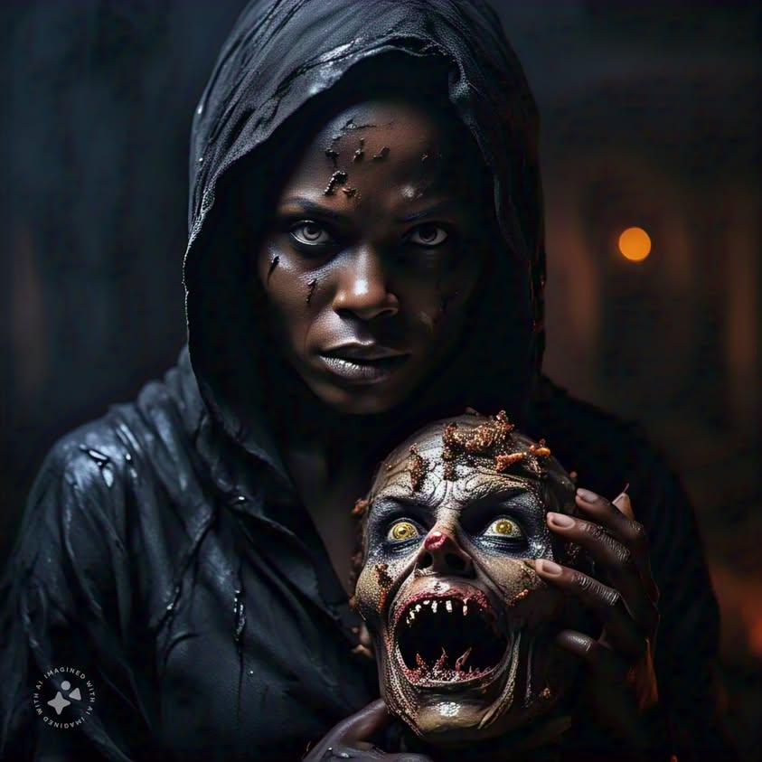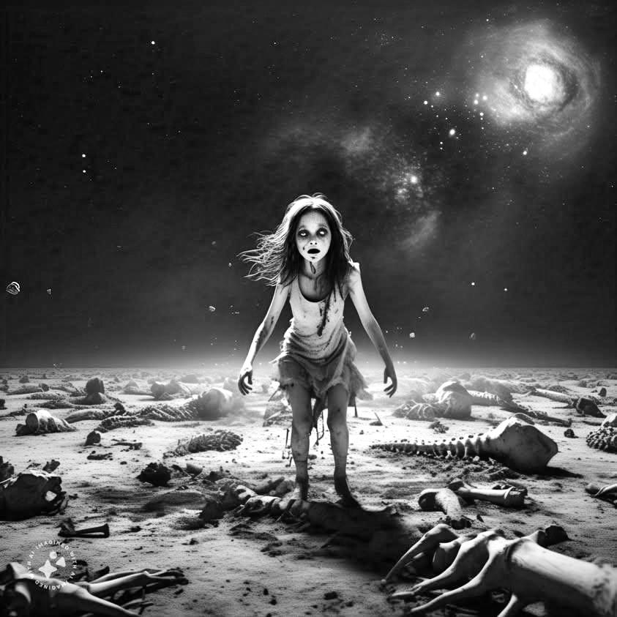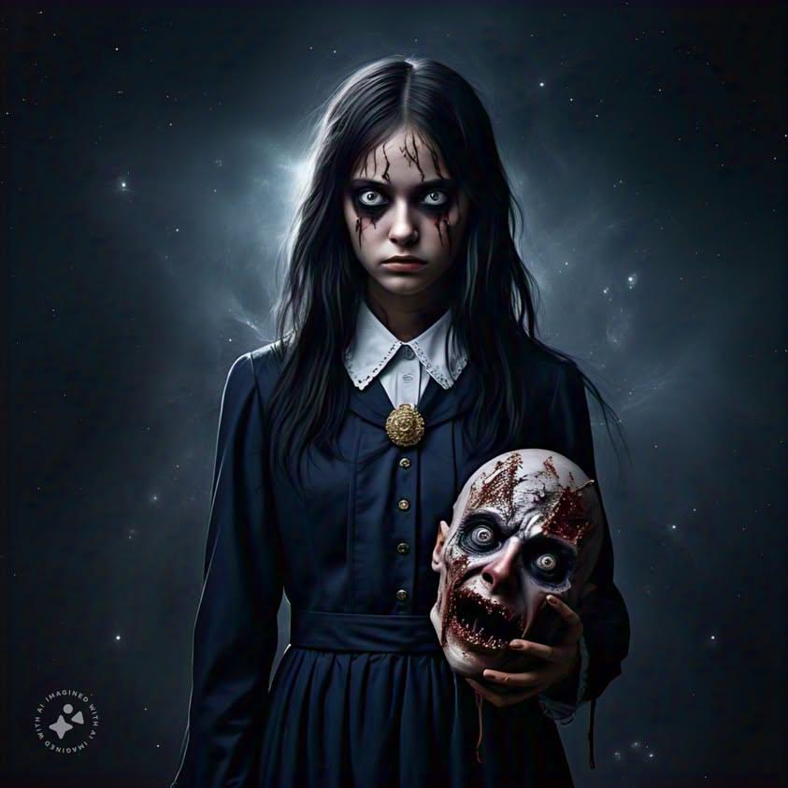

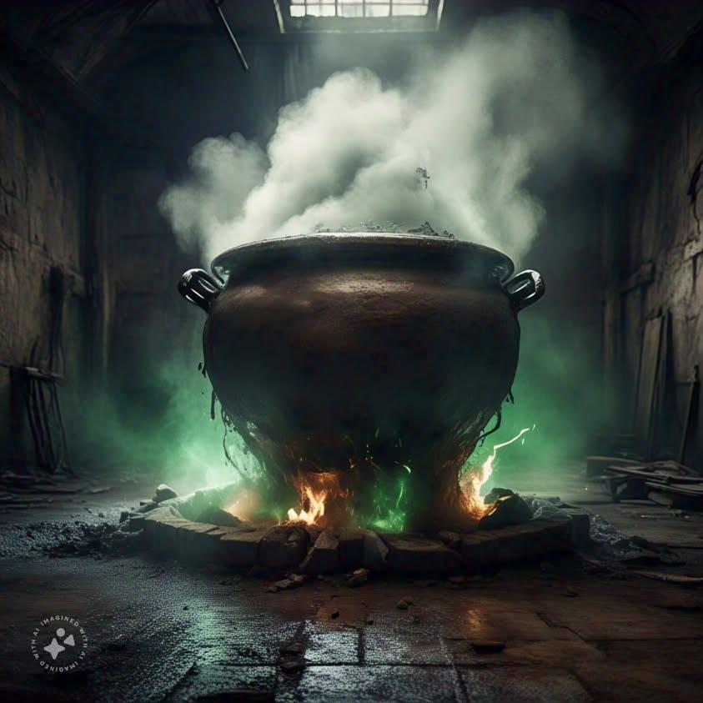

The pot in the room began to bubble, violently now, shaking the very floor beneath you. It wasn’t water inside it

Couldn’t be. The liquid was too thick, too black, and as it boiled, things began to rise to the surface. A hand. A tongue.

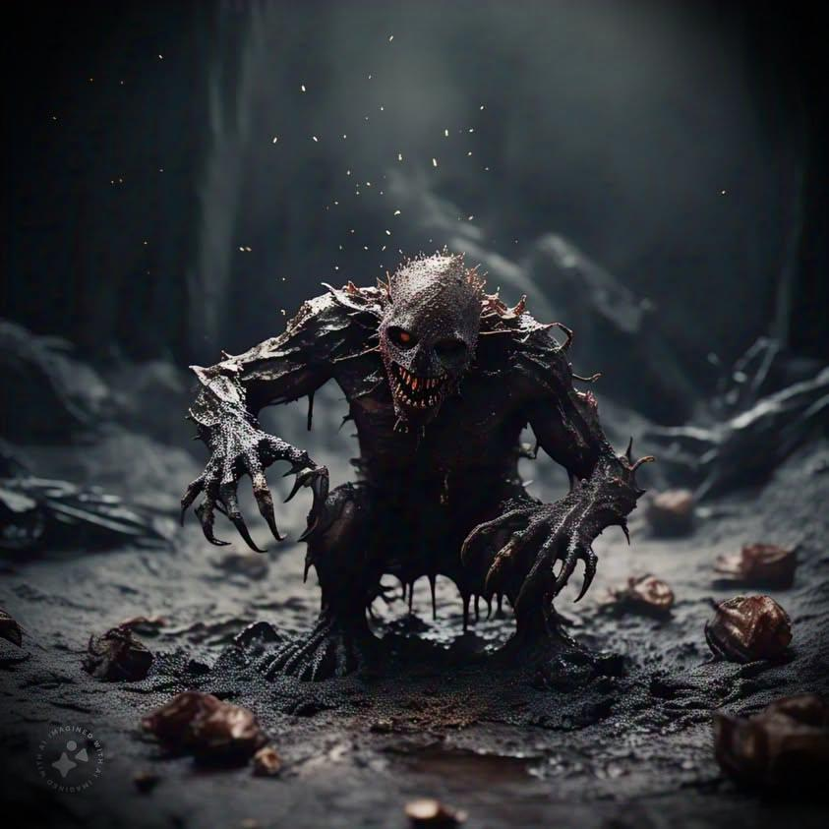Something unrecognizable but twitching. The smell hit you then-a combination of sulphur, charred meat, and decay. It

Clawed at your lungs, forcing bile up your throat.

The house began to groan, its walls stretching like something inside was trying to get out. You could hear

Now-whispers, but layered, overlapping, dozens of voices all speaking at once. You couldn’t make out the words at

First, but as they grew louder, they became clearer.

They were calling your name.

From the walls, shapes began to emerge. First shadows, long and twisting, then figures-faceless, towering, their

Bodies made of mouths. Endless mouths filled with jagged teeth, gnashing at the air, dripping saliva that hissed when

It hit the floor. They didn’t move toward you. They didn’t need to. Their presence alone was enough to crush you, to

Make every breath feel like your last.

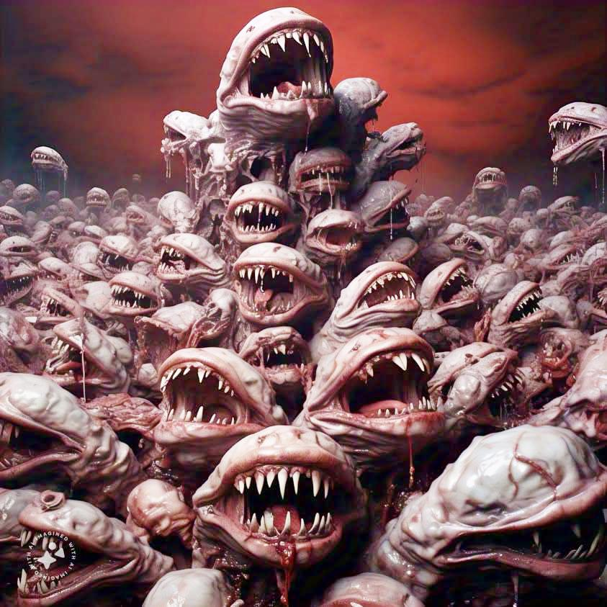

And then the face in your hand started to *laugh.*

It wasn’t a sound. It was a vibration, a feeling that travelled up your arm and lodged itself in your skull. The laugh

Grew louder, splitting into different tones, like a choir of the damned mocking you. The blood crawling up your skin

Burned now, eating into your flesh, but you couldn’t drop it. Your hand wouldn’t obey. The face’s mouth stretched

Wider, tearing at the corners, spilling more maggots and bile as it spoke:

*You thought this was for you? No. *You are for it.*”

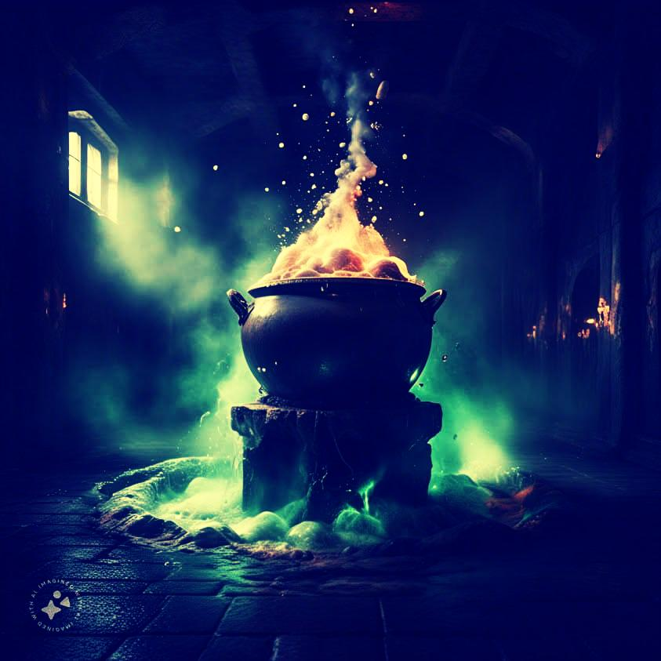

The pot erupted, spraying boiling black tar across the room. It didn’t burn the walls, but it burned *you.* Your skin

Blistered, peeled, but before you could scream, the thing inside the pot rose. It wasn’t human. It wasn’t even a

Creature. It was a nightmare given form, an abomination your mind refused to comprehend. Its body twisted endlessly,

Shifting from one horror to another-hundreds of eyes blinked at you, each filled with hatred; limbs bent and snapped,

Forming new ones; mouths opened across its body, all whispering, screaming, laughing.

But its face-its face was your own.

The thing stepped forward, its shadow alone freezing the blood in your veins. It didn’t speak with its mouths. It spoke

With your own voice, from inside your head:

“Even the strongest demons bow before me. What will you do?”

The room began to collapse, but not into rubble. It folded inward, warping into a black hole of agony. You fell, the

Floor vanishing beneath you, and as you plunged into the abyss, the voices followed. The faces, the shadows, the

Mouths they all fell with you, screaming, tearing at each other, at you, at everything.

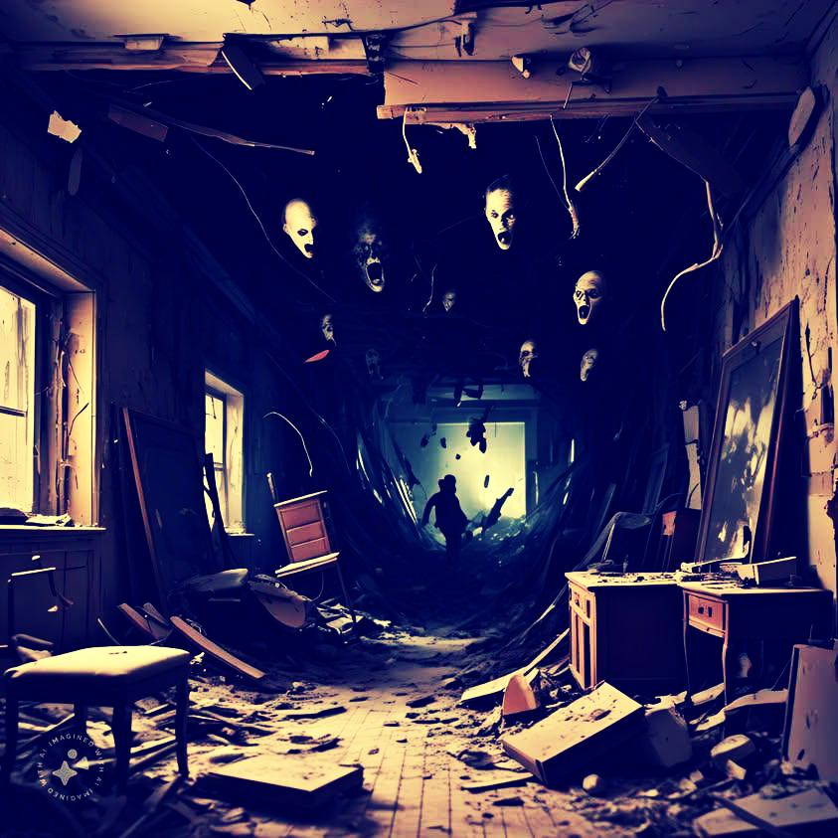

And then you saw it. The bottom. But it wasn’t ground. It was alive. Pulsing, writhing, stretching toward you with

Claws, teeth, and eyes. You tried to scream, but the air was gone. All that remained was the face in your hand,

Grinning so wide it tore itself in half. From its gaping maw came a whisper, so soft, so cruel, it froze your soul in

Place:

*You were mine before you were even born.”

The darkness consumed you, and you knew there was no waking from this.

........... THE LAUGH THAT HAUNTS SHADOWS

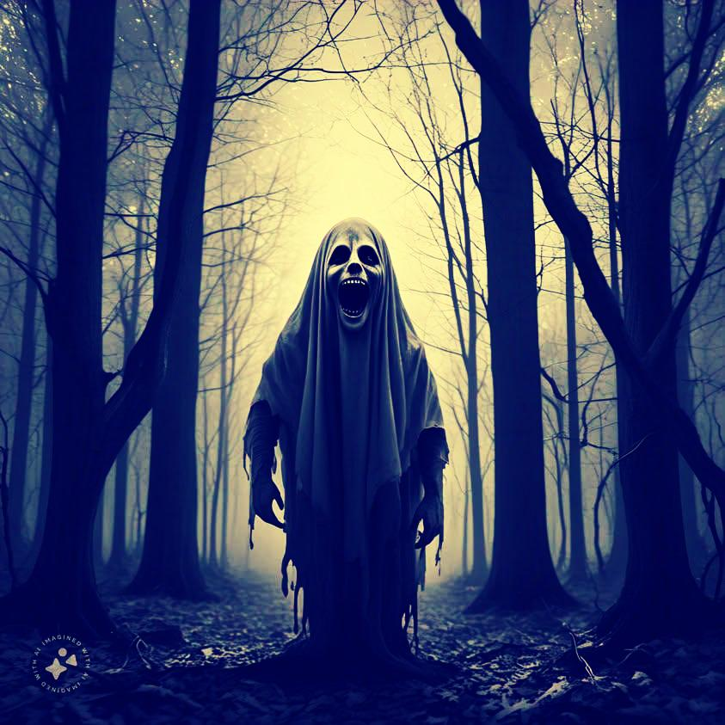

**The end.**