# **FIVE LI(V)ES**

**of poetry and things in between**

**RUCHIKA V COWLAGI**

**FIVE LI(V)ES of poetry and things in between**

Copyright © 2024 by Ruchika V Cowlagi.

All rights reserved.

No part of this book may be used or reproduced  
in any manner whatsoever without written permission  
from the author.

REACH Ruchika

countonlight@gmail.com

# **Content**

*LOVE*

* A Beautiful Realization
* Love is in the Air
* You & Me
* I Do
* Keep the Good Ones
* Little Does (S)He Know
* I Never Loved You

*GRIEF*

* (A) Part
* I’m Ok, You’re Ok?
* Let it Go
* My Special Doll
* A Sense of You
* Only a Pause
* Sail Away…

*WONDER*

* What Do You See?
* Equinox
* Ever-Changing Seasons
* Free as a Bird
* If I Were…
* Flow, Grow and Let Go
* True Nature

*BELONGING*

* Unspoken Words
* Take Heart
* Peace of Me
* I Will Hold You There
* Heart-to-Heart
* Of Love and Life
* Stranger Together

*TRUST*

* Crossroads
* Order, Order
* What’s the Point
* Me, We and Us Three
* Things in Between
* Now You See Me, Now You Don’t
* Believe

**For my Mother**

**Where it all started**

**Where I started**

**Mamma, I am because You are.**

# **How to Read This Book**

Reading poetry can be a deeply personal experience  
with the power to bring up emotions and profound thoughts within us. By exploring various ways of  
engaging with a poetry book, we can enrich  
our own personal interpretations.  
I offer some here -

* Read one poem from each topic at a time, allowing yourself to fully take in the themes and emotions presented before moving on to the next set of poems.
* Choose a specific topic that resonates with you and read all poems consecutively, allowing yourself to immerse deeply into that theme.
* Randomly select a poem from the collection and let it guide your reading experience, allowing you to explore different topics without any predetermined order.

# **\*LOVE\***

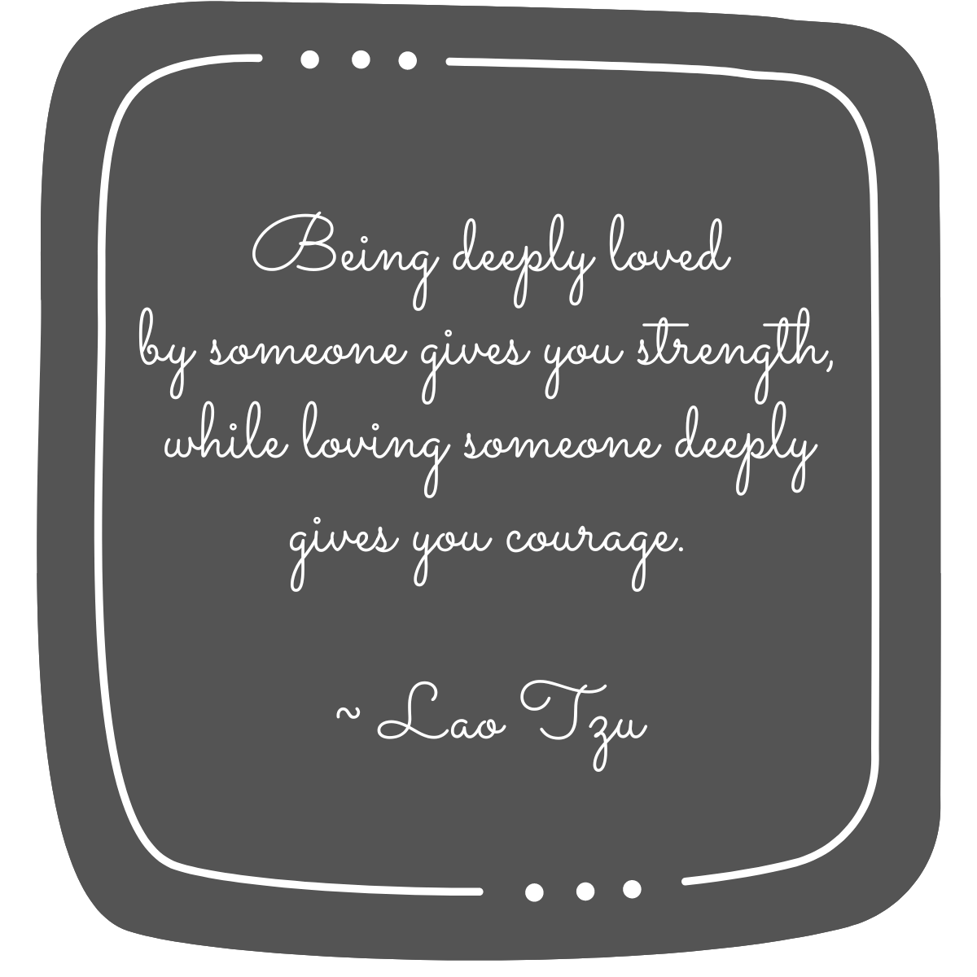

A Beautiful Realization

Should I tell her or should I not?

It is a fact that I love her a lot

With her short, sweet smile

She makes my heartbeat stop for a while

So delicate to touch, even a flower will dare

Her deep, dark eyes tell so much they care

She can understand everyone and all so well

Then why oh why to her, this I cannot tell

Always ready to help, she stands by my side

She takes care of me as a small little child

She may not be beautiful but surely has a charm

How secure I feel by the slightest touch of her arm

She listens to me patiently, my tensions all relieve

And asks me not to fear, but only believe

A ray of hope she gives to my shattered heart

I think I should…No…I’ll give it a start

I wish she was near, right here before me

Oh, there is a knock at the door: Who could it be?

Is this the truth or is it that I’m dreaming

She is right in front of me and her beautiful eyes are gleaming

Unlike other days she didn’t greet me as a friend

She came and sat near me; I felt the warmth of her hand

Time came to a stop and she conveyed through her eyes

That she too loved me; but it was I who did not realize…

Love is in the Air

I don’t know why

When I took a deep sigh

You looked at me as never before

That smile on your face, I could not have asked for more

It was not just a gesture

I knew it for sure

The eyes did not glitter

It was the heart which was pure

Your eyes spoke much more

Than what words could have said

With your serene face in mind

When I lied on my bed

I heard your lips singing

Slowly drifting me off to sleep

And I knew I was not alone

‘Cause I had your heart to keep.

You & Me

I always ask what you saw in me  
You say nothing…  
But your eyes answer that they are in love with me

I want you to tell me what you hear  
You hum anything…  
But listen to me with all your ears

I talk aimlessly hoping you will stop me for a while  
You don’t interrupt…  
But your lips part and break into a smile

I check with you what you think of my hair  
You don’t even look…  
But run your fingers through them to show you care

I try hard to get your attention with my charms  
You hardly compliment…  
But can make my knees weak by just the embrace of your arms

I don’t have to ever hide my flaw  
You never notice…  
But you show me how everything is full of awe

I think sometimes that if you never mind  
You are disinterested…  
But your actions tell me that it is better to be kind

With your kiss you can still make my heart race  
My heart, my soul is your forever special place  
But been there, done that is not your sham  
It’s real that you love me for all that I am.

I Do

Whoever said that marriage is fun  
Never told us that on days you want to run  
Run from yourself, from the world  
To figure out what’s happening, why everything is blurred

Whoever said that all days are great  
Never told us that on some we can’t even stand our mate  
Stand up or sit down, but move forward you must  
It’s only a matter of who does it first

Whoever said that only love is enough  
Never told us that at times giving respect and being patient is tough  
You may choose to close communication or give space  
But let it not linger too long and keep your grace

Whoever said that it’s going to be a fairy tale ride  
Never told us that sometimes you need to swallow your pride  
Cry, scream, be angry or bargain  
Till you don’t learn to shed your ego, it’s all in vain

Whoever said that all stories have a happy end  
Never told us that it depends on our capacity to bend  
Many days are bright but on others there is gloom  
It is your garden, so weed out regularly and it will bloom

I say it will not always be simple or easy  
And I tell you to let go so you can enjoy it when it’s breezy  
I do it because I am blessed to have you  
And no matter what, my answer will always be ‘I Do’.

Keep the Good Ones

I said what I said and you know it was not meant

Let us forget the past rather than repent

Don’t judge me by the words I say

But by the words unsaid in my eyes all day…

There have been times when I’ve wanted to share

And have stopped just so that you can show you care.

I did what I did as I had no other choice

So let us forget what happened and simply rejoice

Don’t judge me by my bigger actions

But by the small things I do to see your reactions…

There have been times when I’ve wanted to choose

And have stopped just so that you don’t lose.

I chose what I chose and maybe it was not right

Let us forget those issues and not fight

Don’t judge me by the things I do

But by the things undone when I cling to you…

There have been times when I’ve wanted to reject

And have stopped just so that you can select.

We are together because of our differences

What makes us stick are these small hindrances

I think if we reach a point when we don’t fight

We will never be able to make our hearts light…

‘Cause our silly ways are the ones which make us realize

That love heals all hearts without any price.

Little Does (S)He Know

If I could give you one thing my dear  
It would be the ability to see clear  
To see yourself clearly through my eyes  
And touch the beautiful soul underneath that lies

If I could tell you one thing my dear  
It would be to let go of the fear  
To keep your heart open even when you can’t find a reason  
‘Cause deep down you know this too will pass like a season

If I could show you one thing my dear  
It would be your strength to bring cheer  
In whatever you do with your innocence so pure  
That it could brighten the darkest of days for sure

If I could bring you one thing my dear  
It would be the peace that surrounds me when you are near  
No bygones beneath, no dreams above  
Just you and I with our ever-growing love

You tell me how we don’t need to do something special each year  
As we share something extraordinary only you and I know my dear  
How blessed, how complete every moment is with you  
Be me for a little and you will know it is true.

I Never Loved You

Is it because you don’t see  
or that I don’t show  
Without learning each other’s language  
How will we ever grow?  
  
Is it because you don’t feel  
or that I don’t care  
Without touching the depths of pain  
How will we ever share?  
  
Is it because you don’t speak  
or that I don’t hear  
Without exchanging meaningful glances  
How will we ever pass any year?  
  
Is it because you don’t include  
or that I don’t belong  
Without confronting difficult moments  
How will we ever make our relationship strong?  
  
Is it because you don’t know  
or that I don’t understand  
Without making the time or effort  
How will we ever let our hearts expand?  
  
Whether it is ‘because’ or it is ‘or that’  
The one thing I am sure of  
Is that I never loved you…  
Never because you loved me  
But because I love you  
And that is enough.

# **\*GRIEF\***

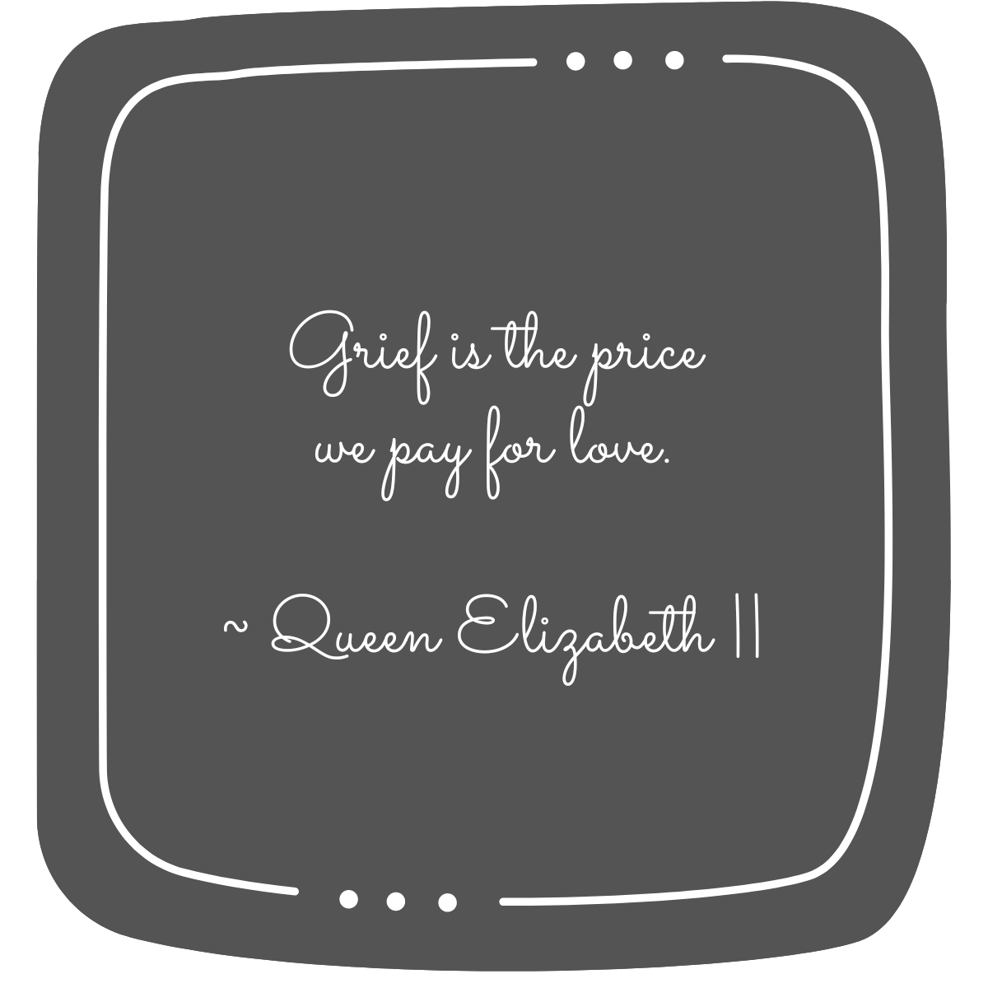

(A)_Part

You are the rhythm to my song  
Soothing the tunes that I get wrong

You are the words I write with ease  
As you caress my creases like a gentle breeze

You are the excitement in my voice  
Sieving through the rest which is just noise

You are the twinkle in my eye  
Making sure that I never have to cry

You are the reason that I smile  
The kind that lasts not just for a while

You are the love I understand  
In your ways that show how it is grand

Even though my heart misses a part  
A part of you is always in my heart

How beautiful you look even from afar  
I am and will always be because you are.

I’m Ok, You’re Ok?

Oh but she is already happy and strong  
Surely that’s because in her world nothing is wrong

Notice the bags under her eyes  
Pierce through her smile and you will see she cries

Take the time to hold her close  
Just do it long enough and you will feel her woes

Her anger is a mask to hide her tears  
Listen carefully and you will sense her fears

Tell her that it is ok to not be fine  
Understand her pain and you will hear her silent whine

Let her know that the fault is not on her part  
Attempt to comprehend and you will touch her heart

‘Cause her heart is enclosed in a tight shell  
As she struggles to protect it, heal and get well

She breathes today as if only to survive  
But dreams of being free and truly be alive

Her journey…her baggage, you say  
Forgetting that in yours she decided to stay  
With or without you is for you to choose  
But know that when she walks with love she will never lose.

Let it Go

I want to say a lot  
But cannot find the words  
The distance has become so long  
As if we have separate worlds

I want to let you know  
That I still do care  
Even though the wide gap  
Does not appear to be fair

I want to be able to  
Sit down with you and talk  
So that we can both heal  
And the memories no longer stalk

Whether or not this can happen  
Of this I can never be sure  
But I want to pray for us  
To be able to find a cure

Time mends everything I hear  
Which gives me hope that we will be near  
Till then I wish for your heart  
To never feel that we ever did part.

My Special Doll

I have a special doll and she is like none  
I loved holding her gently as she turned one.  
  
Her beautiful eyes and her smile oh so true  
Spoke to me without language as she turned two.  
  
Her ways of expressing were so refreshing and free  
I watched her grow magically as she turned three.  
  
She had her ways even as she was finding her core  
I was awed with her blossoming as she turned four.  
  
Some days she would shrink and on others she would thrive  
I saw her behave differently as she turned five.  
  
We would play and eat together whenever she was in a fix  
I started feeling a little older as she turned six.  
  
She enjoyed dancing and could make any gathering enliven  
I imagined how I could be like her as she turned seven.  
  
I loved the colourful and creative things she could create  
While I taught and learnt from her as she turned eight.  
  
My beautiful little princess was finding her own shine  
In everything she explored without me as she turned nine.  
  
She made new friends some of them just with pen  
I was happy to see her individuate as she turned ten.  
  
In her effervescence she had an innocent haven  
Which I had not experienced before she turned eleven.  
  
Her adventures grew and I saw her coming out of her shell  
I wished I had her contagious energy as she turned twelve.  
  
  
  
Then one day she hid herself in a place I have not seen  
I wanted to hold her again but this time tightly  
as she turned thirteen.  
  
I know you are well wherever you are  
You maybe distant but never too far  
So today when I think of your special day, instead of being blue  
I celebrate your full life my little doll  
as you would have turned forty two…

A Sense of You

It’s been long…  
A long time  
In which I have remembered you  
More than the time I knew you  
  
It’s been long…  
A long silence  
In which I have tried to hear you  
More than the voice that I knew only as you  
  
It’s been long…  
A long gap  
In which I have wanted to hug you  
More than the touch that I knew only as you  
  
It’s been long…  
A long hunger  
In which I have attempted to cook like you  
More than the times I ate the food made by you  
  
It’s been long…  
A long vacuum  
In which I have had the desire to smell like you  
More than the times I recall the fragrance only as you  
  
It’s been long…  
A long wait  
In which I have longed to see you  
More than the times I remember the face only as you  
  
It’s been long…  
A long time…without you  
In which I have held on to  
More than what I know only as a sense of you…

Only a Pause

You live in the corner of my smile  
Where it begins, ends or stays a while  
  
You live in the melody of my voice  
Reminding me to use my words as a choice  
  
You live in the rhythm of my breath  
Each one a gift of bridging life and death  
  
You live in the twinkle of my eyes  
Which always search for you in the starry skies  
  
You live in the softness of my skin  
Touching it makes me wonder how you have been  
  
You live in the flow of my blood  
Making my heart pound and feel the flood  
  
You live in the centre of my every cell  
And yet it is not so easy for me to tell  
  
That there are days that I still fear  
And nothing consoles me as I want you near  
That there are moments that I still feel lost  
And nothing makes sense in the freeze and frost  
That sometimes nothing still feels complete and fair  
And it is not enough just knowing you are always there  
  
With each beat, my heart withers and flowers  
Knowing we will be together again beyond space and hours  
Till then I want you and I to know that I am well  
The distance and time is only a pause; not a farewell.

Sail Away…

It’s been many years  
Some with smiles, some tears

Holding on too long  
Not knowing what could go wrong

If I loosened my grip  
What if it will cause me to trip

Will I know how to stand  
Without your support as I land

My feet on the ground  
That shook me when I found

You too are tired and need rest  
So letting go may be best

Sail away Mamma  
I will see you when I come  
Till then, I love and carry you in my heart  
As I find myself and become

A little like you but also me  
Knowing that you will be happy to see

That it’s been many years  
With more smiles, only some tears…

# **\*WONDER\***

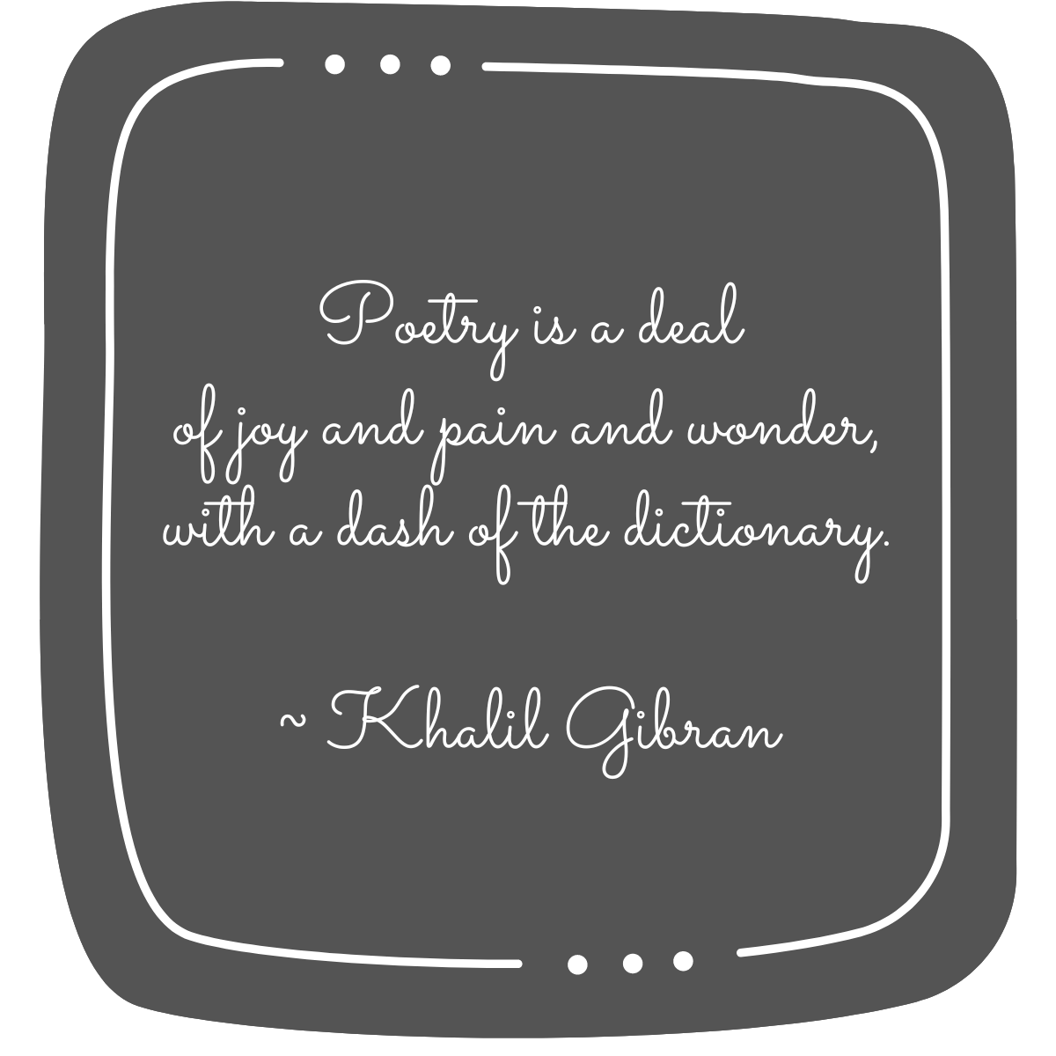

What Do You See?

There is an excitement in the air

I am happy as if I have no care

The sun comes each day to caress my cheeks

Its golden rays bring the brightness I seek

The wind whistles as if singing to me

Its humming creates an endless sea

The chirping of birds is music to my ears

It reminds me of my childhood years

The flowers they dance in their full bloom

Their colours, their fragrance fill up my room

 I can feel, I can smell

I can see and I can tell

That we are so self-engulfed, we forget to stare

And stop to see the beauty around us everywhere.

Equinox

Looking through the window, one fine dawn  
There was fog all around and lovely looked the lawn

The beautiful night, dressed in black, came to meet the day  
And all around her gown, the shining stars did play  
  
With slightly pinkish lips, the moon was her face  
She slowly moved through the clouds, but surely with a grace  
  
Hardly did she reach her beloved, when she stopped for a moment  
The wind blew, the flowers moved and scattered all their scent  
  
Nobody knows what she thought and why she ran away  
The day crept in slowly and waiting for her just lay  
  
The same thing repeated, though she loved him so much  
She came so close to him…yet was never close enough to touch  
  
The day, who too loved her, waited for her…but in vain  
They never met, but he never lost hope and just cried as the rain.

Ever-Changing Seasons

It is very difficult to understand human nature  
‘Cause it keeps on changing like the beautiful nature

Night after day and day after night  
Today if you have might, you are right

Happiness and sorrow, both in the same heart lie  
Like the changing colours of the same sky

The smiles and the frowns on the same little face  
Are like the leaves of spring, which in autumn are hard to trace

Sometimes we are on top of the world and want to do everything  
Just as all those beautiful birds which on the treetops sing

Like an unknown storm, anger comes in any day  
Destroys everything and we have nothing left to say

Tears roll down the eyes, both, in joy and in pain  
Like the curse and the boon of the waters of the rain

Like the birds and the bees, we too care and share  
And love and affection opens to us a world which is rare

In the same person are present, both evil and good  
As on the same earth, there is a barren land and a lush green wood

This ‘nature’ is such that it changes every ‘season’  
But why does all this happen not many of us can reason

Moments just come and they pass away  
Leaving good and bad memories for today

No one knows what will happen tomorrow to this lovely gift to us  
So accept life as it comes, wait for your reward and make no fuss.

Free as a Bird

The grey sky is blue  
This feeling I have is new

The sweetness of the air  
This wind in my hair  
  
The glow of the sun  
This day of mine will be fun

The stillness of the lake  
This fresh breath that I take  
  
The trees that rustle  
This need for me to not hustle

The swaying flowers bloom  
This spaciousness in my room  
  
I can fly, I can flow  
In my freedom to search and grow.

If I Were…

If I were the Ocean  
You may see the vastness I show  
But what is that I carry inside me  
With a calm that makes you grow  
  
If I were the Wind  
You may see the blowing through the space  
But what is that movement inside  
With a freedom that makes you race  
  
If I were the Sun  
You may see the brightness in my blink  
But what is that I hide behind  
With a memory that makes you think  
  
If I were the Moon  
You may see the phases in which I roll  
But what is that feeling in me  
With a beauty that stirs your soul  
  
If I were the Fire  
You may see the urgency in my way  
But what is that burns through me  
With a purity that you can pray  
  
If I were the Tree  
You may see the shade I give  
But what is that thing in me deep down  
With a support that makes you live  
  
If I were the Earth  
You may see where all you want to roam  
But what is that makes me go around  
With a place that you call home

Whether you may see me this way or not  
Is not why I am here  
It is only in your true experience of me  
That you can find me near  
  
Near or far is also not it  
As I can see you everywhere  
But in that hide and seek we play  
You may find a moment to spare  
To know what doesn’t let you see  
The truth that you and I are in everything we bear.

Flow, Grow and Let Go

As a new gardener  
Without a green thumb  
I couldn’t help but wonder  
From where does a plant growth come  
  
What is it that makes them survive  
How at times they naturally thrive  
And yet sometimes it needs an effort  
For them to simply revive  
  
The same environment  
The same care  
Then why does one flower  
And the other becomes bare  
  
Is it something in them  
That brings this about  
or the interaction with their surroundings  
That creates them to self doubt  
  
What if these plants were teaching us  
What we know but tend to forget  
That growth is a tango with ourself  
Giving us a chance to play the game we’ve set  
  
Maybe the plant knows better than us  
or probably remembers from where it came  
Whether it blooms or not it doesn’t fuss  
And comes and goes just the same  
  
Can we too let it come, let it go  
And be like the plant to let life flow.

True Nature

Don’t see the speed  
See the burning desire  
To clear everything in the way  
When I am a wild fire  
  
Don’t see the dust  
See the air thinned  
In the storm that is kicked up  
When I am a wild wind  
  
Don’t see the rush  
See the loud scream  
To carry everything in the flow  
When I am a wild stream  
  
Don’t see the quake  
See the big birth  
In the quivering shake  
When I am a wild earth  
  
Don’t see me as you perceive  
See me as you  
The clouds come and go  
But I remain the sky blue  
  
Unaffected by the weather  
The seasons and time  
For you and I are one  
No other truth is prime.

# **\*BELONGING\***

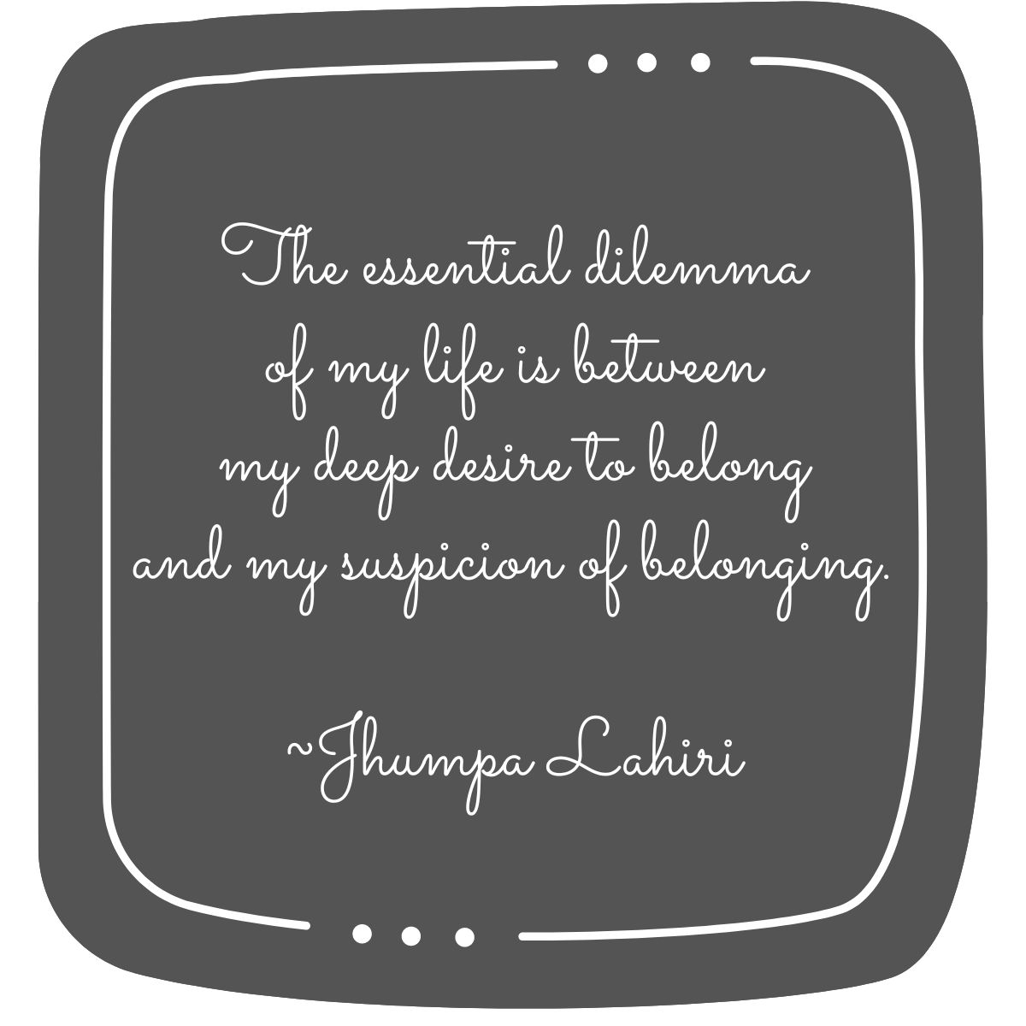

Unspoken Words

A time to meet  
Said the heartbeat  
But some promises broken  
Some unspoken words

A glance to exchange  
Be it awkward and strange  
But some promises broken  
Some unspoken words

A sigh let out  
With no sense of doubt  
But some promises broken  
Some unspoken words

A deep longing  
Isn’t this belonging  
But some promises broken  
Some unspoken words

A tear just fell  
From the eyes that tell  
of some promises broken  
Some unspoken words

A feeling so empty  
Brims up in plenty  
of what could have been  
But remains to be seen  
Till no promises are broken  
And the words are spoken.

Take Heart

There is a part of me that I don’t know anymore  
or could it be a part of me, I wasn’t sure  
Not just distant but it felt a lot more  
A part of me…that always seemed sore  
  
This part of me that I couldn’t find before  
Was hidden behind a keyless door  
The crevices on the wall loudly swore  
of the pain endured and the grief it bore  
  
I wondered what about it was that I adore  
Till I touched it gently and there was an outpour  
Revealing pieces of a puzzle brought to the fore  
Like coming together and yet missing a core  
  
For every tear you cried and every smile you wore  
You were growing and doing your best to get me ashore  
To this part of me who is finding the strength to explore –  
Take heart…I love you and together we will find the wings to soar.

Peace of Me

There came another one  
Flowing down my cheek  
Resting a bit on my lip  
And urging me to speak  
  
Though I have felt this before  
Similar, not the same  
This one came out faster  
Perhaps it was the added blame  
  
Without taking a breath  
I just stood still  
Conflicted like never before  
Till another one gave me a chill  
  
I moved a little  
As I opened my mouth slight  
To release the breath  
That I was holding tight  
  
Not knowing when I did it  
How it opened a barrage  
of words that pierced  
With a mismatched collage  
  
I relaxed my knees  
Even as my heart raced  
And took a deep sigh  
Staring at what was to be faced  
  
And yet another one came  
Between the crevices already wet  
The last of the few  
Before you and I met

No words could describe  
My struggle within  
With a part of myself  
The one I had not yet seen  
  
A deep look into your eyes  
Made me soften my brace  
And understanding you are one of my own  
My arms opened to your embrace  
  
And in that neutral space  
You and I came together  
A little old but also new  
As I pieced what I could gather  
  
It is not easy you know  
So I will keep this one to remind  
That each time I value you  
The more of myself I find.

I Will Hold You There

Even when you wake up not knowing where  
I will hold you there  
Like the wind that blows through your hair  
  
Even when you think it is not fair  
I will hold you there  
Like the faith that breathes through your prayer  
  
Even when you don’t understand the despair  
I will hold you there  
Like the hope in the smile that you wear  
  
Even when you feel the pain and scare  
I will hold you there  
Like the comfort that each breath brings to share  
  
Even when you struggle to find anyone to care  
I will hold you there  
Like the silent partner that surfaces when you are aware  
  
Even when you let go of what you want to repair  
I will hold you there  
Like the pearl in the ocean that is so rare  
  
Even when you hurt with the heavy burden you bear  
Dear heart…I will hold you there  
Like the love that flows through the corners you spare  
I will hold you there…I will hold you there.

Heart-to-Heart

I have a small container  
That I fill with the little I make  
It’s a little tender  
So I care that it doesn’t break  
  
I have a small hole  
That I patch with what I find  
It’s a little tattered  
So I care that it doesn’t wind  
  
I have a small picture  
That I scrub with what I brave  
It’s a little faded  
So I care that it doesn’t cave  
  
When I take this faded picture  
And patch the hole with it  
There’s more that I can make  
To fill the container bit by bit  
  
As the picture clears  
And the hole no longer shows  
The love fills the brim so near  
That the container overflows  
  
Ah the secret of how to make it  
As I now am getting to know  
The more I make and share it  
Allows my container to grow.

Of Love and Life

Sometimes I see you  
Sometimes I feel  
  
No matter how much time does pass  
No matter how much you heal  
  
What matters beyond and above  
Is that you remind me of how I love  
  
It’s true that you taught me to forgive  
But the truth is that you remind me of how I live  
  
There is more to it than just loss and strife  
In this great little story of love and life  
  
That you remind me of by far  
When sometimes I see you, sometimes I feel you my scar.

Stranger Together

There she stood in a corner  
As if alone…as if a goner

No words to speak, no reason to smile  
For me to even notice she is there…took a while

Whether she belonged here or was only there  
Oblivious to the world…which did not care

I couldn’t take my eyes off this stranger in the crowd  
It felt like I knew her…my thoughts became loud

A deep breath I took in and moved towards her  
With focused attention…everything around was blur

She hesitated as I tried to move near  
Was it mistrust…or simply fear

I felt the urge to hold her close and ask  
As this is not really her…she can now drop the mask

She did not even look up but made it very clear  
What took me so long…to finally appear

We met each other for the first time, together  
Gathering our pieces…as gently as a feather

As we came closer, she leaned on me and found her feet  
While I cried and sighed…to see us complete

The lost child in me, she was no other  
Trying to find in me…her missing mother.

# **\*TRUST\***

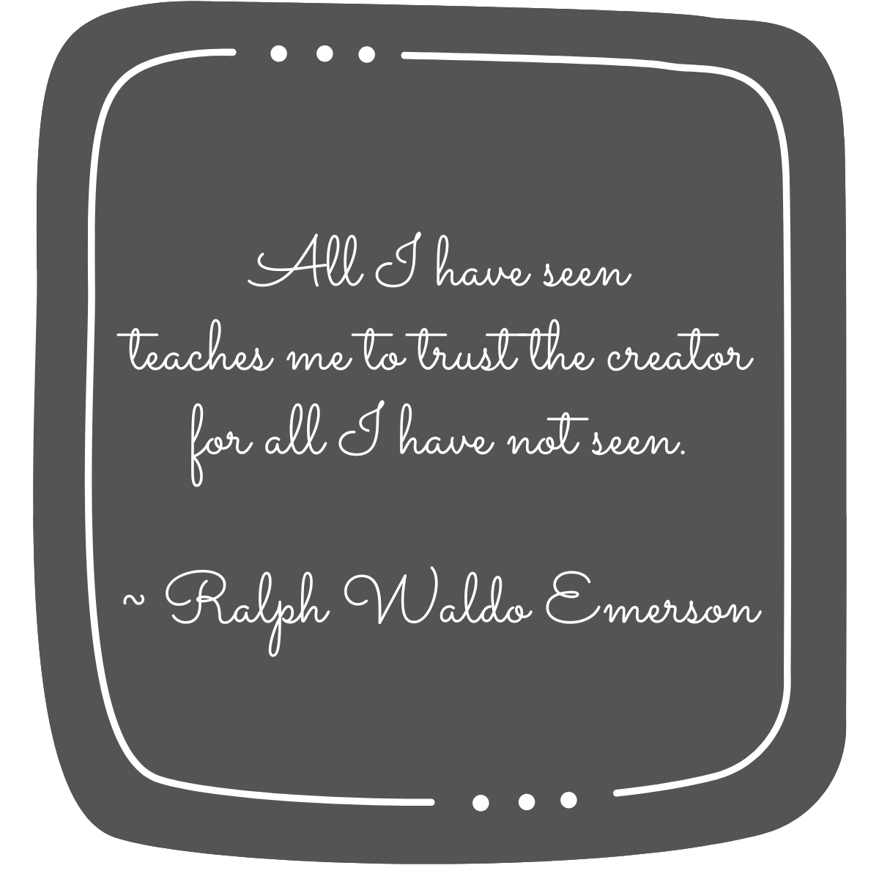

Crossroads

On the crossroads of my life, I met an old man  
I had walked many a miles, he knew it from my tan

I don’t know what made me stop and look into his eyes  
He smiled at me and spoke gently…his words were surely wise:

“There will always be two roads for you to decide  
One will be short and narrow, the other long and wide  
The short road that seems soft and green  
Has only thorns to spare  
While the long road, though exhausting  
Has all the flowers to bear  
Though you may reach early by the short path  
You will remain regretful and full of wrath  
If you take the long road, you will surely be left behind  
But in the end, you will be happy and will have peace of mind.”

I listened carefully to whatever he said  
And before I realized, he vanished and I had begun to tread

Along the road which was long  
And I was already humming a song.

Order, Order

When you don’t know how it is  
or you don’t understand  
Just stop a while and judge me not

If you think you get it  
But you actually don’t  
Just hold your thought and judge me not

Different stories or many sides  
But if you don’t want to really find out  
Just watch your words and judge me not

When you haven’t walked my journey  
or even know the path  
Just step back a little and judge me not

If you have never felt my pain  
But react like it isn’t even there  
Just slow down your breath and judge me not

Things that may or may not have been  
But you have decided how they were  
Just open your eyes and judge me not

Understand that there is no gain in this game  
Perception of something doesn’t mean its the same  
So judge if you must but don’t forget to be kind  
‘Cause only one of them is possible…you will soon find.

What’s the Point?

We live, we die  
We love, we cry  
We try, we lose  
But to learn…we refuse  
‘Cause what is the point of it all?

We talk, we fail  
We smile, we wail  
We promise, we shake  
But instead of understanding…we break  
‘Cause what is the point of it all?

We remember, we hurt  
We see, we blurt  
We give, we take  
But the reasons to not forgive…we make  
‘Cause what is the point of it all?

If one of us falters, together we fall  
Is the point of it all…the point of it all.

Me, We and Us Three

They told me I was not understanding it  
Because my heart was closed  
But they did not understand  
The questions my heart never disclosed  
  
They told me I was being stuck  
Because I was choosing it somehow  
But they did not stick with  
The choices I honoured in my now  
  
They told me I was not ready  
Because I was not willing to change  
But they did not show readiness  
When I took my pieces back to rearrange   
  
They told me I was being complicated  
Because I was not trying hard enough  
But they did not simplify things  
When I reached out on days that were rough  
  
What they told me or not, is not the matter  
Because it is between us  
But my heart aches in places and pieces  
That I can’t change or reverse  
  
So I move ahead with this little secret I learnt –  
That in order to allow love to pass  
To me…and through me…  
I have to make space in its emptiness  
As my heart has room for us all to be free.

Things in Between

Between waiting for a moment  
And letting the moment pass  
Sometimes we forget to breathe…

Between remembering the past  
And planning for the future  
Sometimes we forget to live…

Between weaving big dreams  
And not being able to sleep  
Sometimes we forget to blink…

Between protecting our shell  
And craving to break free  
Sometimes we forget to grow…

Between words not spoken  
And tears not shed  
Sometimes we forget to be happy…

Between trying to hold on  
And wishing to let go  
Sometimes we forget to love…

Between all of this and more, I wonder how…  
Sometimes we forget that Happily Ever After is a series of Now.

Now You See Me, Now You Don’t

I looked and looked…but did not find  
And was almost convinced that I had lost my mind

Here, there, wherever I seeked  
I could not locate you; my heart just shrieked

The darkness engulfed me like an ambush  
As I tried again with a nudge and a push

I could see no longer, so silently wept  
You held my hand and besides me slowly crept

It took me a while before I could tell  
You were always within me, making sure I am well

You come to me whenever I need you  
I may feel you elude me, but you never do

My heart warmed up knowing you are there  
And nothing seemed bigger as I had Hope to care.

Believe

Would you believe me if I said  
That the sun won’t come up tomorrow…  
But believe me when I say  
That there will be an end to your sorrow

Would you believe me if I said  
That the wind will stop to blow…  
But believe me when I say  
That it’s just a bump, continue to flow

Would you believe me if I said  
That the flowers will no longer bloom…  
But believe me when I say  
That life is beautiful not just gloom

Would you believe me if I said  
That the waves will not reach the shore…  
But believe me when I say  
That our blessings are not less, but more

Would you believe me if I said  
That I promise you the stars…  
But believe me when I say  
That it will heal, leaving just the scars

Wounds may be many  
But every scar shows just  
How there is something  
More powerful than we trust

I know it is difficult to believe  
When tears are rolling down…  
But believe me when I say  
That there is an upside down to the frown.

# **About the Author**

One life lesson that I’ve learnt is to hold the identity lightly.

And yet, for the purpose of this book -

I’m a writer personally and a psychotherapist professionally.

Sharing some of my random scribblings with you through this first book. Hope that you enjoy reading them.

https://linktr.ee/reachruchika

# **Acknowledgments**

**Thanks for reading!**

While this book is a collection of selected poems  
from different experiences of my life,  
some may be relatable with yours.  
In that sense, we share a part of our heart  
with the words that flowed through me.

If you resonated with the book or any specific poem,  
please add a short review on Amazon and  
let me know what you thought.