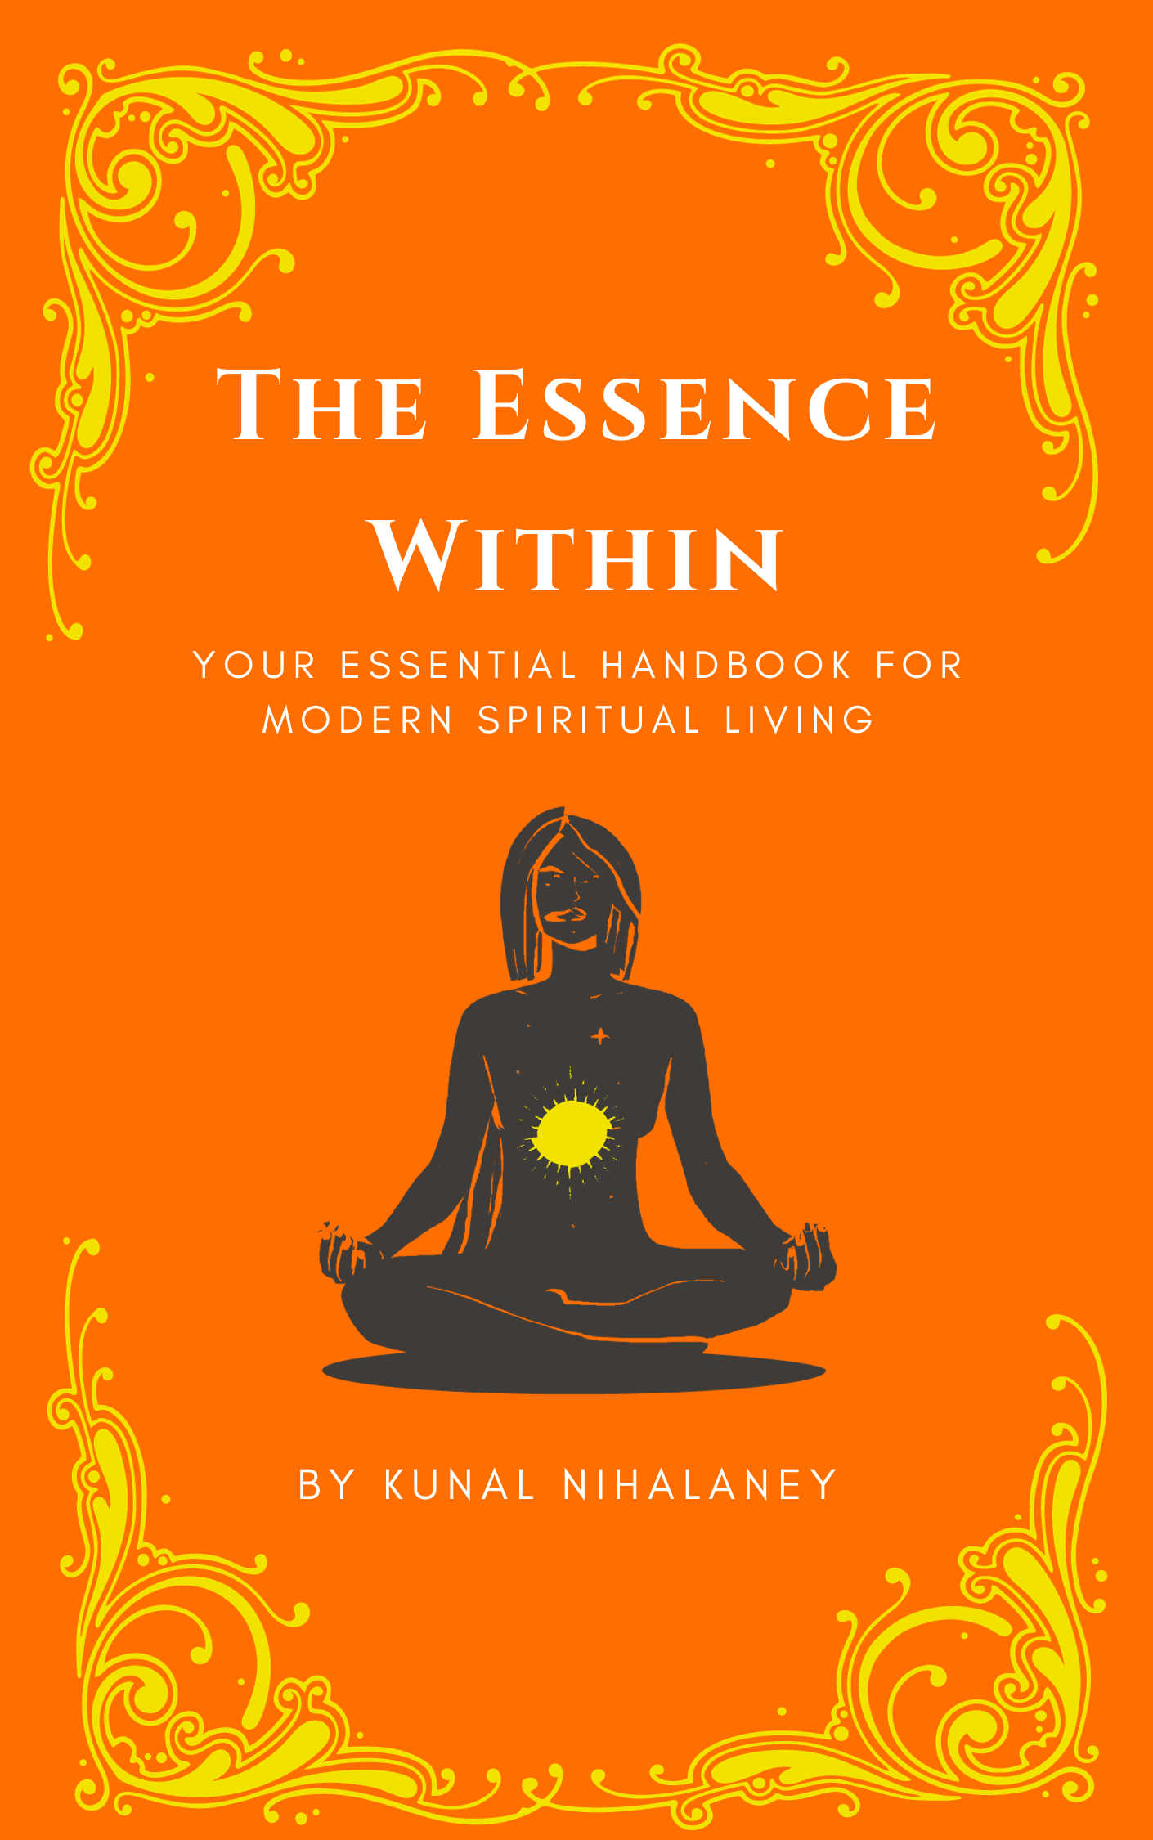

Table of Contents

Introduction 3

Chapter 1: Kill your spiritual ego 4

**Self-Awareness and Constant Reflection of One Self: Exercise 1** 5

# Introduction

Life can get pretty overwhelming, can't it? There's stress, constant deadlines, and this feeling like we're all on a never-ending journey without a clear destination. In the midst of this relentless rush, we often forget to pause, reflect, and connect with our inner selves.

That's precisely why I've crafted this spiritual handbook—because in the midst of life's chaos, we could all use a bit more calm, understanding, and a touch of spirituality to guide us. This handbook is not about escaping reality or retreating into a world of fantasy. It's about finding balance, grounding yourself in the present moment, and discovering the strength and wisdom that lie within.

Let's face it: depression rates are soaring, and it's no wonder. Social media bombards us with seemingly perfect lives, setting standards that leave us feeling demotivated and constantly comparing ourselves to others. It's a tough reality we're living in. We're constantly caught in a cycle of comparison, seeking validation from external sources rather than nurturing our own self-worth. This endless pursuit of external approval leaves us feeling drained, empty, and disconnected from our true selves.

But beyond the surface challenges, there's a deeper issue at play in our era—a spiritual dilemma. With a myriad of religions, it's easy to feel lost, grappling with questions about what to believe, what's right, and what's wrong. I've been there myself. I embarked on a personal exploration of each religion, uncovering beauty and discovering more similarities than differences. This book is a compilation of those beautiful teachings that have profoundly enriched my life. Instead of getting caught up in the differences, I focused on the common threads that bind us all together—the universal values of love, compassion, and empathy.

So, what's the main aim here? It's to help you find purpose in your life and unveil your true essence within. Once you connect with that inner core, you'll start discovering happiness and gratitude even in the smallest things. It's like building a mental fortress, equipping you to face life's challenges with resilience and ease. Consider this book your guide to not just surviving but thriving in the midst of life's unpredictable journey.

At the heart of every major religion lies the same fundamental quest: to connect with the divine, that universal force that transcends all human constructs. Different faiths have developed distinct pathways and practices for achieving this connection, but the underlying goal remains the same. Whether through meditation, prayer, or acts of service, the ultimate aim is to cultivate a deeper understanding of our place in the universe and foster a sense of oneness with all creation.

“God has no religions” – Mahatma Gandhi”

# Chapter 1: Kill your spiritual ego

In a world often marked by religious differences and disputes, where various faiths clash over their unique beliefs, it's crucial to shift our attention away from divisive labels and doctrines. True connection with the divine doesn't lie in outward expressions of religion but in delving into the profound depths of our own being.

Instead of getting entangled in debates about who's right or wrong in matters of faith, envision redirecting that energy towards exploring our individual consciousness. In doing so, we uncover something profound—a shared essence that binds us all, transcending the surface-level differences that often separate us.

This book doesn't oppose religion; rather, it seeks to shed light on the common wisdom found in major religions. It points us towards a shared destination—a place of peace, compassion, and unity. By emphasizing these universal principles, we can foster a broader understanding that goes beyond religious affiliations.

Unfortunately, our discussions about religion often lack a crucial change in perspective. People are quick to criticize without truly studying or understanding the profound teachings each faith offers. This rush to judgment fuels animosity, creating a world where individuals are judged based on their birthplace and religion. Do you believe that any form of God would take pride in such acts of judgement and hatred?

It's time to challenge this mindset. Instead of arming ourselves with preconceived notions ready for debate and unfair judgements, let's lead by example rather than mere words. Historical religious figures like Jesus Christ, Gautama Buddha, Lord Krishna, and Prophet Muhammad inspired through their actions, demonstrating that true influence comes from living in line with one's beliefs.

In our quest for a more harmonious world, let's strive to embody the teachings we hold dear. By doing so, we become sources of inspiration, showcasing the universal values that connect humanity. This change in perspective paves the way for a more compassionate and unified world, aligning more closely with the divine principles that underpin all faiths.

“You must have heard Love your neighbor and hate your enemy. But I tell you, love your enemies and pray for those who persecute you. If you only love those who love you, what reward will you get? Are not even the sinners doing that? And if you greet only your own people, what are you doing more than others? Do not even pagans do that? – Jesus Christ (Matthew 5:43-48)

The quote from Jesus Christ in Matthew 5:43-48 is one of my favorite quotes from the bible as it encapsulates a profound and transformative perspective on love and compassion. In this teaching, Jesus challenges conventional notions by urging his followers not only to love their neighbors but to go beyond and love their enemies, praying for those who persecute them. It's a radical call to a higher form of love—one that transcends personal affinities and extends to those who may cause harm or adversity.

Jesus acknowledges that loving those who love you is a common practice, even among those who may not adhere to a particular faith. However, the true depth of love, according to this teaching, lies in loving those who may not reciprocate, and even those who may actively oppose or persecute you.

This teaching challenges us to rise above the instinctual response of only loving those who share our values or treat us kindly. It invites us to embody a love that surpasses boundaries, reaching out even to those who might be considered adversaries. By doing so, Jesus suggests, we emulate a divine love, a love that mirrors the expansive and all-encompassing nature of God's love.

I find this teaching particularly impactful because it transcends the conventional understanding of love and challenges us to stretch beyond our comfort zones. It encourages a love that is not contingent on the actions or beliefs of others, but rather, is a reflection of our own commitment to a higher spiritual principle.

### **Self-Awareness and Constant Reflection of One Self: Exercise 1**

In our collective journey toward transcending the ego and fostering a more harmonious world, understanding the pivotal role of constant self-awareness and continuous reflection emerges as a transformative step.

I strongly encourage you to integrate a weekly practice of self-reflection into your routine, a dedicated time to understand the depths of your mind and identify lurking traces of the ego.

Take a pause, allowing your thoughts, beliefs, and actions to come into focus. Picture it as casting a spotlight into the concealed corners of your mind and heart. Engage in an open conversation with yourself, questioning whether your thoughts carry hints of superiority or a yearning for external validation. These inclinations, though common, often stem from the ego's desire to assert itself and maintain a sense of self-importance.

Next, delve into the realm of beliefs, the guiding compass of our spiritual path. Do your beliefs foster unity and understanding, or do they inadvertently create divisions, leading to a sense of superiority over those with different perspectives? Examining our beliefs in this light can be an illuminating experience, revealing the potential for ego-driven biases.

Then, shift your focus to behavior, the tangible manifestation of your inner world. Have you ever found yourself acting in a way that seems virtuous or spiritually enlightened, but upon deeper reflection, uncover an underlying desire to project an image of perfection or enlightenment? This exploration goes beyond superficial appearances, delving into the authenticity of our actions.

Often, individuals find themselves performing actions that, on the surface, appear virtuous or spiritually elevated. For example, someone might perform a charitable act, speak passionately about kindness, or engage in rigorous spiritual practices. However, the key question lies in the motivation behind these actions.

Is the motivation genuinely rooted in a desire to contribute positively to the world, or is there an underlying intention to be perceived as virtuous or spiritually advanced by others? In essence, this self-inquiry challenges us to examine the purity of our intentions, determining whether our actions stem from a sincere and humble place or are, perhaps subconsciously, influenced by a craving for external validation or the cultivation of a specific image.

As you navigate this introspective journey, recognizing instances where the ego takes the reins is crucial. However, this recognition is not an exercise in self-criticism; it is about shedding light on the idiosyncrasies and complexities of human nature. Self-awareness is not about uncovering faults to belittle ourselves; it is about understanding our motivations and behaviors, empowering us to cultivate positive change.

The journey of transcending the ego is an ongoing, evolutionary process, akin to breaking a coconut. The task may seem daunting, the outer shell seemingly impenetrable. Yet, with perseverance and determination, we can crack open this shell, revealing the sweet nectar of pure bliss within.

Top of Form

Bottom of Form



This symbolism aligns with Hindu traditions of breaking coconuts in various religious ceremonies, signifying the breaking down of ego barriers and the attainment of spiritual sweetness.

Remember, this process is not about achieving perfection or eradicating the ego entirely. Instead, it is about cultivating a deeper understanding of our inner selves, recognizing the ego's influence, and making conscious choices to align our thoughts, beliefs, and behaviors with the values of compassion, humility, and interconnectedness. As we progress on this path of self-awareness and continuous reflection, we open ourselves up to a more harmonious and enlightened existence.