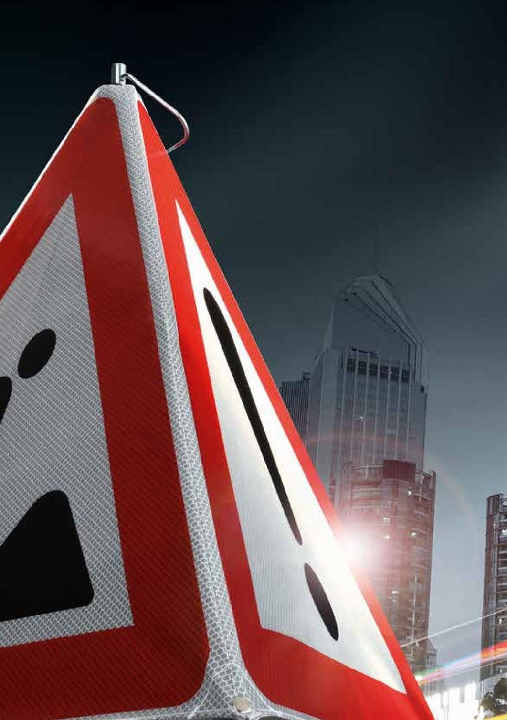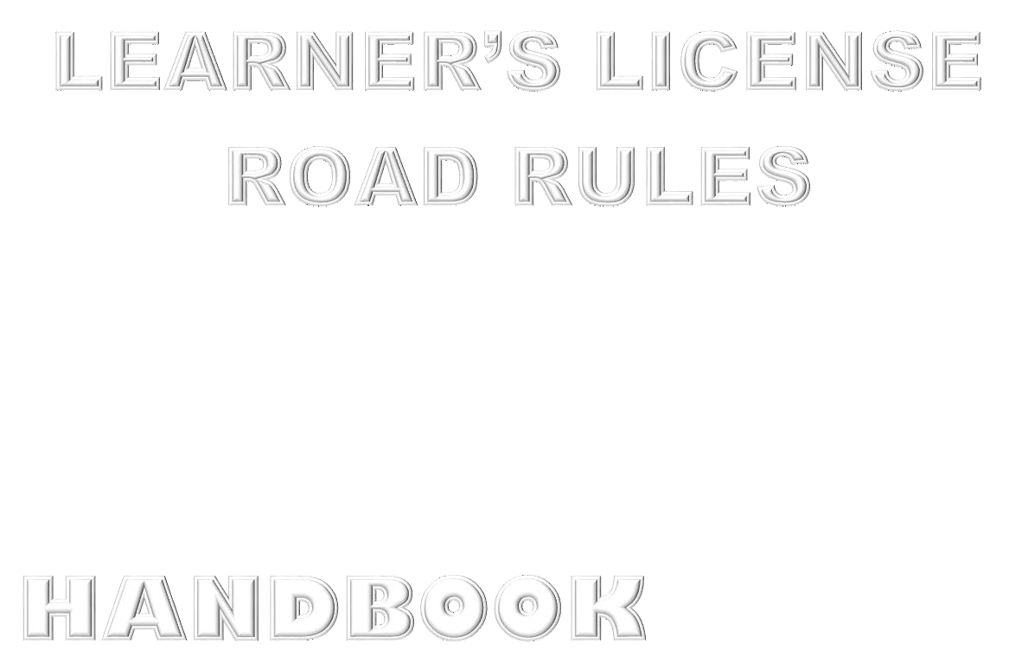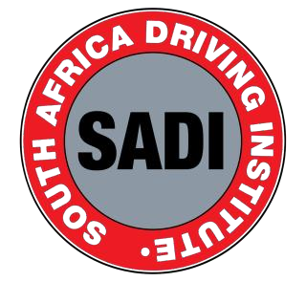

Motor vehicles are an important part of our day-to-day living and provide a means for people and goods to be transported from one location to another.

The goal of driver training is ensure that you, as the driver, are equipped with the right knowledge of how to handle your vehicle and how to act appropriately when using the road.

Most traffic accidents are caused by human error, however this can be easily prevented when the driver is adequately prepared for the traffic situation. This training also ensures that you are prepared with the necessary skills to provide safe and efficient transport services for goods and for passengers.

Trafic Signs and Signals

Trafic signs and signals are used to communicate on the road.

* There are two types of trafic signals; hand signals and light signals
* Trafic signs are used to guide, provide information and warn all road users.

Most signs fall within three broad categories although there are exceptions. These are

Triangle: Warning Rectangle: Informing Circle: Giving an order

Introduction 1

Licences pg1

Speed limits

Safe Following Distances pg2

Light & heavy motor vehicle 19

No Stopping or Parking Inside,

No parking areas: pg3



Vehicle Towing 27

right of way applicable overtaking on your left hand side

Learner’s license holder 28

pg4

not allowed to Overtaking 32

On a Freeway 39

drive on Yellow Line 43

Collisions 46

may not be used on a public road- 49

Tyres Safety Check

Pg5

changing lanes 57

**Loads and Projections** 58

**Animalsonpublicroads** 62

**Vehicle safety belt**



**Pg6**

**Vehicle must be equipped with exhaust silencer Intersections known as Junctions**

**Vehicle’s Hooter**

**Every light and heavy motor vehicle Emergences**

**Using the gears**



|  |  |
| --- | --- |
| **Equipment** | **Function** |
| Reflector Triangle | All motor vehicles (excluding motorcycles) should have theseat all times. The reflector should be used when the motorvehicle for any given reason stops on the road. These should be placed 60 metres ahead and 60 metres behind a disabled vehicle. |
| First aid kit | A fully equipped first aid kit should have the following items - gauze dressings, triangular bandages, rolled bandages, safety pins, disposable sterile gloves, tweezers, scissors, alcohol-free cleansing wipes, sticky tape, antiseptic cream, painkillers such as paracetamol, antihistamine tablets, distilled water for cleaning wounds, eye wash and eye bath |
| Tools Box | Tools such as a jack and spanner can be used to do minimal repair when the vehicle is disabled. |
| Fire Extinguisher | This enables the motorist to deal with fire emergencies. Ensurethat the fire extinguisher is inspected regularly to ensure that it isgood working condition. |
| Fire Axe | In the event of a fire, the fire axe is a handy tool to rescue passengers. |

|  |  |
| --- | --- |
| **Equipment** | **Function** |
| Tow ropes | This rope is reinforced to handle the weight of the car and canbe used to tow vehicles in case of a breakdown. |
| Spare tyre | It is important to have an inflated spare tyre and restore thedeflated tyre back as soon as possible  This tyre should be inflated |
| Jumpstart Cable | The jumpstart cable is used to reignite the engine. |
| Survival Gear | This is particularly important for motorists operating in places with extreme conditions such as extreme cold, extreme heat andrough terrain that is likely to damage the car. Survival gear mayinclude blankets, a torch, a small supply food and water. |



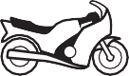

**Learner’s license codes & Motor vehicles**

**Motorcycles** If you are under the age of 18, you may only ride a motorcycle with a cylinder capacity not exceeding **125 cubic centimeters**

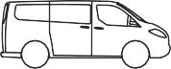



**Light Motor Vehicles** Vehicle Mass shall not be more than **3500 kg.**





**Passenger Vehicle (Bus & Minibus)** . vehicles **exceeds 3500 kilograms. **





**Heavy Motor Vehicle** shall apply in respect to- • a goods vehicle with a **GVM of more than 9000 kilograms;**

|  |  |
| --- | --- |
| **South African Speed limits** |  |
| shall apply in respect of every public road situated  **within an urban area;** | **KM/H** |
| shall apply in respect of every public road **outside**  **an urban area;** | **KM/H** |
| shall apply in respect of every **freeway**. | **KM/H** |
| shall apply in respect of-   * **bus, and** • **a minibus** | **KM/H** |
| shall apply in respect to- • a goods vehicle with a  **GVM of more than 9000 kilograms**; | **KM/H** |

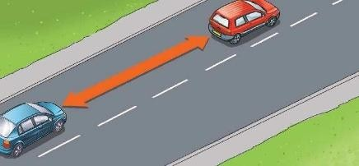

**Following another vehicle**

**Keep a Safe Following Distances**

Safe following distance for motorcycles 2 second rule Safe following distance for light motor vehicles 2 second rule

Safe following distance for heavy motor vehicles 3 second rule All distances should increase in bad light and weather so you stop without swerving

|  |  |
| --- | --- |
| **Light & heavy motor vehicle** |  |
| **Bright light** must emit a white light clear visible at a  distance of at least | 100 meters |
| **Dipped Beam** Must emit a white light clear visible  at a distance of at | 45 meters |
| * **Must be switched on from Sunset to Sunrise** * **When it rains and you can see a person or a vehicle**  * **When you can see 150m in front of you** |  |
| **Number Plate** Every letter and number must be  clear visible from a distance of | 20 meters |
| **Parking Lamps** A vehicle may not be driven on a public road with only the parking lamps lighted while such vehicle is in motion |  |
| **Fog Lamps** Must be used in condition of poor visibility  caused by | Snow, Smoke, Fog,  Mist and Dust |
| **Spot Lamp** |  |

|  |
| --- |
| **No Stopping or Parking Inside, On or Closer Than** |
| A pedestrian crossing 9 meters |
| Next to or opposite a vehicle where the road width 9 meters  is less than |
| A tunnel, subway, bridge or railway reserve 6 meters |
| Railway level crossing 6meters |

|  |
| --- |
| **No parking areas:** |
| An intersection 5meters |
| Fire hydrant 1,5meters |
| Road edge outside urban area 1meter |
| Pavement ( only to open a gate to get into yourproperty |
| You not allowed to park facing oncoming traffic |

|  |
| --- |
| **Vehicle Towing** |
| Maximum distance of towing between two vehicles 3.5M |
| Minimum distance of towing requiring a red flag to 1.8M  show the rope |
| Maximum speed towing permitted with rope or tractor with trailer and  passengers 30KM/H |
| No Passengers allowed in a vehicle that is being towed |
| You may carry passengers in a towing semi-trailer |

**When is right of way applicable**

When you within a traffic circle

When you have stopped first at a 4 way or 3 way stop

When traffic lights are not work, are to be treated as 4way stop At an intersection oncoming traffic have a right of way

**May overtaking on your left hand side**

When a vehicle in front of you indicates that is going turn right When the road has two lanes for both in the same direction

|  |
| --- |
| When a traffic offer order you to do so |
| **Only have learners license** |
| There must be someone with you in a vehicle with the same driving license |
| Driving on a freeway is prohibited. Unless you are companied by a license  driver for the same vehicle class |
| Transporting passenger is prohibited |
| Learners license is valid for 24 months |
| Validity for clearance certificate (license disc) 12 Months |



|  |
| --- |
| **You not allowed to Overtaking** |
| On a white solid line |
| At an Intersection |
| On a Curve |
| On top of the hill |
| When you cannot see a person or vehicle 100 meters in front  Of you due to poor visibility |

 No vehicle drawn by an animal; No pedal cycle

**Driving on a Freeway**

No pedestrians

|  |
| --- |
| No stopping or parking unless traffic officer orders you to do so |
| **When to drive on yellow Line** |
| In daytime when you want other vehicle to pass you |
| When you have a flat tire. |
| When a traffic office orders you to do so |

**A heavy motor vehicle may not be used on a public road-**

if the fuel tank is not fitted with an effective cap;

unless the electrical wiring and battery are properly installed, insulated and maintained so that such wiring and battery do not constitute a source of danger

No person shall operate on a public road a vehicle in such a manner as to cause any excessive noise.

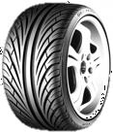

# Tyres Safety Check

Check the tyre pressure

Ensure you have a spare tyre that is in good condition  Ensure that tyre treads are in good condition

Ensure that tyre treads are not less than 1mm in depth





**You** must see if anyone has been killed or injured.

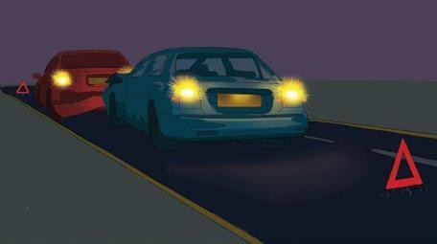

**SET UP THE REFLECTOR TRIANGLES 45M BEHIND YOUR VEHICLE**

**In an Accident or Dealing with an emergences**

**You** must report accidents to police within

**DO NOT** move injured people from their vehicles unless they are in danger from fire or explosion

**You** should always stop and offer assistance where possible

0,05 grams per 100ml of blood or more

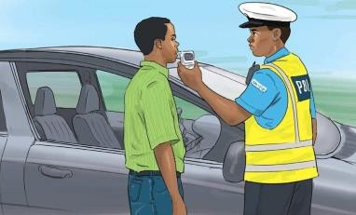

**Alcohol will affect your Ability to drive your vehicle**

**DO NOT DRINK AND DRIVE**

**Alcohol**

0,02 grams per 100ml of blood or more in a case of a professional driver

|  |
| --- |
|  |
| **First Aid on the road** |
| Someone with First Aid training can often prevent a victim’s condition from worsening and may save their life. The aims of having First Aid on the road to driver’s license holders are to: |
| **1st Preserve life** |
| **2nd Be prepared to give First Aid** |
| **3rd Prevent a casualty’s injury from getting any worse** |

 

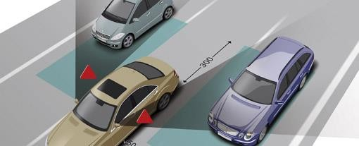

**BLIND SPOT**

**When changing lanes**

**1ST** you must switch on your indicators to indicate your direction

**2nd** You must check the rearview mirror vehicle behind you.

 **3rd** You must check the side mirror to ensure of any danger



|  |
| --- |
| **4th** Last action is to check the blind spot |
| **Loads and Projections** |
| Cars & Trucks: Goods may not extend in front of the vehicle for more than: 300mm |
| LMV/HMV: Goods may not be wider than: 2.5M |
| Cars & Trucks: Goods may not extend to the back of the vehicle for more  than 1.8M |

**Animalsonpublicroads**

The people controlling animals on a public road

 

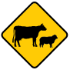

Must carry a warning at least 150m ahead of and beyond the herd as follows

**Sunset to sunrise: a red light**

**Sunrise to sunset**: a 300mm square red flag

If there are less than 10 animals only one light or flag is required

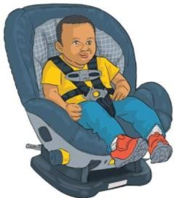

**Vehicle safety belt**

Seatbelts are compulsory to wear when in a moving vehicle. Children younger than 14 year must wear seatbelts

It’s not compulsory to wear seatbelt when reversing

The driver of a motor vehicle must ensure that a child seated on a seat with seatbelts



|  |
| --- |
| **Vehicle must be equipped with exhaust silencer, which must;** |
| Allow the exhaust gas from the engine to be projected  through such silencer; |
| Be in such a position that oil or other flammable liquid or material cannot  drip or fall onto it, |
| Be so maintained that exhaust gas or smoke does not leak into the driving  cab or passenger compartment of the vehicle. |



|  |
| --- |
| **Intersections known as Junctions** |
| Oncoming traffic have a right of way |
| Always yield to your oncoming traffic when turning right |
| Vehicle may overtake vehicle turning right at the intersection if there’s  enough space |
| you must also give way to pedestrians crossing the road that you’re turning  into. |

|  |
| --- |
| **Vehicle’s Hooter** |
| No person shall use the hooter of a vehicle except on the grounds of safety. |
| Vehicle’s hooter must clearly audible by a person of normal hearing from a  distance of 90 metres. |
| Sirens or warning devices that play a tune may not be used in private vehicles |
| The tone of pitch of the sound may not change |

|  |
| --- |
| **Every light & heavy motor vehicle must be equipped with;** |
| A service break,  A parking brake,  An emergency brake. (Same as parking brake) |

|  |  |
| --- | --- |
| **Using the gears** |  |
| **1st Gear –**This gear is fortravelling between | 0 and 30 km/h |
| **2nd Gear –**It is also the ideal gear for moving downhill from  astationary position. | |
| **3rd Gear -** This is the appropriate gear for travelling between | 35 and 70 km/h |
| **4th Gear –** This is the appropriate gear for travelling between | 60 and 110 km/h |
| **5th Gear -** This is the appropriate gear for travelling  between | 80 and 110 km/h. |

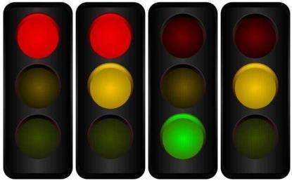A B C D

A: RED means STOP

B: RED and AMBER also mean STOP C: GREEN means you may go

D: AMBER means be ready to stop

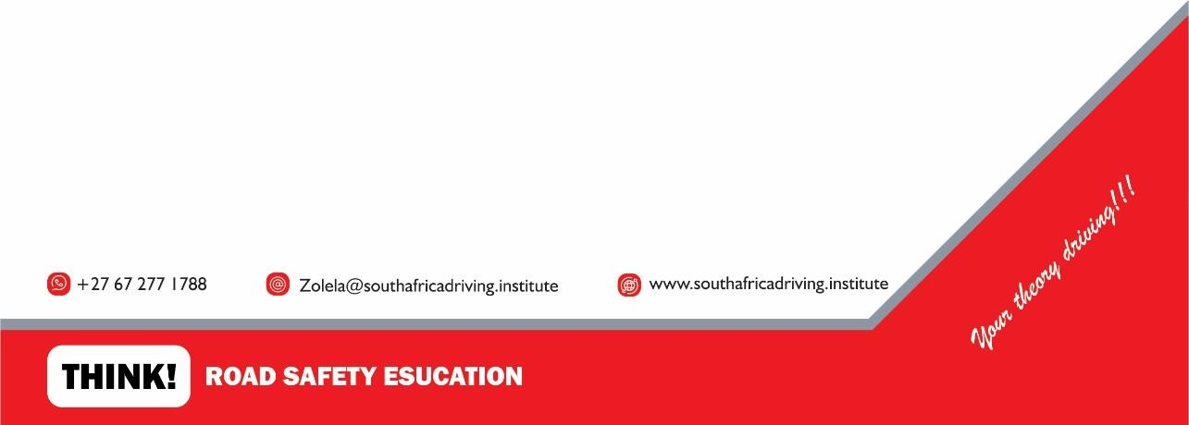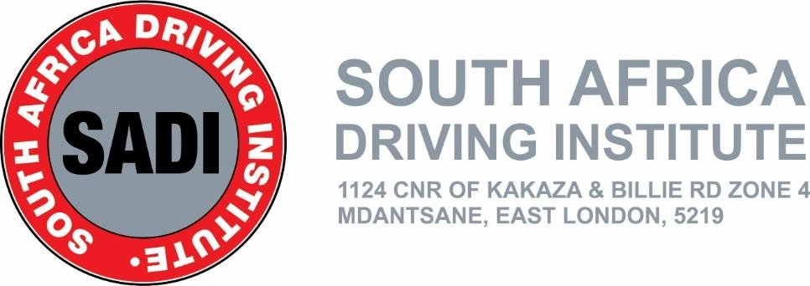

LL Training Manual number 09/24

Disclaimer

While all care is taken in producing this work, no responsibility is taken or warranty made with respect to the accuracy of any information, data or representation.

This work is not intended to substitute a reader’s reference to relevant laws and Transport for NSW expressly disclaims all liability in respect of the consequences of reliance on the contents of this work.

© South Africa Driving Institute (2024)

Users are not allowed to copy, reproduce and distribute extracts from this work as the copyright owner and the title of this work is referenced as the source.