# 

*“I LOVE YOU"*

GUNN ARORA

(BTS)

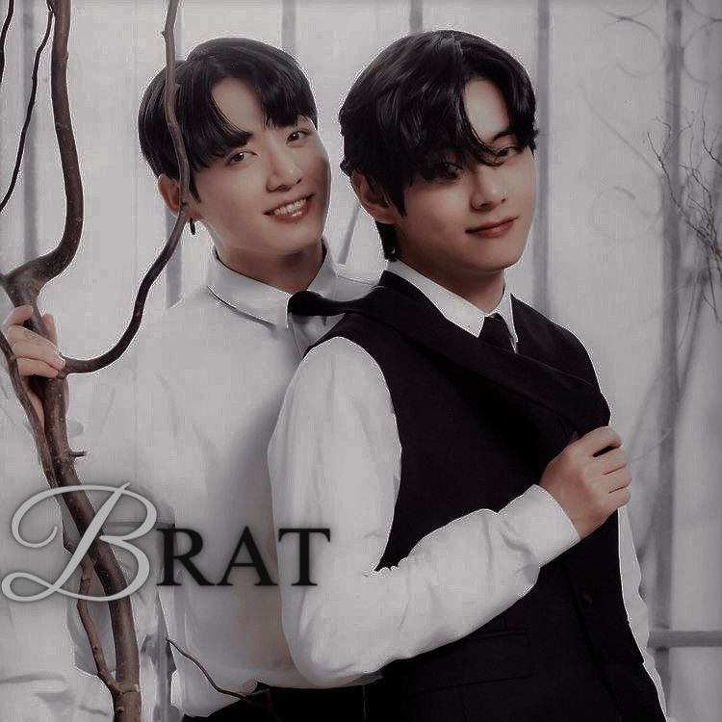



BRAT

Copyright © 2023 by Gunn Arora.

All rights reserved. Printed in India. No part of this book may be used or reproduced in any manner whatsoever without written permission except in the case of brief quotations em- bodied in critical articles or reviews.

This book is a work of fiction. Names, characters, businesses, organiza- tions, places, events and incidents either are the product of the author’s imagination or are used fictitiously. Any resemblance to actual persons, living or dead, events, or locales is entirely coincidental.

Contact Information :

<http://www.website.com>

Front Cover Design  by : Gunn Arora

Editor : Gunn Arora

Male Protagonist : Kim Taehyung AND Jeon Jungkook

Formatting Template : Derek Murphy

Author : Gunn Arora

ISBN: 123456789

First Edition: October 2023

10 9 8 7 6 5 4 3 2 1



”I LOVE YOU” is not a question that I need an answer for. It’s a statement. It ends there whether you say it back or not.

Dedicated to all delusional people out there.

CONTENTS

BRAT i

CHAPTER 1 ..X

# 

"Hello, my lovelies, how are you all doing? I guess you missed us a lot right? So guess what I'm here with a new prank today. And this is gonna be so fun".

Taehyung moves closer to the screen and whispers, "Today I'm going to sleep separately." He giggles, "I know you guys are shocked too. But look at my setup. I'm in the guest room now. And here I'm gonna do this and Jungkook will go crazy."

Taehyung moves closer and picks up the camera. He moves the lens to show the entire room. There is one small bed only.

"As you all know how much clingy Jungkook is and he can't stay one minute without me. And sleeping alone is next to impossible for

him. So this prank will blow his mind totally."

He winks. "So what you say, ain't it be fun, hmm?" He giggles, getting up from the bed. Taehyung holds the camera close and winks at it. He then puts the camera on the top of the closet and adjusts the angle so the entire room can be visible. He then goes to sit on the bed.

"So this is my bed and as you can see I have brought my blanket and pillow here already." Taehyung giggles, "So now I will sit here and

wait for Jungkook." he chuckles again, "I'm imagining his face already and it's making me laugh so much." He gathers the duvet and pulls it over him, covering his legs as he sits on the bed leaning against the headboard, smirking.

Just after a few minutes, slow footsteps approach and Jungkook's tired voice comes from the door, "Hyung where are you? Let's go to sleep." Jungkook enters the room yawning. He reaches for Taehyung on the bed, frowning. "Why are you sitting here at this hour? Let's go to sleep". Taehyung shrugs, "I will sleep here today. You go and sleep."

Jungkook frowns, "What? What is happening? Hyung it's too late and I'm sleepy. Please let's go." he almost begs. Taehyung picks up his phone and starts scrolling, ignoring the younger.

Jungkook keeps gazing at him for a while before he jolts on the bed beside Taehyung and buries his face into his lap. "Then I will also sleep here tonight. I won't sleep alone," he says groggily. Taehyung looks at him, biting back a smile. He then looks at the camera and smiles. "I didn't sleep properly for a few days. Please don't be a brat now and go to sleep," he says in a serious tone.

Jungkook peeks his head a little to look up at him. A visible pout on his lips. "Why are you doing this? Please let's go to our room." his voice cracks.

Taehyung arches a brow, "Because I said I will sleep here tonight. Why aren't you listening to me?" Jungkook hoists himself a bit on his elbow, still pouting, "Then I will sleep here with you too." Taehyung sighs, "But I don't want to sleep with you." Jungkook frowns.

"But why? What did I do?"

Taehyung shrugs, moving away a bit from him, "I just don't want to." Jungkook looks at him for some seconds and again lays back on his side, burying his face in the duvet. "But I want to sleep with you and I will sleep here. I won't sleep alone". Taehyung exhales, "Why are you not listening to me?" Jungkook groans, "Because you know I can't sleep without hugging you." He looks up again, pouting. "Hyung why are you doing this to me? Did I do anything wrong? Did I make you angry?" his voice cracks, eyes wet.

Jungkook sits on the bed crossing his legs. "You know I can't sleep without you. You know I can't even stay without you a minute. Then why? Don't you love me anymore?" he reaches for the elder's hands.

"You don't want to go there but I will stay here with you. I will sleep here." He lays on his chest again beside Taehyung and buries his face on the pillow. Taehyung looks at him for a second before looking up at the camera and biting back a smile. He then looks over his shoulder and says in a low voice, " I don't want to sleep with you Jungkook."

"But I want to. And I will sleep here with you." Jungkook murmurs. Taehyung smiles a bit. Winking at the camera. He clears his throat, "OK then I'm going to that room," he moves to get up but Jungkook stops him holding his thigh, "Don't come back if you go." he turns at his side again. Taehyung arches a brow looking at the camera.

A playful smirk in his lips. He slowly pulls the duvet to him and leans in, "You brat, really can't sleep without me hmm?" he whispers in Jungkook's ears. Jungkook doesn't answer. Taehyung let's out a chuckle. He turns Jungkook towards him, grabbing his shoulders, and making him face him. Jungkook is still pouting. But he looks away, turning his head at the side. Taehyung chuckles, leaning in and pressing a kiss on his jaw. "It was a prank baby. Oh my gosh look at this pout.". Jungkook still doesn't react, he keeps pouting and looking away. Taehyung cups his face, turning towards him. "Ohh, my baby is angry now?" he teases. Jungkook now looks at him, "What do you expect?" he murmurs. Taehyung laughs, "Shit! Look at you. Well you can punish me, Should I start by kissing away this pout?" he leans closer, whispering.

But Jungkook swats him, pulling away his face. Taehyung

holds his face again and this time he presses a kiss on his lips, "Oh my baby, you are looking like the angriest bunny. I can't resist myself kissing you breathless." Jungkook keeps sulking, fidgeting with his fingers. Taehyung giggles, pulling him closer, "Look over there, the camera. Our weekly episode is done and I won again."

Jungkook's eyes widen, "Hyung you were filming this? Why didn't you tell me?" He swats Taehyung and jumps from the bed, "I won't talk to you. I'm going to my room. You stay here. Bye." he steps towards the door but Taehyung stops him, grabbing his waist and pulling him onto the bed again.

"Well, you came here yourself but you can't go without my approval."

He hovers over his husband, kissing down his throat. "And also you can't sleep without hugging me. So no way." Jungkook still pushes him away. He gets up from the bed and storms out of the room, leaving Taehyung dumbfounded. Taehyung swallows, looking at the camera. "Was it too far?" he whispers. But before he says anything Jungkook rushes into the room and lifts him in his arms. "Even if you won the challenge but in the end I'm the winner. Now let's go to the bedroom and tonight I will show you the power of the double bunny."

Taehyung was stunned at first but then he managed himself. He wraps his arms around his husband immediately. "I am always ready to see that power, my love. More specifically, to enjoy that," he says,

nuzzling into Jungkook's ears. Jungkook arches a brow, "Ohh, are you ready Daddy?" Taehyung kisses his nose. "I'm always ready, love," he whispers looking at the camera and winking at it.