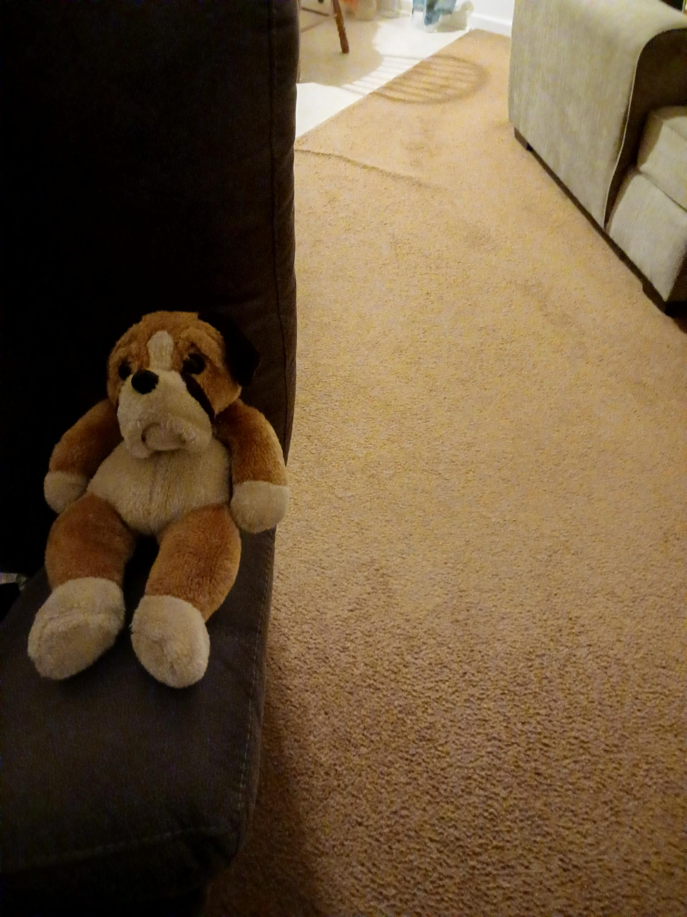

Rising Above

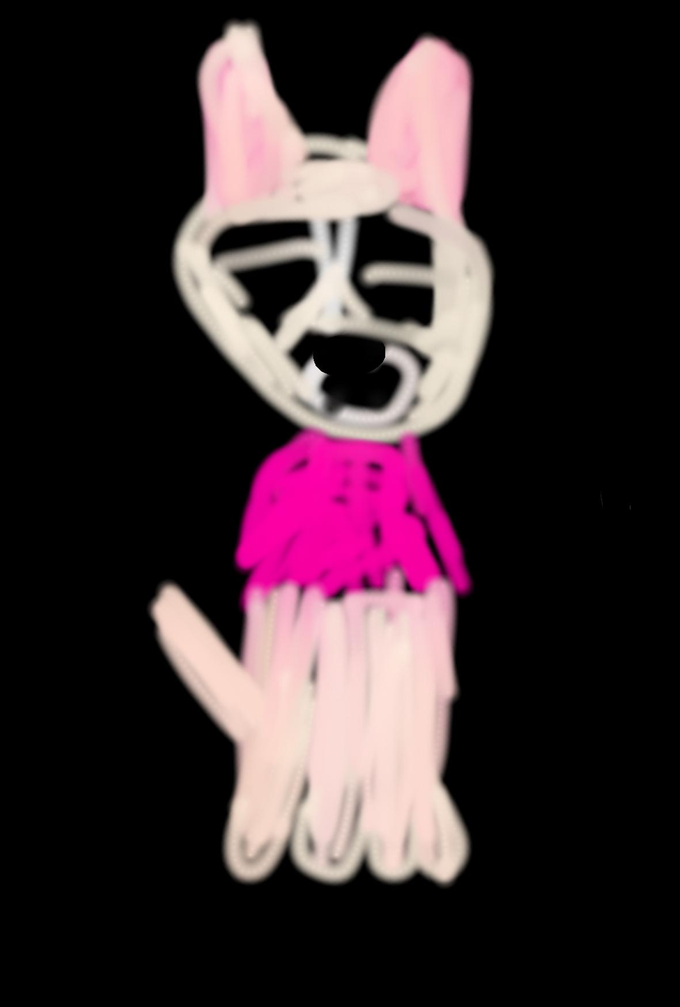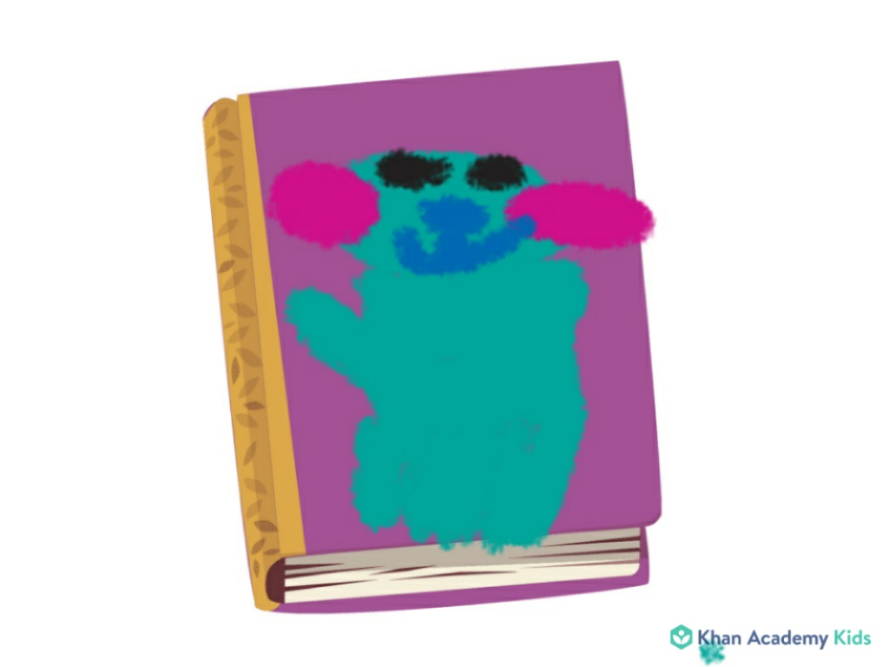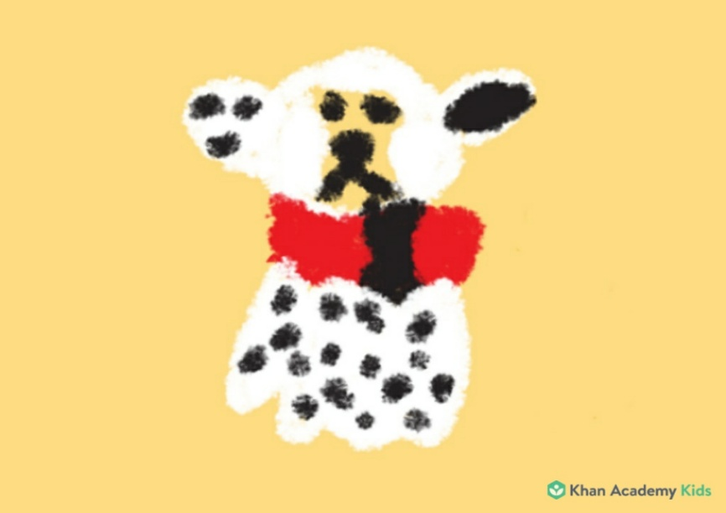What’s up, y'all? My name is Mugsy and these are our cousins, who have also been adopted by Uncle Ace:

Kookie, who was born in 2003;

Pico, who was born in 2007;

Hydrant, who was born in 2008.



This is Uncle Ace, who is our older cousin who has adopted us as his own offspring during our puppyhood.

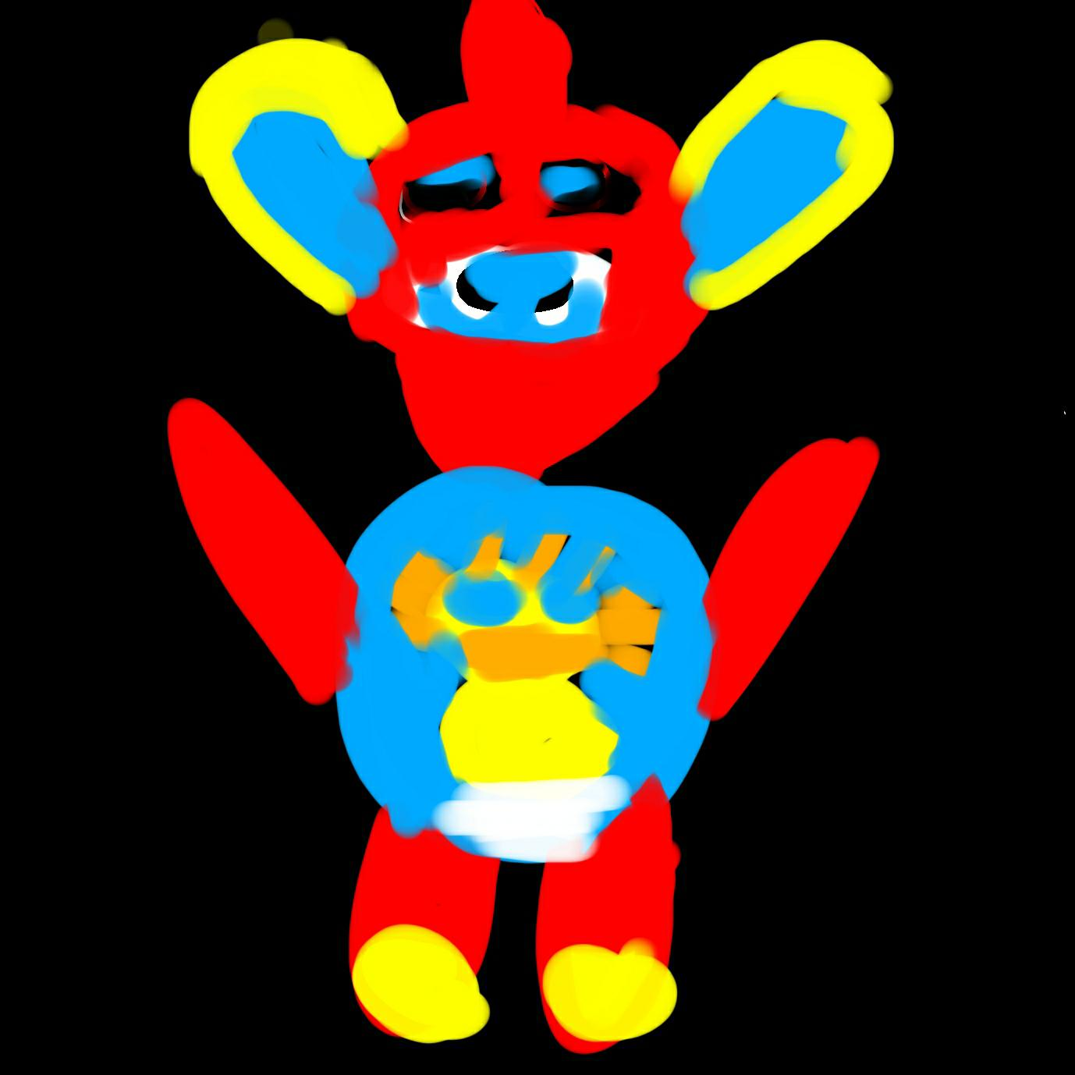

He is really like a father to us and he has adopted all of us because we have been bullied by our birth parents, who had been bullied by their own parents. In fact, they themselves had been bullied by their parents and this cycle of bullying goes all the way back to our ancestor

Morty the Miacis.

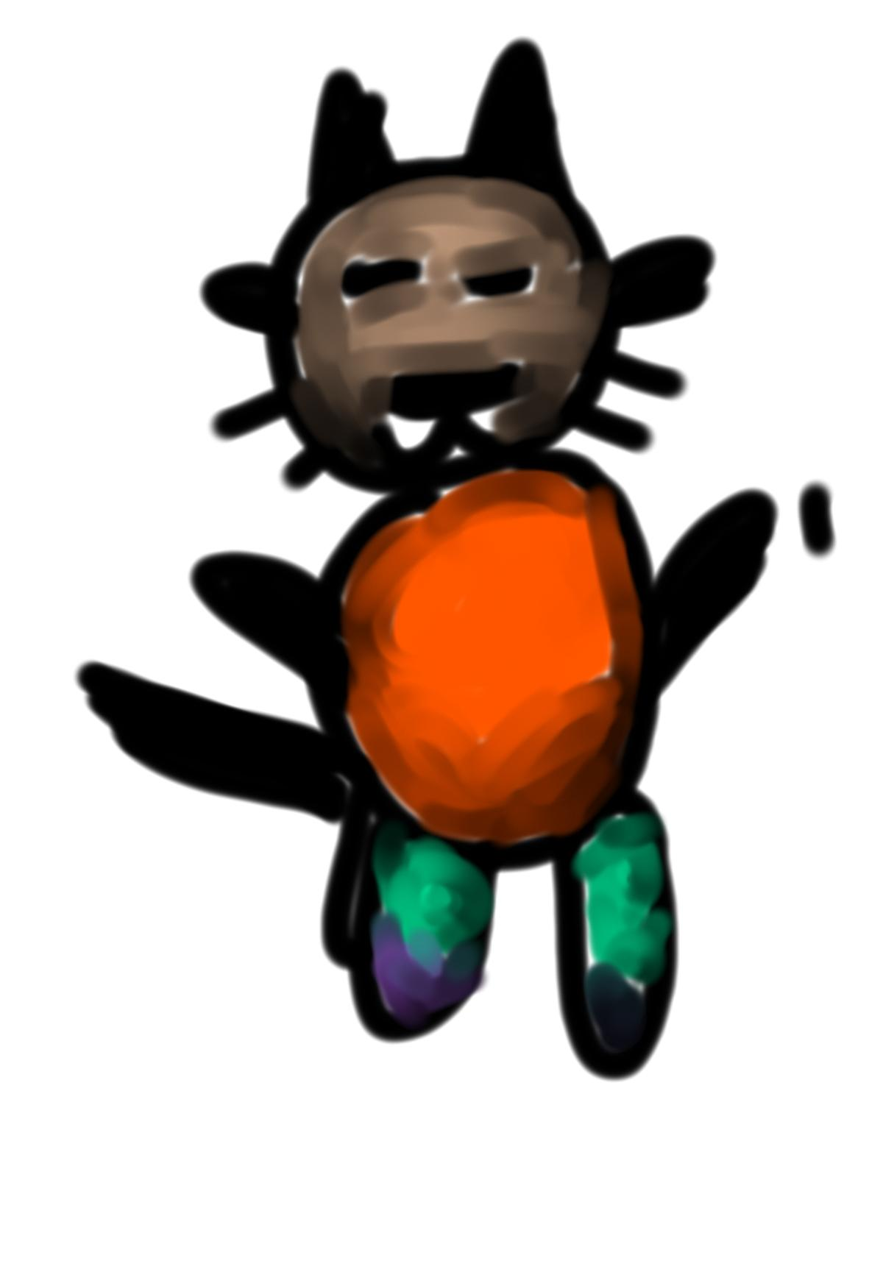

“ Roof!” barked Uncle Ace.

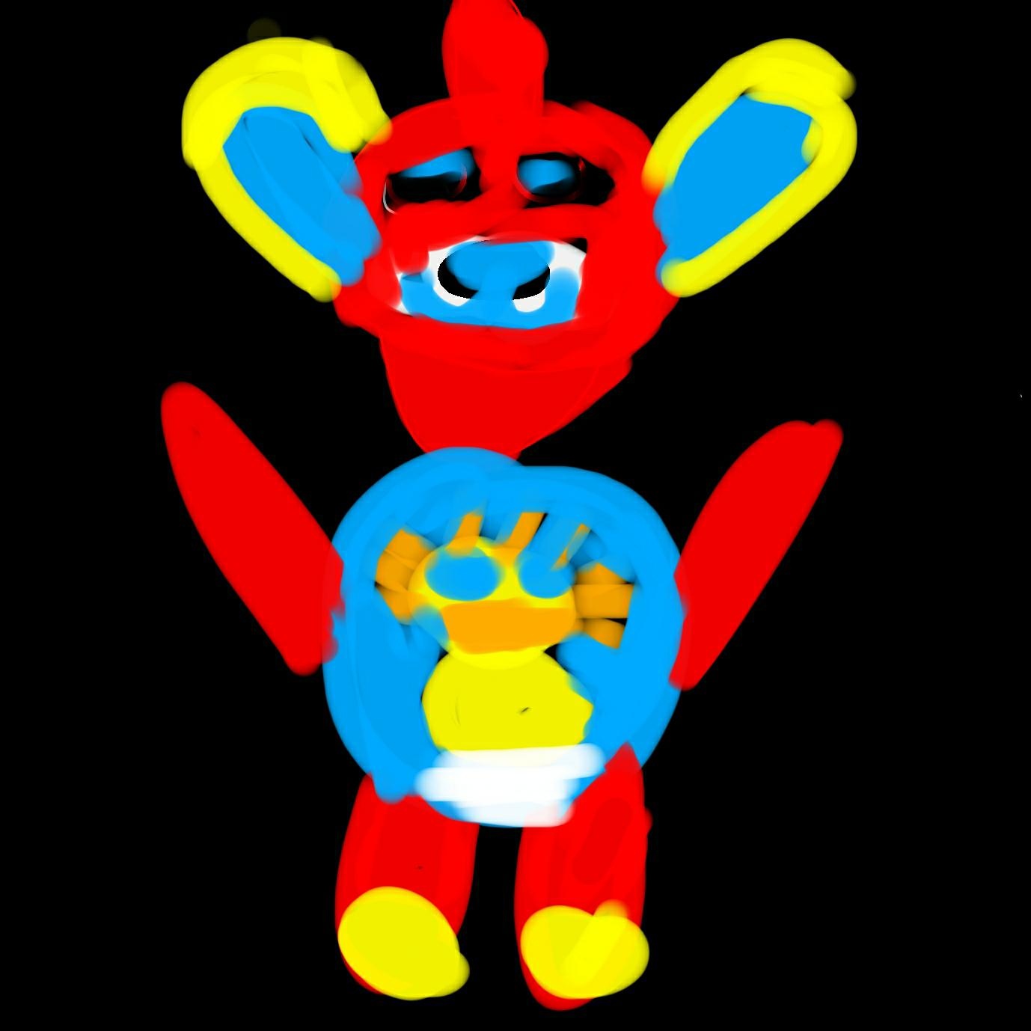

“You know how much we love you and we really want to be better than our ancestors, especially Father Morty and all of his descendants who had come before us.

Thus, we need to break the iniquity of bullying that has started with him yet can end with us.

“What do you mean, Brother Dog? Can you please make yourself clearer?” asked our mothers and fathers.

“Surely,” he replied. “The bullying really needs to stop for the sake of the puppies, family, and society at large.”

“We're sorry, puppies!” our parents had said to us.

Even though we could talk back because we were puppies and we didn’t want to be disrespectful to them, we would rather be with Uncle Ace so that we could grow up in a safer, healthier environment. Besides, our parents had come through a very poor lineage themselves so they could not give to us

what they did not have themselves.

Thus, Uncle Ace had asked his cousins if he could adopt us so that we would not have to struggle like they and our ancestors had struggled. After all, he himself wants all of us to be better than he is and El Shaddai has provided him with more than enough resources so that we can go further than those who had gone before us.

Because Uncle Ace has been a police dog, his cousins have figured that they can trust him to keep all of us safe. So much so, that he has become very protective of not only all of us but the community at large in response to all of the bullying that has been

occurring not just in our family line but in the world by and large.



Like most individuals in high school, we have often felt overprotected. Just like most of the teenagers, we want freedom and identity.

Yet Uncle Ace loves all of us and he really wants all of us to be safe, healthy, happy, and prosperous.

We want the same thing, too.

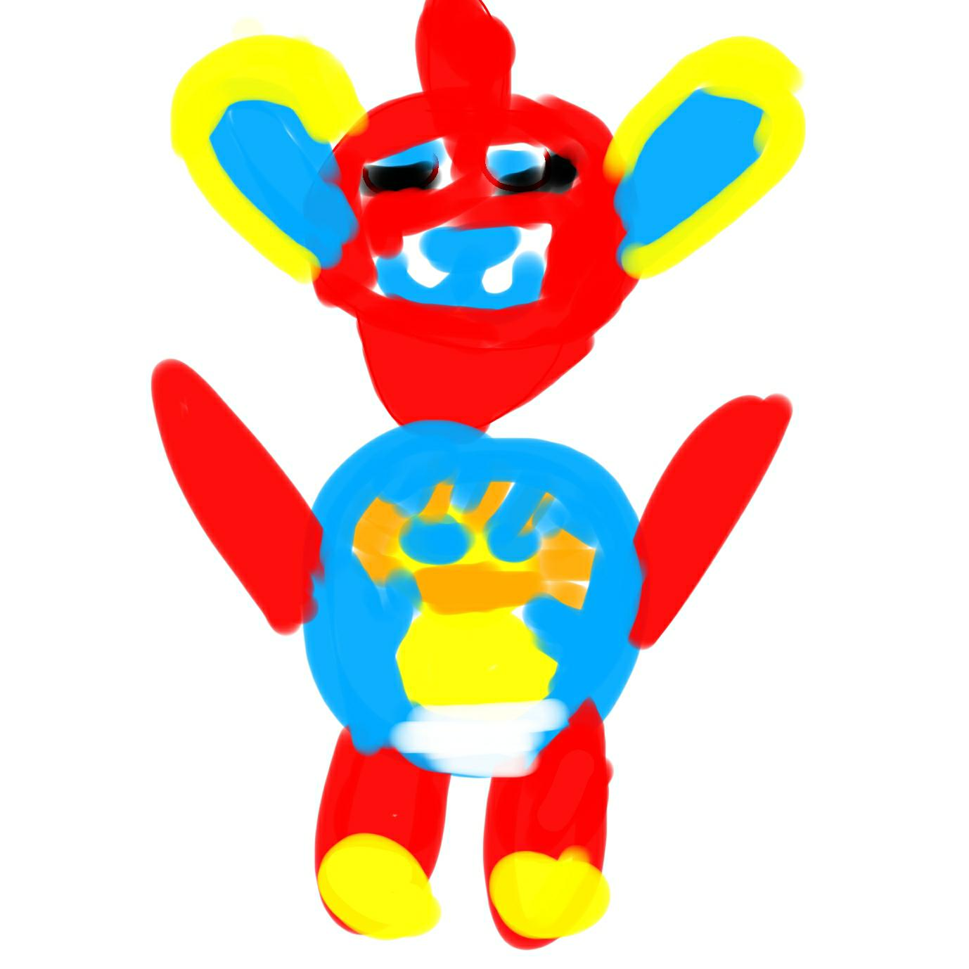Therefore, Uncle Ace has encouraged us to stay in school and study hard. Simultaneously, he has discouraged us from getting jobs right now so that we

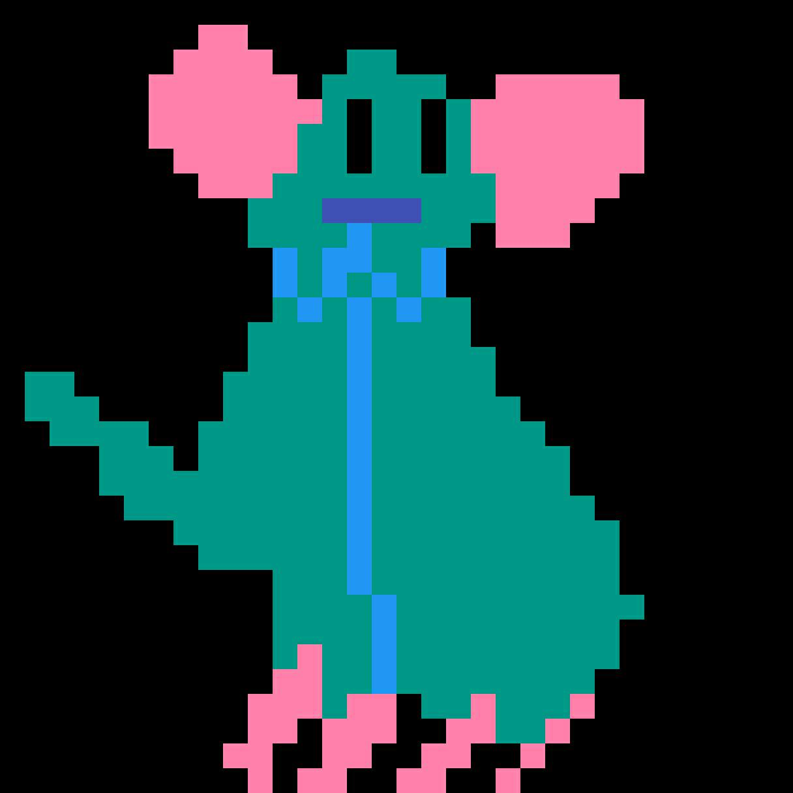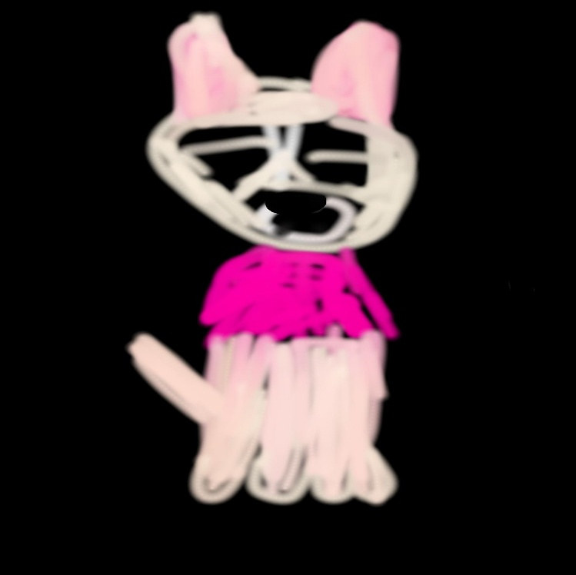focus on school.



He has also suggested that we go to college and major in General Studies, the

Liberal Arts/Sciences, or anything that might help us to eradicate bullying.

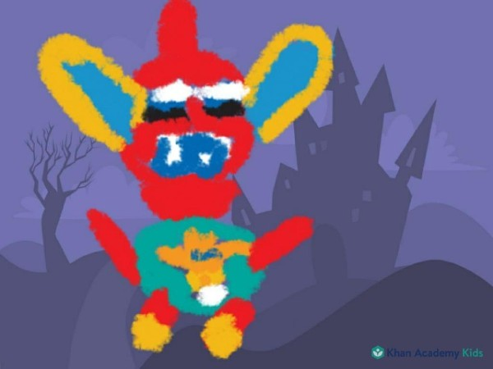The sky is the limit for us and we can conduct our research in the meantime.

Happy studying !