Across The

Universe

Snithik Arjunkumaran

Copyright © 2024 Snithik Arjunkumaran

All rights reserved.

TABLE OF CONTENTS

Across The

Universe

1

U

sing a beaker and some other tools, a raven-haired boy with hazel eyes mixed many chemicals into some water in the beaker, forming a foam.

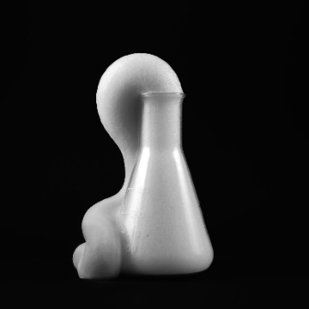

“This is called elephant toothpaste,” The boy said.

“How is it, guys?” He asked his friends around him.

“That was amazing, Snithik,” says a girl wearing a school uniform with her name, Thanusri in the pocket near her heart.

She also had a lot of sweat dripping from her hair, which was golden brown, probably because she just run and come to this spot.

“What do you think, Dabbie and Yosinth?” asks Snithik.

The latter, Yosinth, replied, “It was very interesting

Yosinth had a school uniform, the same as Thanusri’s but with his name. His hair was dark brown.

Another girl, Dabbie also goes with what Thanusri said.

She had the same uniform as the rest of the group. The uniform shirt was dark blue, and the pants were light grey.

Their school name was written in dark red on the backside of the uniform, which was Amilash Tech Academy.

The four were present in a garden, under a large, lush green maple tree. Beside Snithik was a notebook with a sentence on the cover, “Th[ink]”, which had the steps to make the foam.

Suddenly they all heard the bell ringing, indicating the school was over.

“See you guys at the mansion!!!” Yosinth exclaimed and ran out of the gates.

Snithik, Thanusri, and Dabbie also went to their respective homes, but not as fast as Yosinth, who went like the wind.

2

T

he next day, the friends arrive at the old, abandoned mansion that lies far on the outskirts of the town. Looking at it, Snithik feels a bit scared as well as curious.

Yosinth was excited and ready to go, but Snithik was holding the collar of his shirt.

Dabbie and Thanusri, on the other hand, were taking hundreds of pictures, with no sense of fear.

Finally, after a few seconds, Snithik said, “Let’s go inside,” and the others went inside along with him.

The interior of the mansion is scarier than the exterior. Everything is rusty, and covered with spider webs.

As they go deeper inside, it becomes even more darker.

Suddenly, they hear an electric spark. Yosinth immediately took out his phone and scanned the area.

His phone gave a signal, saying that it was coming from their left side, and so they turned.

They all screamed in fear because there was a skeleton head. Yosinth, who wasn't afraid, examined the door even further.

He took a cloth from his pocket on the hip and cleaned the part of the door near the skeleton head.

After cleaning it, they saw a lettering, which said, ‘Be Aware’ in bold letters.

“Shall w… we go in…” Snithik asked, which Yosinth nodded and pushed the door. It got opened, but below them, the floor vanished, and they all fell into the trap, screaming and shouting.

**\*BOING\***

They all fell on something soft, which was revealed to be a jumping castle. As they jumped out of it, they saw a machine, covered in spider webs and dust.

Snithik and Yosinth took off all the webs and dust, while Thanusri held a flashlight, for their guidance.

The machine looked like some sort of a teleporter, but a lot different.

Dabbie, who gained little courage, started touching the machine and saw a red button.

“Guys, maybe we can go out if we use this thing?” Dabbie said to the others, while others refused to do so.

But without listening to them, she clicked the red button and the machine burst open.

3

A

nd the machine burst open.

It revealed a big hole and it started sucking everything and everyone, including the jumping castle.

And they fall somewhere very noisy

Very. Very noisy.

They have fallen into an area where a conflict was happening.

“Intruders!!! Go and attack them!!!” A creature with a robotic body on one side and a human on the other side shouted at the four.

Some other creatures went near them and helped them up. Before our heroes saw the people, they ran and gestured to follow them. And they indeed did.

While they were running, Snithik got a strange feeling near them. He then turned and saw Thanusri, who was about to get shot by some laser gun thing.

He quickly pushed Thanusri and got zapped by the laser.

“No! Snithik!” Thanusri shouted, making the others stop, even the strange creatures.

One of the creatures said, “We’ll carry him, you go to the camp over there.” while pointing to a small green-coloured tent.

Yosinth and the others started running again, still worried about Snithik.

Suddenly, the creatures swooped in and snatched Snithik away, carrying him off to their mysterious camp.

As they laid him on the ground, the group couldn't help but notice how identical each creature looked.

One leaned in and whispered urgently to Thanusri, "Please, I need that serum - give it to me!"

Without hesitation, she took a small green bottle containing a powerful serum and handed it over to the creature, wondering what strange secrets it held.

The creature took some drops of the serum in a syringe and injected it into Snithik. They all waited for a few minutes. But suddenly,

**\*BOOM\***

4

**\*BOOM\***

“Oh my god! What happened!” Thanusri exclaimed.

The one, who looked like Snithik peeked his head out of the tent and saw the horrible scenery caused by the war.

“I think one of our battle robots has been destroyed by the Nihelians,” Said he.

“Wait what! You guys have battle robots! I would love to see them!” Yosinth exclaimed.

“But sorry, you could not see them but I guess we could introduce ourselves,” The creature that seemed to look like Dabbie, said, waiting to know their names.

Snithik then slowly opened his eyelids, to see the 7 teens, 4 being aliens.

“A… am I alive?” Snithik asked, to which everyone nodded. Then he smiled.

“Anyway, we’re about to introduce ourselves. I’m Himashi, I know I'm a bit like you, umm…” The alien that looked like Snithik asked.

“Snithik, that's my name” Snithik completed.

“I am Yosinth,” Said Yosinth, waiting to know the name of the alien that looked like him.

“And I am Yamato!” Said the one who looked like Yosinth.

“Myself, Chloe! Nice to meet you,” Chloe said, who looked like Thanusri.

“Wow, I was about to say the same to y'all, I am Thanusri” Thanusri said, who was amazed by Chloe's words, as she was about to say the same.

“I am Dabbie, nice to meet ya!” Said Dabbie.

“And I am Amelia!” Said Amelia, the same one that looked like Dabbie.

“Okay, so a small question,” Snithik said.

“What is it, dude?” Yamato asked, to which the raven-haired teen answered, “Can… we help you guys… for winning this kind of… an invasion?”

The aliens looked at each other, and then they smiled, saying,

“Well, if you wish so,” Himashi replied to Snithik’s curious question.

"What should we do?" Thanusri asked.

"Hmm... maybe you can go to their planet Nihelia and start attacking there?"Himashi replied.

"But how will we go there?" Dabbie asked, puzzled.

"Well, we discovered a unique type of teleporter on three different planets, which can travel across the other two planets. One is in Nihelia, one in here, and lastly one on your planet," Yamato explained.

He continued, "There is an old sensei who knows about these things, maybe me, Amelia, and you four can go there and get some knowledge from him,"

"That's fine by us," The four Earthian heroes said.

"Then me and Himashi will be here, guarding the planet from destruction," Chloe said, with Himashi nodding to Chloe's statement.

All the eight teenagers laid their hands on top of each other, and Snithik shouted, "Let's go!!!" With everyone taking their hand off at the same time.



5

O

n the other side of Enigma, Snithik, Thanusri, Yosinth, Dabbie, Amelia, and Yamato are standing outside the door of the sensei's house.

The house was small, but it was well-maintained from the exterior.

Snithik went and pressed the doorbell, which then produced a "TRIIING!" sound.

"Coming!" A sound was heard.

A few seconds later, a wise old man, looking like the leader of the modern tribal people of the Earth, came out.

"Wait wait wait. More humans?" Asked the Sensei.

"What? That means there are humans out here too?" Yosinth repeatedly asked the same question.

"Come inside, I will explain." Said the Sensei.

The interior of the Sensei's house is similar to a Ninja Dojo on Earth. The Sensei led the six to the room, where some other-worldly marshmallows were being burnt.

"Here, have these, to energize you. 'cause this will be a long story." The Sensei said to the others.

Snithik and Thanusri took three other-worldly marshmallows each, Yosinth and Dabbie took one each, while Yamato and Amelia didn't take any.

"So, what do you mean that there are other humans here?" Thanusri asks.

"You will understand at the end of this story what I am gonna say to you," The Sensei said.

"So, my name is Sheroy." The Sensei said in a very bold voice.

"Wait, wait! You're Sheroy? Sheroy Jins Antony, the founder of Jins Technological Companies?" Snithik and Yosinth asked with a surprise.

"Yes. but no questions, please." Sheroy asked and the others nodded.

"Me and my friends Himashi, Yamato, Chloe, Amelia, and Nidarshan built a mansion so we could live there. But as we dug deeper and deeper for the infrastructure, we started to see a small door kind of thing." Sheroy said as he remembered the exact thing that happened during his days on Earth.

Hearing this, something like glue came out from Yamato's and Amelia's faces, revealing a human face; this time, it was not similar but exactly like Yosinth's and Dabbie's.

"WHAAAAT!" Yosinth and Dabbie exclaimed as they gobbled up the marshmallow.

"I remember now, my old friend, you please continue," Yamato said.

"The door then materialized to be a teleporter of some sort. We completed building the mansion and worked to make the teleporter work for several weeks.

But then one day, when Himashi and I were cleaning the teleporter, we discovered a button, and immediately, the others gathered up and painted the button red so if it was harmful or dangerous, we think the other generations wouldn't touch it." Sheroy said seriously.

"Then you guys ended up here, right?" Snithik guessed as he completed eating the second marshmallow.

"Yup, that's right." Sheroy replied, "Except Nidarshan."

"Hmmm. Right. Anyway, we came to you because according to our research, we think you will know about the teleporter on this planet." Yamato asked.

"Well, certainly yes. I saw a map about the teleporter. But here, it is not a door kind of teleporter but a gate," Sheroy answered to Yamato's question.

Sheroy then stood and looked for the map everywhere, and finally found it in a library of maps.

"Here it is. The map." Sheroy told as he gave it to Snithik.

"Thank you, Mr. Sheroy. It was very surprising meeting you," Snithik said as they all thanked Sheroy and started to leave when suddenly, a knocking was heard.

6

"Knock knock. Mr. Sheroy Jins Antony, are you there?" A robotic voice was heard.

"Oh my god! I never thought that the Nihelians and their robots would track us down here!" Thanusri exclaimed.

"Guys? I guess it's 'cause of me." Snithik said, as he revealed his hand, where a tracker of some sort was placed. He immediately took it out and broke it into pieces.

Sheroy went and peeked outside the door, where different battle robots of different sorts were seen.

"You don't worry, my friends, Amelia and I will take care," Dabbie said as she and Amelia rushed out to take the battle suits Yamato took and kept as a backup.

"Come on guys, we will go to the gate," Sheroy said as he took a bag. "This will transform into a battle robot called Sheroid and I will carry you all to the gate." And they all went outside.

Sheroy pressed the switch on his backpack and he got engulfed by it, and after a few seconds, a battle robot emerged.

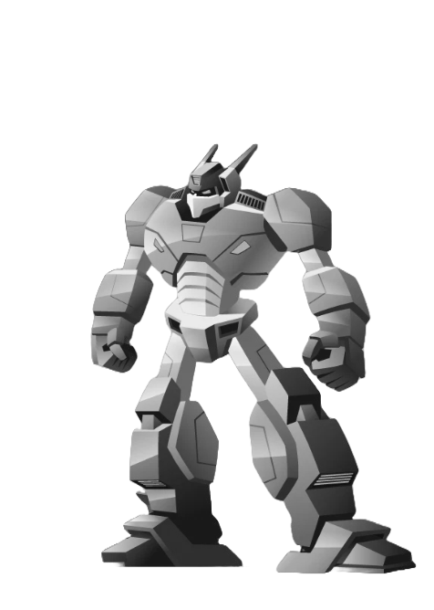

The Sheroid

Some kind of missile shot from his now-robotic hand, destroying a battle robot.

"Come on, let's go," Sheroy said as Snithik, Thanusri, Yosinth, and Yamato stood on one of Sheroid's hands.

And they fly on the vast planet of Enigma.

7

A

fter a few hours of searching, the Sheroid landed and another mansion was seen. As they came in, they saw a gate.

"What! A mansion just for a gate?" Snithik exclaimed.

Sheroy came inside as a human and said, "Hmm... Interesting."

"And there's no red button," Yamato said as he looked closely at the gate.

"Then what should we do?" Snithik asked.

"Hey! Look! There's something on the back side of the map !" Sheroy shouted to the others as he showed it to them.

"I will tell," Yosinth said.

As he was about to say something, the door opened, revealing a dog, which transformed into a battle robot.

"You do it Yosinth, I will take care of it," Sheroy said as he tapped the switch on the bag, revealing The Sheroid.

Sheroid launched a missile from his hand, but the counter missile from the battle bot made him very injured.

A fierce fight happened, with the Sheroid gaining a kind of upper hand.

Yamato wanted to help Sheroid because it became too hot and if it exceeded the limit, the whole machine would burst, killing Sheroy in the process.

The battle robot spat out a huge missile, switching off the Sheroid.

As Sheroid fell, it said in Sheroy's voice, "Don't worry, just do it !" and it powered off after launching a missile, which destroyed the battle robot.

Seeing this, tears started coming from Thanusri's eyes.

"Sometimes it's like this. What can we do." Snithik said to her as she slowly stopped crying.

"Yeah, let's keep our hands together, as a remembrance of Sheroy." Thanusri agreed with Snithik and they all kept their hands together and said, "Let's... Go!!!!”



8

A

fter a few moments, Yosinth started chanting, "Achhak. Mojjjak. Achhak. Kajjak. Mojjjak. Achhak." And the gate opened, absorbing Snithik, Thanusri, Yosinth, and Yamato.

And they land in a place very high.

Very. Very. High.

They seem to be atop a skyscraper, almost the height of Mt. Everest on Earth.

"Wow... So beautiful..." Thanusri said as she came near the observation binoculars, only to notice that it was a shooter.

After noticing, she immediately came a foot backward, bumping into Snithik.

"Sorry," She said and she saw another thing, robots.

"You are under arrest by the 54382901 law; please come with us." The robot told as it took a handcuff and kept it on the gang.

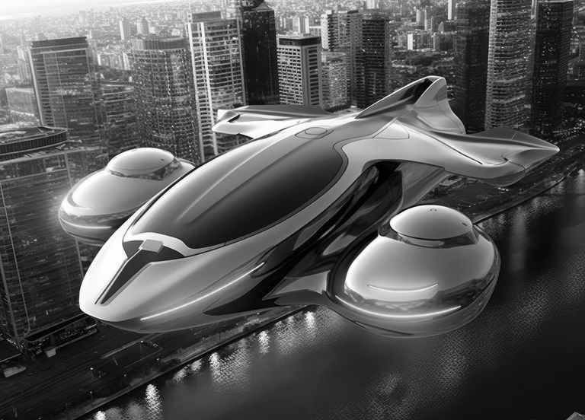

It then showed their way to a flying car, which took them to the jail.

"Welcome to the Nihelian prison, dear Prisoners," A creature with a human body on one side and a robotic body on the other welcomed them after exiting the car. And as they looked around, they were surprised. It's because,

The jail was so good.

So good that it felt like a resort.

"Okay... I am Jazz, the receptionist of this prison."The creature, Jazz, said.

"So... Y'all are going to be in cell number 124 in AS block," Jazz said optimistically.

"AS block, that's so many!" Yosinth exclaimed.

"It's because every single prisoner in the whole of Nihelia is here." Jazz explained.

"Okay, let's go to your cell," Jazz said.

After miles of walking, going in trams, and more walking, they finally arrived in block AS.

"Here's your cell," Jazz said.

"This... is not a prison," Thanusri said.

"This is... a LUXURY HOTEL!!!" Snithik exclaimed.

The creature smiled at them and gave Thanusri the keys.

"This is the key to your cell, and now this is the main rule, you are allowed to move around the block and outside sometimes," Jazz explained.

"But you are not allowed to go out of the jail," It completed.

"Oh... Ok," Yamato said, surprised.

"Enjoy the stay!" Jazz said, and started walking the way back.

After she went, Thanusri opened the door.

Inside, five rooms are seen. Four are opened, but one is not opened.

They all chose and settled in their rooms, and planned to knock on the fifth door.

"I hope this guy is not a monster," Snithik said and knocked on the door.

And the door opened in a few seconds, and a human in his 30s with a robotic hand was seen.

"Nidarshan?" Yamato asked.

9

"Nidarshan?" Yamato asked, surprised.

"Yamato! What are you doing here, and... humans! What the Hell is happening?" Nidarshan exclaimed, so shocked.

"Well... do you want the long story to be short or be it long?" Snithik asked Nidarshan.

"Let it be a long story," Said Nidarshan, as he sat down on the luxurious sofa in the pathway between the five rooms.

After the story was completed explaining, which was after an hour or so, Nidarshan stood up very tired of hearing the story, which was told by Thanusri and Snithik.

"And also... another thing that we forgot to mention, it's that..." Thanusri started.

"Sheroy... died," Snithik finished, very sad.

"He... he died?" Nidarshan asked, and the others nodded.

After a bit of awkwardness, Yosinth finally asked, "What's your arm made of?"

"Same as yours. Bone, muscles, nerves, blood vessels, etc." Nidarshan explained.

"No, I mean the artificial arm?" Yosinth asked.

"Oh... It's made up of titanium, aluminum filling, stainless steel, silver, gold, iron, and copper." Nidarshan explained.

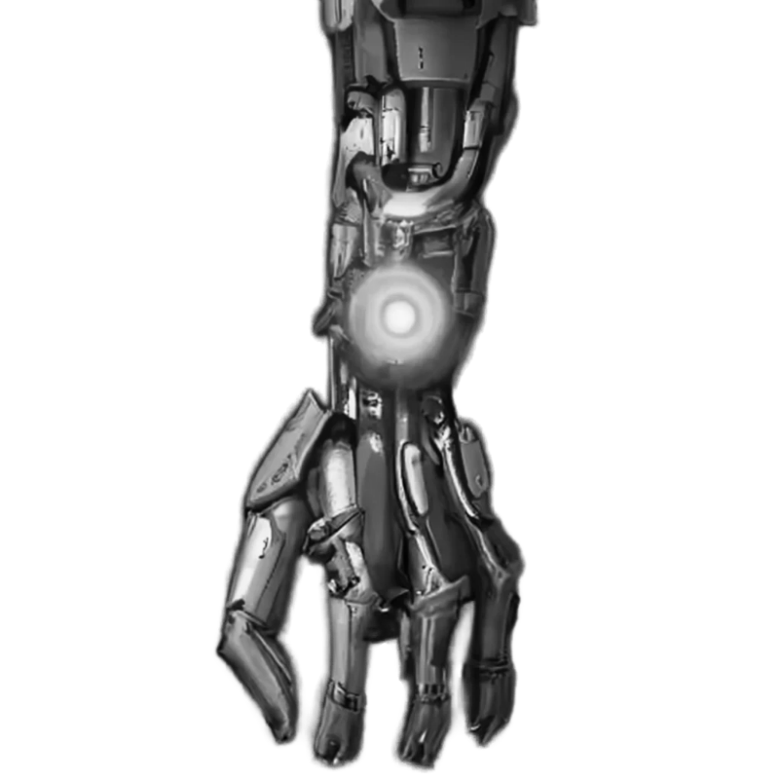

Nidarshan’s Robotic Arm

“Oh… nice,” Yosinth said, much impressed.

“So, do you know any way to get out?” Thanusri asked Nidarshan, as he was in this jail for 2 years, which is more, according to them.

“If there is a way out, I would have gone already,” Nidarshan replied.

“Fine, leave that topic aside, how did you end up here, my friend?” Yamato asked him.

“It all started after we tested the teleporter we found at the mansion. After the teleportation, I ended up in the middle of the Nihelian Civil War,” Nidarshan started.

“A group of Nihelians, led by the leader Sinige, shot a deadly missile at me, breaking my arm,” Nidarshan said, remembering his memories of the Nihelian Civil War.

“The opposition group made this robotic arm and I helped them. But after a few days, Sinige secretly assassinated the most important members, except me, to be in shame.” Nidarshan said, and the others are seen visibly sad.

“I hid for 3 years, but then they caught me and here I am now,” He stopped, with everyone very sad.

“That’s a very sad story,” Thanusri said, very sad about Nidarshan’s past.

“Now let’s go to sleep guys. Tomorrow we try to plan a way out.” Snithik said, as he got up and went to his room, and the rest did the same.

10

T

he next day morning, the team of now five prisoners gets their plan’s **Phase 1** into action.

On the way to the daily breakfast canteen, which is opposite their room, Nidarshan bumped into one of the robotic security guards.

And using this opportunity, Snithik took the access card that it had in its wrist, shutting it down.

He then slid it over to Thanusri, who had just come out of their cell.

She then went back into the room to take something, which was also part of their plan.

After their breakfast, they went to their room and started **Phase 2** of their plan.

Thanusri took the access card that she held in her pocket and scanned it on Nidarshan’s robotic arm.

It made the orb on his arm disappear, which allowed it to change into whatever type of weapon he thought of.

He closed his eyes and said, “A sword,” and the arm became a sword, with everyone’s mouth open wide, out of surprise

“Yes! It works!” Nidarshan exclaimed, very happy, and returned it as an arm back.

Then they got out of their cell to go to the side entrance of the jail.

As they get near the side entrance of the jail, they discover that the other security robots have found the powered-off security robot.

“It is the humans! Attack!!!” One of the robots cried.

Immediately, all the other robots started rushing toward us, shooting multiple weapons.

Nidarshan launched a smoke ball from his hands, and then,

**\*BOOM\***

A huge smoke cloud emerged, which gave them some time to get away.

They finally get to the side entrance of the jail, and use the access card, which didn’t work.

“Oh no! What will we do now?” Thanusri cried.

“Just… die!!!” A robot’s voice was heard. They turned around and saw the robot charging toward them.

Nidarshan immediately changed his hand into a sword and slashed the robot right in its neck.

“That… was amazing!” Yosinth exclaimed, and at the same time, Snithik discovered something.

“Guys, there is a hole right next to the access card scanner. I guess we need to put the rot’s arm into the hole,” Snithik said.

Nidarshan took the robot’s arm and gave it to Yamato, who pushed the robot’s finger.

ABOUT THE AUTHOR

|  |  |
| --- | --- |
|  | Snithik Arjunkumaran is a kid who loves writing stories and learning new things |

.He plays piano and reads books during his free time. He cares a lot about his friends and family. His stories are mostly about science fiction and Fantasy. He is currently in India, aiming to be a tech manufacturer