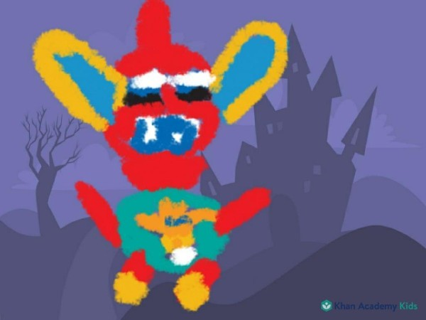

Getting A Grip on The Basics of Art

**Getting A Grip on The Basics of Art**

**Table of Contents**

1. **The Definitions of Art**
2. **Synonyms for Art**
3. **Benefits of Art**
4. **Examples of Art**
5. **Examples of Artists**
6. **The Elements of Art**
7. **The Principles of Design**
8. **Art History**
9. **Art Media**
10. **Review Game with Ace the Dog**
11. **References**

**Chapter 1: Definitions of Art**

**There are various definitions, or meanings, of art including but not limited to:**

1. **Creative expression**
2. **Any practical skill or application**
3. **Original innovation**
4. **Expression of thoughts, feelings, or observations**
5. **Outlet for human imagination**
6. **Any skill gotten by experience, education, or observation**
7. **Various branches of creative activity or experience**
8. **Any form of self-expression**
9. **Works created**
10. **Skills or abilities**

**Chapter 2: Synonyms for Art**

**There are a variety of words that mean basically the same thing as art, or innovative expression, including but not limited to:**

1. **Adroitness**
2. **Aptitude**
3. **Artistry**
4. **Craft(smanship)**
5. **Design**
6. **Dexterity**
7. **Draft**
8. **Expertise**
9. **Handicraft**
10. **Ingenuity**
11. **Masterpiece**

**Chapter 3: Benefits of Art**

* 1. **Can heal trauma, the soul and spirit at large**
  2. **Can heal the community and society at large**
  3. **Can facilitate self-expression and connection**
  4. **Can facilitate problem-solving and problem-based learning**
  5. **Can provide rest, relaxation, and reward**
  6. **Can enhance soft and/or social**

**skills**

* 1. **An outlet for stress and strong emotions**
  2. **Builds self-esteem, self-confidence, self-acceptance, self-worth, etc.**

**Chapter 4: Examples of Art**

**There are many illustrations of this innovative expressiveness including but not limited to:**

1. **Creative Arts, e.g.**
   1. **Architecture**

**II. Basketry**

**III. Collectibles**

**IV. Drawings**

**V. Films**

**VI. Games**

**VII. Jewelry**

**VIII. Music**

**IX. Photography**

**X. Toys**

**Chapter 5: Examples of Artists**

**Who are some craftsmen from the Traditional Era, or the time period before 1900 AD?**

1. **Mr. Myron, who composed Discus Thrower in Ancient Greece between 800 BC and 323 BC**
2. **Mr. Duccio, who crafted Majestas Altarpiece between 300 AD and 1400 AD**
3. **Mr. Leonardo da Vinci, who handcrafted Mona Lisa during the Renaissance**
4. **Mr. Rembrandt, who made the Night Watch**
5. **Mr. Canaletto, who composed the Grand Canal**

**Who are some artists from the Modern and/or Post-Modern Era, which includes 1900 AD to the present?**

* 1. **Mr. Braque, who co-created The Table**
  2. **Mr. Miro, who made the Painting**
  3. **Mr. Rothko, who composed Four Darks on Red**
  4. **Mr. Segal, who worked on The Bus Driver**
  5. **Mr. Christo, who co-created Valley Curtain**
  6. **The Disney Family, who co-created Walt Disney World in FL and Disneyland in CA**

**Chapter 6: Elements of Art**

**These are the basic building blocks of this original expression at large and these foundations include:**

* 1. **Line = most basic building block of artwork and involves a moving dot**
  2. **Shape = 2D object**
  3. **Form = 3D object**
  4. **Color = reflected light**
  5. **Value = degree of lightness or darkness**
  6. **Space = reference of depth**
  7. **Texture = how something feels or looks to feel; how things feel when touched**

**Chapter 7: The Principles of Art, or Design**

* + 1. **Alignment = how the elements of art are lined up on a page**
    2. **Balance = equal distribution of weight**
    3. **Contrast = the difference between at least two objects in art**
    4. **Emphasis = focal point**
    5. **Harmony = combination of similar elements**
    6. **Proportion = relative size**
    7. **Rhythm = visual beat**
    8. **Unity = separated parts working together**

**Chapter 8: Art History**

**This is the study of creative expressions from the past:**

**Ancient History = the past before 1500 AD, e.g. Stonehenge and The Tower of London that were built in England during Antiquity and Middle Ages, respectively**

**Modern History = the past after 1500 AD, e.g. Salvi's Trevi Fountain in Rome during the Early Modern Times**

**Hints: Antiquity is the historical period before 500 AD and the Middle Ages are those years from about 500 AD to around 1500 AD.**

**The Early Modern Times are the years from approximately 1600 AD to roughly 1800 AD.**

**Coincidentally, all of the years before 1900 AD include the Traditional Era.**

**Global History involves Prehistory, the time before writing, to now.**

**Chapter 9: Art Media**

**These are art tools that are usable in the Arts, any learned skills or trades.**

**Examples of such tools include but are not limited to:**

1. **Computer**
2. **Color Instruments**
3. **Interactive Notebooks**
4. **Multimedia**
5. **Paper**
6. **Stencils**
7. **Straight Edges**
8. **The Visual Arts period**
9. **Writing Instruments**

**Chapter 10: Review Game with Ace the Dog**

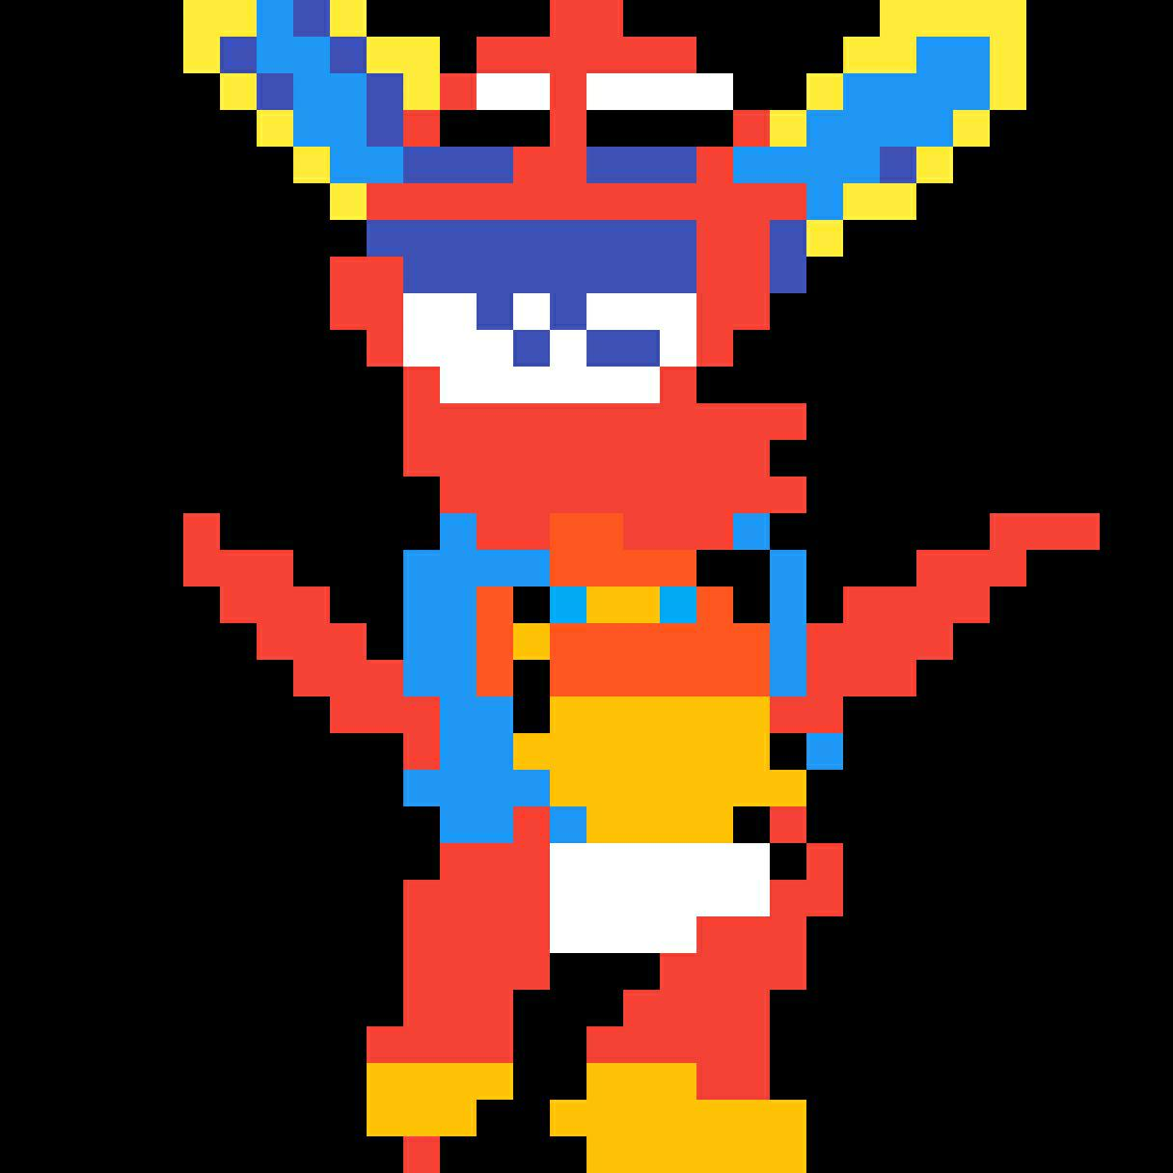

**Ace the Dog will ask a series of questions relating to art and these questions will be either multiple-choice, fill-in-the-blank, true/false, matching, short answer, or a combination of types:**

**Round 1: Mixed Question Types**

1. **Creativity, Innovation, and Design are words that mean the same thing as art:**

**True or False**

1. **What is one benefit of Art?**
2. **Provide an example of art: A. Drawings B. Paintings C. Games D. Music E. All of the Above**

**Round 2: Matching**

**Hint: You can match the right letter to the right description.**

1. **Line B. Balance C. Color D. Harmony**
   1. **Combination of similarity:**
   2. **Moving dot:**
   3. **Equal distribution of weight:**
   4. **Reflection of light**

**Bonus Round: Short Answer**

**Provide an example of art from the Traditional Era, or the time period before 1900 AD.**

**Provide examples of art media that can be used for sketches, or drawings that can spur ideas for creative expressions later on.**

**Chapter 11: References**

**Elements and Principles of Art Vocabulary Slides by You**

**Khan Academy at** [**https://www.khanacademy.org**](https://www.khanacademy.org)

**Study Stack at https://** [**www.studystack.com**](http://www.studystack.com)