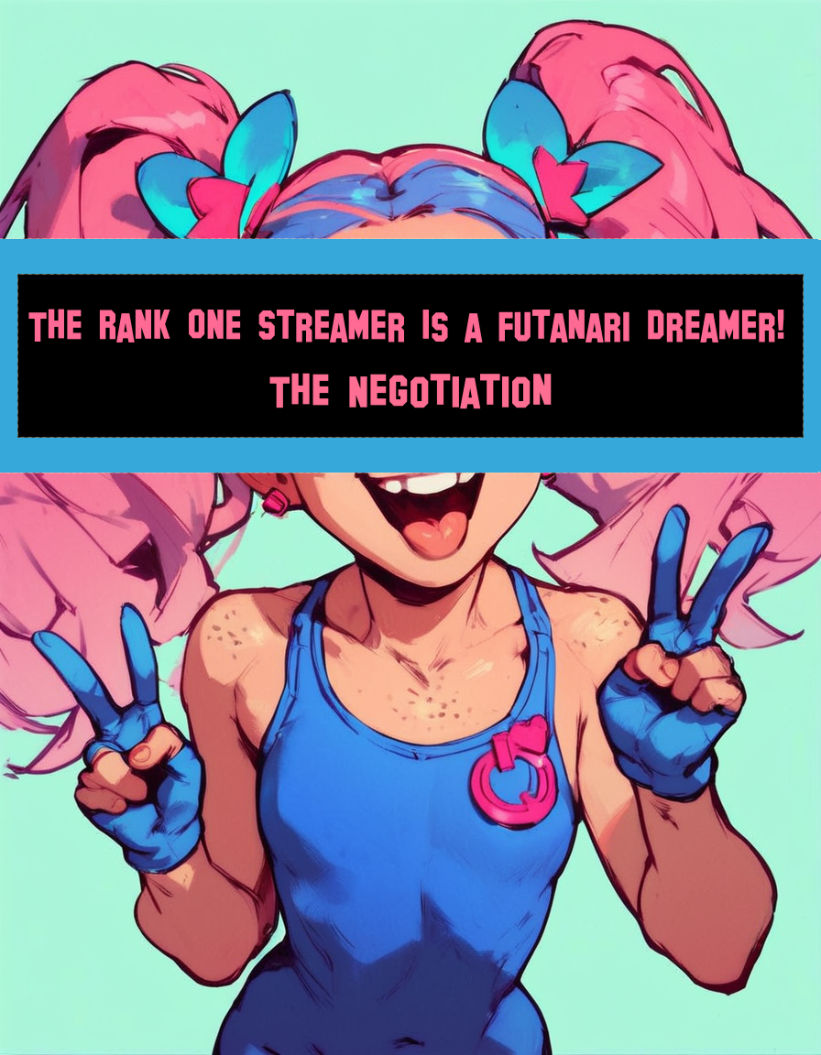

The Rank One Streamer Is A Futanari Dreamer! : The Negotiation

by Nyx Aurion

# Chapter 1

## The Intro

“Hey chat!”  
  
I smiled and waved as I sat down at my computer. It was time to start another long day of streaming.  
  
“Today I’m supposed to have a meeting with Miss P!”  
  
Miss P was a nickname for Sheila Pietila, who was the CEO of the streaming platform that I used. The two of us would finally sit down and have a conversation after being thorns in each other’s sides for a long time. Due to my controversial stream content, she’d banned me many times. However, I was so popular that they always unbanned me before too long. This time it was different though. She wanted to discuss terms for my permanent return to streaming.  
  
“So...I guess let’s just chill until she shows up?”  
  
I spent some time talking to my viewers until there was a knock at the door. It looked like she was here!

#

I hopped up and went over to the door to answer it. When I opened it, Sheila stood on the other side wearing a tacky-looking green-and-yellow business suit. Her grey hair was tied back into a ponytail and her face had the most neutral expression I had ever seen. It was clear she meant business.  
  
“Hey Miss P!”  
  
I hugged her tightly and she begrudgingly returned it. We stepped into the room and I closed the door behind us.  
  
“Have a seat!”  
  
I gestured towards the pink couch that was the centerpiece of the living room. She took a seat, and I pantomimed to the chat about how huge the woman’s ass was. I repositioned my webcam where the viewers could see our conversation. After all, having the CEO on the channel was bound to give me massive viewership.  
  
“Want something to drink?” I offered as I headed towards the kitchen.  
  
“Tea please.”  
  
“What kind?”  
  
“Plain black tea is fine.”  
  
“Okay.”  
  
The chat continued to go crazy as I prepared us both cups of tea. I returned to the room with two steaming cups in hand and placed one in front of Sheila. I took a seat next to her and took a sip of my tea.  
  
“...So let’s talk.” I began. “We both know that I make you too much money for you to get rid of me, and that I’m not going to change.”  
  
Sheila sipped her tea before responding. “You’re right, we do both know that. But you can understand why we need to set boundaries.”  
  
“Why? You allow adult content on your platform, and my streams are tagged as adult only. So why am I the only streamer you have a problem with?”  
  
“Izanami,” she paused, looking at me seriously. “It’s not about you. It’s about the young audience you attract.”  
  
“Oh come on!” I exclaimed, “My viewers are all adults. How can you accuse me of having young fans when I don’t allow any children on my platform?”  
  
“I understand what you’re saying, but our investors have a problem with it.”  
  
“Well, just because you and your investors are old, sexless boomers doesn’t mean you can ban me. I read the rules. There’s nothing saying that I can’t fuck on stream.”  
  
“You’re making this more difficult than it needs to be.” She sighed, “We just want a safe platform for our viewers. There are other ways we can make an agreement without taking away from your streams.”  
  
I nodded and thought about what she was saying. I knew my fans loved me and my outrageous content. They didn’t mind seeing me do things others wouldn’t, but I did care about the company I represented.  
  
“Alright,” I conceded, “Just try it my way one time. You do one stream with me today, and if we don’t double your investment money, then I’ll play by your rules.”  
  
Sheila considered it for a moment before nodding her head. “Agreed.” I leaned in towards her and whispered into her ear. “Then what kinks are you into?”  
  
“W-What?!” she responded.   
  
“Not so loud.” I whispered. “You agreed to do it my way, and that means you get freaky with me on cam. So....what are you into?”  
  
Sheila looked taken aback, but I could tell that the idea of getting kinky on camera excited her. It was only then that I noticed her pants were wet from her obvious arousal.  
  
“Well...” She began, hesitant to admit her fantasies aloud, “I’ve always wanted to try anal.”  
  
“Perfect,” I said, grinning widely. “I’ve been waiting for this day. Let’s do it.”

# Chapter 2

## Showtime

I led Sheila towards the desk, where we began preparing. I asked her if she had ever been fucked before, to which she shook her head no. I felt a pang of guilt knowing what I was about to do, but the opportunity was too great. I took off my clothes and instructed her to do the same. She did so nervously, her eyes wide as she gazed at my massive dick. I guided her off of the couch and towards the camera, making her turn around so that her massive ass was towards the camera with my dick throbbing hotly against her doughy flesh.  
  
“Okay guys! So here’s the deal! Miss P said she’d let me take her butt cherry on stream, but if you guys don’t give me a bunch of subs and donations to show her you guys love this then I’m totally gonna get banned afterwards! So show us your support, ‘kay?”  
  
“You ready Miss P?” I asked her, as I took my dick into my hand and beat one of her butt cheeks with it.  
  
“Just...just do it,” she breathed.  
  
I rubbed some lube onto my dick, making sure the camera had a nice view of it before moving on to lubing up Sheila’s ass. Her asshole had a ring of hair around it, evidence that she truly was a virgin and didn’t expect that to change when she’d shown up today.  
  
“Dude...look at this.”  
  
I spread her asshole with my fingers, giving the audience a perfect view of her fuzzy backdoor. She flinched and whimpered, but she didn’t try to stop me. I turned her around and shoved her over my desk, making her face the camera’s focus. Her ass was so big that you could still see it in the background of the shot, with me standing behind it. I rubbed my dick head against her asshole, slowly pushing it into her.  
  
“Guys, she told me she was a virgin! I wouldn’t believe her if she wasn’t so...ngh...tight!”  
  
I’m sure she didn’t appreciate me telling the world that she was a sexless virgin in her older age, but humiliating her was part of the fun. I pushed forward and felt my dick head pop inside of her, and her pained face drove the chat insane. I stopped for a second to let her get used to me, but soon started thrusting forward again. The sound of her fat ass clapping against my thighs echoed through the room, and a bunch of donations came in in response.  
  
“Keep going! Breed that old bitch’s shitter!” came a message from the chat.  
  
I didn’t need to be told twice. I thrust in and out of her, enjoying every second of it. The pain in her face was quickly turning into pleasure, as she bit down onto her bottom lip and her eyes rolled into the back of her head. I felt a little guilt at using her like this, but that guilt only meant that I was providing entertaining content. I decided to lean into that feeling and push her even further. I leaned forward and grabbed a handful of her grey hair and pulled, forcing her to lean into the microphone.  
  
“Tell the audience how my dick feels.” I demanded.  
  
“I’M FUCKING...CUMMING!”  
  
Sheila reached climax, squirting all over my carpet. I kept fucking her through it, the rhythmic claps of her ass functioning as a metronome to keep urging me forward.  
  
“I want to make you a fucking dad. Please fuck my pussy, Izanami.” she asked through a shaky, desperate voice.  
  
She was looking over her shoulder directly at me at this point; almost like the audience wasn’t even there. The thought of her wanting my seed was incredibly arousing.  
  
“You can have kids for round two.” I playfully responded through moans and grunts as I continued to pound away at her ass. I wrapped my arms possessively around her waist and pulled her backwards into me. Now the chat had a view of her midsection and pubic area. There was something so sexy about having a woman more than twice my age begging for me to make her a mom. I stood on the tips of my toes now as I went from thrusting into her to rolling my hips, making sure she felt every inch of me.  
  
“imagine slutting out the CEO lol” came another donation from the chat. I groaned and my tongue lolled out of my mouth as I finally came, flooding the older woman’s bowels with my seed. She furiously rubbed her pussy, driving herself to her second orgasm.  
  
“I’M CUMMING!”  
  
The spasms from her climax caused her ass to tighten and wink around me, milking me for every drop that I had.  
  
“Ooh, f--”  
  
The sounds of us moaning was drowned out by the loud sounds of a stream of donations coming in.  
  
Still, anyone that knew anything about my streams knew that the first round was never the last. I pulled out and guided Sheila to turn around again.  
  
“Spread your cheeks and push the cum out. Big finish!”  
  
She did as she was told and pulled her massive ass apart, pushing my cum out with a moan and a loud, undignified fart.  
  
I approached her from the front, and she instinctively went to drop to her knees to service me. I lifted her face with my hand, though, and she followed my lead like putty in my hands. The woman was far taller than I was, and I had to stand on the tips of my toes to reach, but I locked lips with her. I felt her go slightly limp as I grabbed onto her hip to cop a feel.

# Chapter 3

## The Big Finish

“Let’s get you bred.” I whispered against her lips before gesturing towards my kitchen table. The thing was practically a prop used only for me to fuck my guests on since I lived alone. I walked towards the webcam and adjusted it so that the audience could still see despite having to zoom in to the kitchen behind us. The woman sat on the table and lay back slightly, spreading her legs so I could easily access her honeypot.  
  
“Oh fuck!” Sheila moaned as I slowly slid my dick back inside her. I kissed her deeply and passionately as I did so, and it wasn’t long before we were fucking like rabbits on that kitchen table. The audience was loving every second of it, donations coming in non-stop as I took Sheila’s pussy like the desperate animal I was.  
  
“You ready to go from CEO to stay-at-home mom?”  
  
Her pussy clenched around me as she climaxed at my words, causing her body to tremble and her walls to spasm. I didn’t last long after that, cumming inside of her in a gush of thick, white jizz. The audience was ecstatic, and they cheered for us as I pulled out, my dick glistening with their fluids.  
  
I had fucked the woman that could potentially end my career, and we did it on a table that could be cleaned off in a matter of seconds. Sheila had become just another conquest on my journey to become the most popular streamer of all time.  
  
“That was fun, Miss P!”  
  
I flashed her a toothy smile, and she managed to chuckle weakly at my remark. She was panting heavily, trying to catch her breath.  
  
“I don’t know about you guys, but I think we got our answer. See you guys tomorrow then! Same time, same place!”  
  
I flashed the camera a peace sign, a wink and a smile before ending the stream.